Level 2: Future Proofing Influences.
Technology Future Proofing Influence Worksheet.
Teacher Note:
This worksheet provides an example of technology future proofing Influence based on drones.
Discussion questions - Stimulate discussion and understanding of drone technology and its use in agriculture.
Future Proofing Influences Questions

Up, up and away
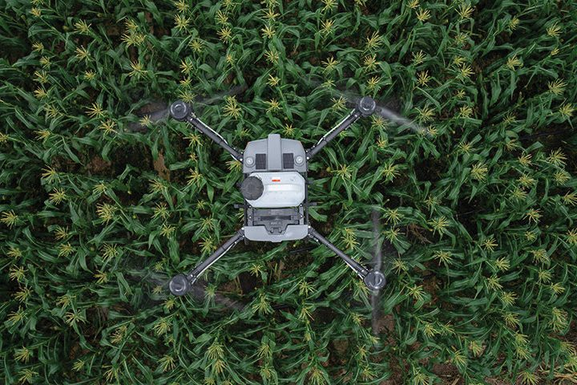
Country-Wide August 2022
The latest and greatest developments in drones was the topic of a South Otago field day. Over two days more than 80 people came to look and learn about the potential of drones on-farm.
A range of drones were on display, from the portable and entry price level to trailer-towed commercial spray drones.
Drone specialist company Ferntech overviewed the capabilities and uses of Mavic, Phantom and AGRAS spray drones. What became obvious was the big leap forward in drone technology over a short time such as the improved high definition and zoom capabilities of cameras along with the developments in thermal imaging and mapping. Drones could capture more precise and accurate information than before, Luke Johnson of Ferntech said.
Drones have come a long way and their capabilities in agricultural use are significantly improved. By Lynda Gray.

A growing area of use was for the spraying of crops and weeds. Spray drones have been around for about five years but there was not huge interest initially because of the small payload capacity of about 10kg, Johnson said. However, the development of 30kg payload drones made them a more practical option for farmers.
“The more they can spray and faster makes them a more attractive option for spraying.”
He gave a demonstration of how to plot a grid map for a spraying mission which included continuous and spot spray areas.
Onlooker and an early adopter of drone technology Brett Sanders (Country-Wide, July 2017) was interested to see the spray drones in action. They are expensive at about $50,000 which includes necessary accessories to map a spraying mission, but he thinks they could work out on extensive hill properties reliant on helicopters for the spraying of crops and weeds.
“If you are spending $15,000 a year to spray 100ha using a helicopter, that money might be better invested in a drone which could be used for more spraying around the farm.”
However, he says the big turn-off for most farmers would be the mandatory requirement for Civil Aviation Authority 102 certification which applies to owners of drones used for the application of agrichemicals. Certification costs between $2,500 to $3,500 and takes about a year to complete.
Johnny Bennett, another farmer at the field day was impressed with the improved zoom capabilities of the new drone cameras. He has owned two drones and used them for checking sheep, water troughs and for picking up obvious issues on regular flights over his Te Houka farm. The first, a Phantom 4 went for about three years until it went AWOL on a pre-planned mission, never to return. It was replaced with a second-hand drone, but that met with a crashing end due to a burst of speed at the wrong time. Despite the run-ins, he is still keen on them because they saved a lot of time, especially checking ewes at lambing time.
“The drone could do a circuit around the farm in 20 minutes which was enough to uncover any problems. To do the same driving would have taken four hours.
“There’s greater accuracy than with the older drones. Often, I would see there was a problem but not the detail whereas I probably could now. I will buy another one at some stage, but it is not a priority at the moment.”
The field days organised by the Otago South River Care group with MPI funding attracted a lot of interest.
“We asked local farmers about innovations they wanted to know more about, and drones was a reoccurring topic,” Rebecca Begg, group coordinator, said.
“A lot are interested in the technology but not necessarily at the tipping point of buying one. The idea of the field day was to let them see the technology in action and start more conversations.”
Drone rules and regs
You do not need a licence to fly a drone in New Zealand provided it is less than 25kg fully loaded and is not being used for the application of agrichemicals.
However, all drone users need to follow the Civil Aviation Authority Part 101 drone rules.
Go to: www.aviation.govt.nz/drones/part-101-rules-for-drones/
Pilots of drones used for agrichemical application need CAA Part 102 certification. This takes about 12 months and costs $2500-$3500. Go to: www.aviation.govt.nz/drones/part-102-certification-for-drones/
New versus second-hand
There is a second-hand drone market, but Brett Sanders thinks buying new is probably the better way to go. Newer models have intuitive technology, so they are easier to use. A new release model, a Mavic Mini 3 which retails for about $1,400 and includes one battery could be a good option. If a control base and screen were included it would cost $1,700-$2,000.
“For that amount you should be able to get good quality pictures.”
His advice for buying second-hand is to go with a reputable brand, and check that the batteries are in working order and hold their charge.
A Mavic Mini 3 is a possible option but Luke Johnson said it would not withstand the wind conditions on exposed farms. A better choice was a Mavic Air 2S for about $2500 which would provide quality video and photography.
Farmers wanting a ‘barking drone’ and thermal imagery features would need a Mavic Enterprise Advanced or similar ($9,500).
A ready-to-go AGRAS spray drone with a 30kg payload and supporting mapping functions costs about $50,000. This would include three batteries which could be rotated to enable continuous spraying.
Spot on
Covid led to the start-up of Bill Paterson’s drone contracting business. Until March 2020 Bill’s main income was from helicopter flying tourists in and around the Queenstown southern lakes region.
That business dried up with Covid leading Bill back to the family-owned Waikaka Station where he was able to combine helping on the farm with development of a drone contracting business.
In January, he started out with a $70,000 XAG P30 which has a 16kg payload. It has been used for spraying and seeding work throughout Otago and Southland. Bill mapped and precision-sprayed areas for thistles and insect strike, and spot sprayed for particular weeds. He is also reseeded areas of crops that did not establish due to the dry summer. There is potential for more seeding jobs once he gets a bigger payload system in place.
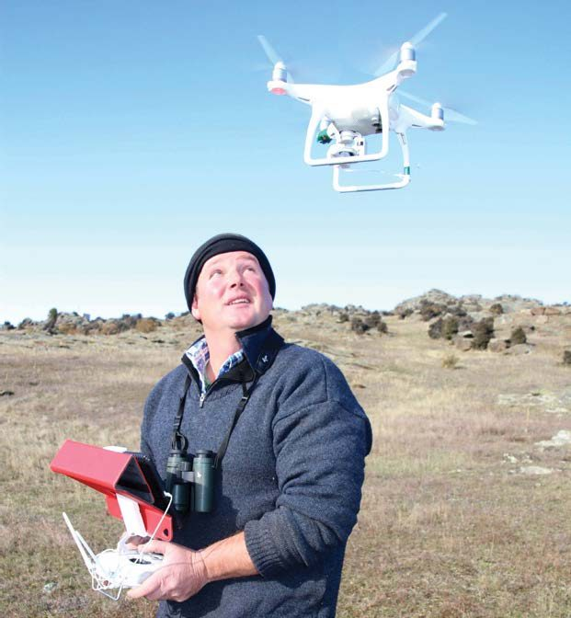
“There is a lot of potential but there is still a lot of R&D to do.”
Self-taught pilot
Brett Sanders is a self-taught drone user. He soldered together his first drone in 2013 from a basic frame with add-ons and bought a DJI Phantom in 2016. It was used a lot for mustering and was especially good at hunting out elusive Merinos from steep schist and briar country.
Brett also used it to accurately map the slope and drainage of land. The Phantom had probably flown the length of the country when it was replaced with a Mavic Enterprise Advanced last year for $10,000.
“It’s a lot of money, but I am an experienced user and know how to get the most out of them,” Brett said.
The thermal imaging is great for tracking down sheep and pests such as wild pigs and the zoom power of the camera means it is possible to identify the ear tag numbers of ewes in a paddock without disturbing them.
At the field day farmers were interested to hear about Brett’s dog barking drone which had reduced the workload of Matangi’s working dog team.
“We still use dogs, but they are probably not on to it as they used to be. When the drone comes out, they sit back and watch.”

Discussion Questions
- What are the benefits of drone technology for an agribusiness?

- What are the negative impacts of drone technology on an agribusiness?

- What are the legal influences agribusinesses need to be aware of with drone technology?

- In your opinion, could drone technology affect the viability of an agribusiness?

- How might the rapid development of drone technology influence decision-making in agribusiness operations?

- How does drone technology support the shift toward precision agriculture in the future?

- In what ways can drones reduce labour dependency on farms, and what are the long-term effects of that?

- How can drones help agribusinesses meet environmental and sustainability goals?

- How might drones improve farm management through data collection and analysis?

- How could drone technology change the business models of agribusiness service providers (e.g., spraying contractors, consultants)?

- What impact could widespread drone use have on helicopter-based agricultural services in rural regions?

Discussion Question Answers
- What are the benefits of drone technology for an agribusiness?
Drone technology offers several benefits to agribusinesses, mainly through improved efficiency, accuracy, and cost-effectiveness.
- Drones can be used for tasks such as crop and weed spraying, livestock monitoring, and mapping terrain. These tasks, when performed manually or by helicopter, are time-consuming and expensive e.g., Johnny Bennett explained that using a drone to check on his ewes during lambing saved hours of work, allowing a full farm check in just 20 minutes.
- Modern drones now have higher payload capacities (up to 30kg), enhanced zoom cameras, and even thermal imaging capabilities. This allows for more accurate data collection, spot spraying, and seeding, all essential for precision agriculture.
- For farmers like Brett Sanders, replacing helicopter spraying with drone operations could result in long-term savings. Over time, drones help future-proof farms by enabling more sustainable land management, real-time problem detection, and digital data recording for decision-making.

- What are the negative impacts of drone technology on an agribusiness?
Despite their advantages, drones can present several challenges or drawbacks for agribusinesses. These include:
- The initial cost can be significant, especially for commercial-grade spray drones like the AGRAS models, which cost around $50,000 with accessories. This upfront investment may be prohibitive for smaller farms or those with tighter budgets.
- There is also the risk of drone damage or loss. Weather limitations and technical malfunctions can interrupt operations, creating reliance on backup systems or manual work.
- Another potential downside is the learning curve and the requirement for ongoing technical skills. Older or less tech-savvy farmers might find drone operation, maintenance, and software use intimidating or time-consuming without proper support or training.

- What are the legal influences agribusinesses need to be aware of with drone technology?
- Legal compliance is a crucial aspect of integrating drone technology into agribusiness. In New Zealand, drones under 25kg that are not used for spraying agrichemicals fall under CAA Part 101 regulations. However, if a drone is used for applying chemicals, CAA Part 102 certification is mandatory. This certification can cost between $2,500 and $3,500 and typically takes about 12 months to obtain.
- These regulations are in place for public safety and environmental protection, but they can also act as a barrier to adoption. Many farmers are put off by the time and cost required to gain certification, especially when considering the already high price of the drone hardware. Non-compliance can result in fines or legal issues, so understanding and following aviation and chemical application laws is essential for agribusinesses.

- In your opinion, could drone technology affect the viability of an agribusiness?
(Sample answer – students can provide their own opinion)
Yes, drone technology could significantly affect the viability of an agribusiness both positively and negatively, depending on how it is implemented.
For proactive, innovative farmers, drones can offer a competitive edge. They can lower long-term costs, improve yields through targeted crop management, and enable faster response to issues such as pest outbreaks or irrigation failures. For instance, using drones for spot spraying or reseeding, as Bill Paterson does, could save time and reduce chemical use, leading to better margins and more sustainable practices.
However, if a business cannot afford the initial costs or navigate the regulatory hurdles, they may fall behind in efficiency compared to competitors who embrace the technology. Additionally, over-reliance on drones without adequate training or risk management (such as insurance or backup systems) could expose farms to operational disruptions.
Ultimately, drone technology represents a powerful tool for futureproofing, but its success depends on thoughtful, well-supported integration into farming systems.

- How might the rapid development of drone technology influence decision-making in
agribusiness operations?
The rapid development of drone technology is equipping agribusinesses with more precise, timely, and high-quality data, which significantly improves decision-making. For examples, enhanced camera zoom, thermal imaging, and mapping allow farmers to detect issues earlier and respond faster, such as identifying weed outbreaks or water shortages.
As drones become more capable, with higher payloads, better weather resistance, and automated flight planning, decisions around spraying, planting, or monitoring stock can be based on real-time field data rather than guesswork or delayed observations. This will lead to more confident, data-driven decisions that save time, reduce waste, and increase productivity.

- How does drone technology support the shift toward precision agriculture in the future?
- Drone technology is a key enabler of precision agriculture. With their ability to capture detailed imagery and geospatial data, drones can identify variability within a field and enable targeted actions such as spot spraying, variable-rate application, and site-specific fertilizing.
- As drone software evolves, it can integrate with farm management systems to automate decision-making and resource allocation.

- In what ways can drones reduce labour dependency on farms, and what are the long-term effects of that?
- Drones can perform tasks that traditionally required manual labour or costly services. These include checking livestock, monitoring paddocks, spraying weeds, and even seeding small areas. For example, as Johnny Bennett said, using a drone to check ewes reduced his workload from four hours to just 20 minutes. Over time, this shift can reduce a farm's dependency on hired labour, especially for repetitive or hard-to-access tasks.
- The long-term effects could include reduced labour costs, fewer workplace injuries, and a need for more tech-skilled workers. However, this could also challenge traditional rural employment and require retraining for displaced roles.

- How can drones help agribusinesses meet environmental and sustainability goals?
Drones support environmental goals by enabling precise, targeted interventions. For example, instead of blanket-spraying entire paddocks, drones can spot-spray only where weeds are present, significantly reducing chemical use and runoff. Drones can reseed damaged or underperforming areas without disturbing the soil structure.

- How might drones improve farm management through data collection and analysis?
Drones provide a valuable source of high-resolution, real-time data that can be used for analysis and improved farm management. They can survey large areas quickly and gather visual, thermal, and multispectral data to assess crop growth, plant health, livestock movement, and water infrastructure. With software mapping tools, farmers can create detailed records of farm activity and conditions over time, improving planning and record-keeping. This allows for faster, evidence-based responses.

- How could drone technology change the business models of agribusiness service providers (e.g., spraying contractors, consultants)?
- As drones become more capable and accessible, agribusiness service providers may need to adapt their models. Traditional spraying contractors, for example, might invest in drone fleets to offer more precise and flexible services. Drone-based service offerings could include not just spraying, but also crop scouting, thermal imaging, mapping, and yield prediction.
- Consultants could shift toward offering data interpretation and tech support, helping farmers make use of drone-collected data. While this opens up new opportunities, it may also increase competition and pressure on existing businesses to stay up to date with drone technologies and certifications.

- What impact could widespread drone use have on helicopter-based agricultural services in rural regions?
- Widespread adoption of drones, especially those with large payloads and autonomous mapping capabilities, could significantly reduce demand for helicopter-based services in rural agriculture. Farmers like Brett Sanders already see drones as a cost-effective alternative, particularly when helicopter spraying costs reach $15,000 annually. Drones offer more precise application, lower operating costs, and the ability to be used more frequently. Over time, this could lead to a decline in helicopter use for tasks like spraying or monitoring especially on smaller or more remote properties.
- Helicopter services may need to diversify or specialise in areas where drones are less effective, such as in extremely large or rugged terrain where flight time and payload limits remain a challenge for drones.
Technology future proofing influence questions.

Answer these questions using a hill country farm as the agribusiness.

- Using technology as an influence outline some of the short- and long-term impacts on a hill country farming business.

- Using the technology influence, explain the impact beyond the hill country farming business e.g. socially.

- What are the consequences of these impacts on the hill country farming business?

- Using these consequences, explain how each consequence might affect the viability of the hill country farming business?

Answers
Answer these questions using a hill country farm as the agribusiness.
- Using technology as an influence, outline some of the short and long-term impacts on a hill country farming business.
Short-term impacts:
- Drones can increase efficiency by saving time on task such as checking of stock and infrastructure saving time.
- New drones with zoom and thermal cameras have high accuracy so can help detect issues more easily and earlier.
- Buying a quality drone (e.g. AGRAS spray drone for $50,000) is a big investment. Certification (CAA 102) also adds cost and time.

Long-term impacts:
- Over time, drones may replace the need for expensive helicopter spraying, saving money (e.g. $15,000/year for 100 ha).
- Drones reduce the risk of injury from mustering in rough terrain or spraying with helicopters.
- Drones allow greater precision agriculture practices such as mapping, spraying helping to meet environmental goals.

- Using the technology influence, explain the impact beyond the hill country farming business (e.g. socially).
- Job changes in rural communities - As drones take over tasks like spraying or mustering, demand for helicopter pilots or even working dogs may decrease.
- New business opportunities - People like Bill Paterson created drone contracting businesses, offering services to other farmers, a new rural job path.
- Education and upskilling - Farmers are learning new tech skills, and young people may be more attracted to farming because of the use of high-tech gear.
- Community knowledge-sharing - Events like the field day help farmers connect, learn together, and discuss future innovations.

- What are the consequences of these impacts on the hill country business?
- Lower operating costs over time - Savings from fewer helicopter flights and quicker inspections.
- Need for ongoing training - Farmers must learn how to use drones and software or hire someone who can.
- Upfront financial pressure - Buying and certifying drones is expensive, especially for smaller farms.
- Technology dependence - If drones crash or malfunction (like Johnny Bennett’s drone), the business might temporarily lose key functions.
- Changing labour needs - Less need for traditional labour (e.g. dog work, helicopter pilots), but more need for tech-savvy operators.

- Using these consequences, explain how each consequence might affect the viability of the business.
- Lower operating costs increase profitability and help the business remain sustainable long-term.
- Training needs may be a barrier for older or less tech-confident farmers, affecting how widely technology is adopted.
- High initial costs might delay adoption or lead to cash flow problems, especially for small farms.
- Technology dependence could mean higher risk if the drone breaks, crashes, or gets lost disrupting key operations like lambing checks or weed control. Any disruptions can influence production, cash flow and long-term viability.
- Changing labour needs may affect staffing decisions, with businesses needing to hire or train people with drone or data skills, possibly changing the traditional structure of farm teams. This all adds costs which may not be financially viable.

