Level 2: Future Proofing Influences.
Technology Influence Worksheet

Teacher Note:
The future viability of dairy farming is being significantly shaped by emerging technologies.

Activity: Read the article and summarise the key points on the technological influence on the future viability of a dairy farm.

The future of farming: How technology can get NZ farms a competitive advantage
https://www.rnz.co.nz/news/country/515991/the-future-of-farming-how-technology-can-get-nz-farms-a-competitive-advantage
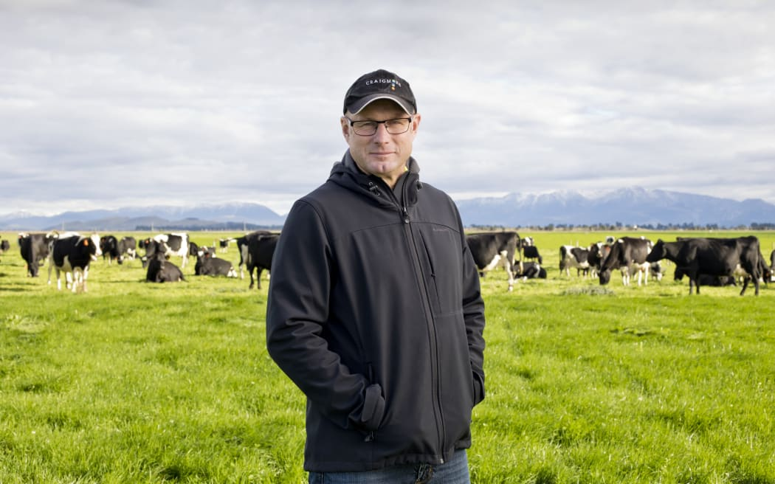
It is an exciting time for robot and drone-based technology use on farms, fifth generation farmer Stu Taylor says.
He is the general manager of Craigmore Sustainables, which manages more than 25,000 hectares of farming, forestry, and horticultural properties. The company oversees a number of social, educational and environmental innovations including two scholarship programmes and devices for animal monitoring and methane reduction.
Stuart Taylor is GM Farming at Craigmore Sustainable. Photo: Juliette Capaldi Etta Images.
Taylor told RNZ's Afternoons he has always been passionate about the future of the industry.
"It is a really interesting space as different generations and technologies and techniques come together over the next ten years and if we lay that over with what is expanding with AI and just how farmers will interact with that information... and working in synergy with that technology to really create a high performance farm based on what New Zealand's great at - which is growing pasture."
It was an exciting time for robot and drone-based technology use on farms, he said.
Work was being done to create cameras for dairy farms that will fly around a farm to measure the grass growth on a daily basis.
Another type of camera can be used to measure the nutrient and moisture content of different pastures.
"So, you get this visual data from drones and also we've had ground-based robots out on farms already. They are working on robots that identify weeds and specifically spray weeds and pasture, so that's cutting down the risk for an individual to be exposed to spray and also being really accurate."
Taylor had already started to trial future farm technologies. He has been working with Lincoln University and Ravensdown which produces an eco-pond system - an iron sulphate that is mixed with effluent as it goes from the cow shed into the holding pond.
"That stops methane being released from that effluent. That's about 4%... per farm of our greenhouse gas equivalent effect."
Kowbucha was a trial Craigmore Sustainables was doing with Fonterra - a biostimulant that reduces methane from the animals for at least the first two years of its life - about 20% per animal.
"And then of course we're looking a farm efficiently, being a better farmer also reduces your effects on greenhouse gases."
New Zealand could have a competitive advantage to be the closest to net zero dairy in the world, he said.
"I still believe farming is the greatest job, greatest industry in the world and what is happening in New Zealand is really positive change as we listen to our customers around the world, adapt to what they need..."

Answer:

Summary
The future viability of dairy farming is being significantly shaped by emerging technologies, particularly in robotics, drones, AI, and environmental innovations. Taylor sees these innovations giving New Zealand dairy a competitive edge, potentially becoming the world's closest to net-zero dairy industry.
Stuart Taylor, GM of Craigmore Sustainables highlights how these tools are enabling smarter, more sustainable farming practices:

- Robotics & drones:
- Drones equipped with cameras can measure grass growth and pasture quality daily.
- Ground-based robots are being trialled to identify and accurately spray weeds, reducing chemical use and human exposure to sprays.

- Data and AI integration:
- Advanced imaging and AI allow farmers to make real-time, informed decisions, improving efficiency and productivity on pasture-based farms.

- Methane reduction technologies:
- Eco Pond System: Developed with Lincoln University and Ravensdown, it uses iron sulphate to reduce methane emissions from effluent by about 4% per farm.
- Kowbucha: A bio-stimulant trialled with Fonterra that cuts animal methane emissions by around 20% for the first two years of life.

- Sustainable farming practices:
- Efficient farm management not only improves output but also reduces greenhouse gas emissions, aligning with global consumer expectations and sustainability goals.

