About OCHO and Own the Factory

Dear Reader
This venture began in July 2017 when Mondelez announced the closure of the Dunedin Cadbury Factory. This document covers what has happened to date and our plans for the future. Please consider investing to grow premium chocolate manufacturing in Dunedin. This is about Dunedin-made chocolate and a company owned by kiwi chocolate-lovers.
Jim O'Malley (Own The Factory) and Liz Rowe (OCHO)

Our share offer

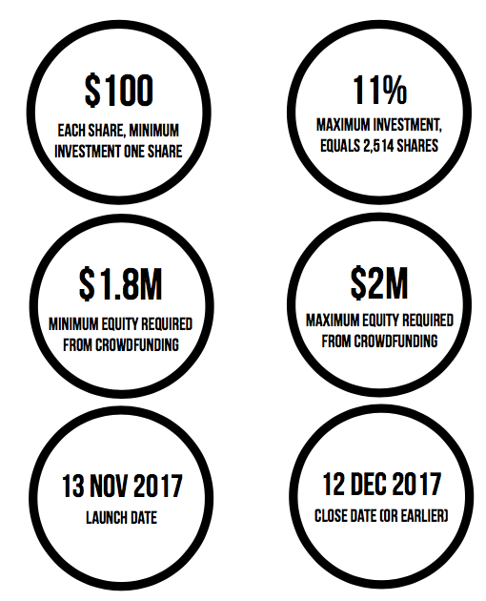

Our share offer is a little different from the ordinary. We aim to attract as many investors as possible and are limiting the total that any one person can own to 11% so that no single investor can dominate.

Instead of one or a few large 'cornerstone' shareholders, OCHO Newco will be owned by a broad base of investors. Each share is $100 and all shareholders will have voting rights. We never plan to sell OCHO because we believe that chocolate manufacturing should stay and grow in Dunedin.

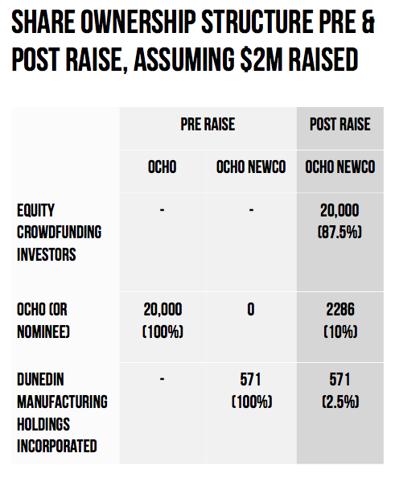

Our intention is to run the business profitably. Initial profits may be reinvested to help OCHO grow, but longer term our intention is to pay a dividend on shares. In additional all shareholders will be REWARDED WITH CHOCOLATE by being able to buy OCHO chocolate at a 20% discount through the online website and OCHO store in Dunedin.

Please note: The campaign for Ocho Newco Limited is raising $2million on a pre-money valuation of $57,100. This means if the offer is fully subscribed through PledgeMe the company will be worth $2,057,100.
Ocho Newco Limited are planning on completing a transaction after the crowdfunding raise to purchase Ocho Limited. This will be part paid for in cash ($75,000), and by issuing new shares in Ocho Newco Limited ($228,600). This means after that transaction the company will be worth $2,285,700. The equity investors that come in during the PledgeMe campaign will still have shares worth $100, and own 87.5% of the company after that transaction.

About our Team

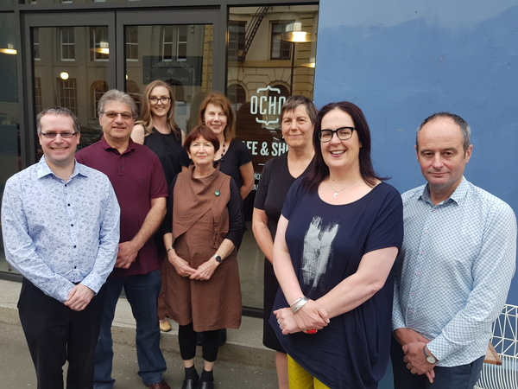
(left to right) Stewart Cowan, Vito Iannece, Anna McDonald, Tami Louisson, Liz Rowe, Rachel Elder, Nicola McConnell, Jim O'Malley

Board of Directors
An establishment board of directors has been appointed to lead OCHO for the first 12 months. Positions will be revised after 12 months at which stage one staff board member will be appointed. There will be a maximum of five directors at any one time.
In looking for directors we have searched for a mix of people with strong practical skills especially in the food & beverage area, and in scaling companies for expansion. All the directors are Dunedin-based except for Tami Louisson, who lives in Wellington. OCHO founder Liz Rowe will continue working for OCHO as general manager.
Tami Louisson co-founded SHOTT Beverages, Tami was CEO for eight years before retiring in 2015. She remains on the board. The company has now grown to employ 35, with turnover of more than $10 million and exporting half its sales. Originally trained as an artist, Tami was a silversmith and glass art worker before turning her hand to drinks. Tami believes there is a logical connection between art and business – conceptualising, translating that concept into a product, building a brand, developing markets and selling the product. Tami was an Ernst & Young Entrepreneur of the Year finalist in 2012 and a finalist in the Next Woman of the Year Award in 2014.
Vito Iannece along with his wife Penny, founded Pasta d’Oro 30 years ago. They have grown it from a kitchen enterprise to a company employing 18 which supplies trade and supermarkets with a range of high-quality artisan pasta. Vito brings start up experience in FMCG as well as experience on factory establishment. He is committed to the development of food manufacturing in Dunedin.
Stewart Cowan is Enterprise Systems Manager at Silver Fern Farms. He is a Chartered Accountant and an IT specialist. He brings project management skills as well as IT systems integration. He understands the quality control issues required for farm to table tracking systems in the meat industry. He is enthusiastic about the challenge of building up a strong manufacturing capability in Dunedin and the role OCHO will play.
Jim O’Malley is a Dunedin City Councillor and was instrumental in starting the Own the Factory campaign and achieving the initial pledging of nearly $6M towards saving jobs in the city. He has 25-years' R&D experience in biomedical research in the USA. He has led project development teams at Pfizer Inc and been involved with in-licensing and joint ventures. He has also founded his own biotech company and successfully managed an $8 million project to develop a novel bone growth agent for use in orthopaedic surgery. He recently returned to live in Dunedin and has extensive experience in project management and scale-up, along with experience in the culture of large organisations.

Key folk
Liz Rowe started OCHO in 2013 and has grown the company from one person producing 15 kilos of chocolate per week to producing 90 kilos per week and employing five staff. Last year OCHO moved premises to Vogel St in Dunedin's new Warehouse Precinct and now has a shop & cafe as a front of house to the chocolate production. Liz trained as a journalist and worked overseas and then in Wellington in a number of journalism and communications roles before moving to Dunedin in 2004 to attend the Dunedin School of Art, graduating with a BFA in 2007. Chocolate was a change of direction that surprised Liz as much as anyone else, but she is now firmly committed to seeing OCHO grow as a strong and sustainable business in Dunedin. She will continue working for OCHO as general manager.
Nicola McConnell is a marketing communications professional who specialises in the area she loves - food and drink. She trained as a journalist and has worked for the Otago Daily Times and Radio New Zealand before heading across the ditch and working in Sydney and Melbourne in marketing and corporate communication roles. She’s been back home in Dunedin since 2014, setting up her boutique marketing company Brand Amp. In October 2016 she co-founded Marvellous Marketing, which is a specialist food, drinks and lifestyle marketing communication agency. Marvellous Marketing established the Outstanding NZ Food Producer Awards and co-owns the NZ Chocolate Awards which were held for the first time in 2017.
Rachel Elder & Marie Laufiso, along with Jim O’Malley, were the team who started the Own the Factory movement. Both Rachel and Jim are Dunedin City Councillors. Rachel has stayed with the team throughout the planning process and remains a key cheerleader in the quest to keep jobs & manufacturing in Dunedin. Seeing communities and individuals grow and thrive is very important to Rachel and she has worked over the past 30 years across the health, education, church, community, employment and business sectors. Marie’s connections with the workers at the Cadbury Factory helped in the initial phase of the campaign.
Anna McDonald recently graduated with a Master’s in Entrepreneurship from the University of Otago, majoring in New Venture Strategy. She jumped on board with the Own The Factory campaign at a community meeting when she learned of the socially responsible and ethical business model the team was looking to build. Anna’s involvement has been in business planning, research, analysis, and evaluation of OCHO’s strategic options. She currently works at Timely, as the Business Relationship Manager, and is on the Dunedin Branch Executive for the National Council of Women.
OCHO’s current five staff will continue working for the new company. We have two baristas who look after the cafe & shop plus help with packaging & labelling when there’s time. Two staff look after tempering, moulding and the bulk of the packaging of bars and one staff member does the roasting, winnowing and loading of the grinders. Currently everyone prefers part-time work, so this team equates to 3.6 FTEs.
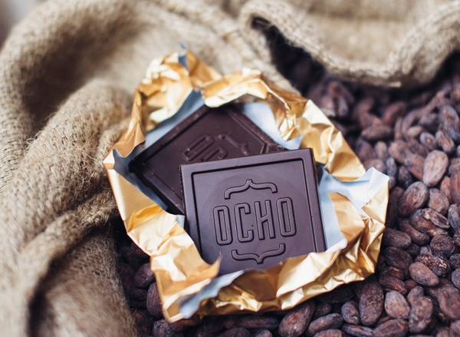

What we've done so far

Own the Factory
When Mondelez announced it was closing the Cadbury Factory in Dunedin, New Zealand, a group of local citizens decided something must be done to keep chocolate making skills and jobs alive in the city. With the help of PledgeMe and Firebrand set up the “Own the Factory” web landing page to gauge public interest in investment to retain confectionary and chocolate manufacturing in Dunedin. During the two week campaign considerable national and international media coverage resulted in $5.7 million pledged.

OCHO
An existing Dunedin-based craft chocolate maker, Otago Chocolate Company Ltd (OCHO), approached DMH with the proposal that it would benefit both parties to combine forces to establish a large scale chocolate manufacturer in Dunedin under the premium brand already established by OCHO. Internationally, the key growth area in the chocolate industry is in premium quality chocolate. Premium chocolate is defined by the use of quality cacao, limited ingredients, traceability of cacao beans, ethical sourcing, attention to craftsmanship, continued search for excellence and quality, and high quality brand presentation.

Combining forces
This business proposal is to form a new company (OCHO NewCo) that will raise $2M in equity through crowd funding. It will then acquire OCHO, expand production and look to move into new markets and products. The new company will aim to develop a visitor experience in Dunedin and establish export markets. OCHO NewCo will continue trading as OCHO.
OCHO has been growing since its establishment in 2013. However, more investment is required to develop the space and production capability to produce enough chocolate to gain a significant share of the New Zealand premium chocolate market. OCHO is a perfect fit to establish a modern model of growth in the manufacturing industry with its values of quality ingredients, fairly traded cacao beans that are sourced from our Pacific neighbours, community and ethics which are central to operations. OCHO will provide staff and manufacturing expertise and the initial growth of the new venture will leverage the established OCHO market.
The Own the Factory team, under the umbrella of Dunedin Manufacturing Holdings Incorporated, will bring a strong focus on keeping a broad base of community ownership, paying fair wages to workers, keeping worker-CEO pay ratios within an agreed multiple, and a strong commitment to regional development through profitable businesses.

