Strategic Capital

Expenditure Decisions

http://www.nzherald.co.nz/business/news/article.cfm?c_id=3&objectid=11847022

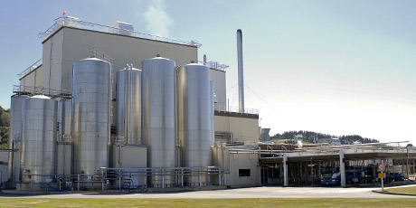 | 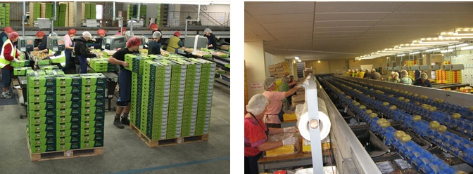

Introduction
Owners or managers of an agribusiness need to plan, manage, record keep & monitor their financial progress. This will help them develop an understanding of the profitability and cash flow of the business. In particular this will provide information to aide in forward planning & expansion of agribusinesses when the opportunity exists. Part of the expansion will require an awareness and ability to plan for & finance a large capital item. This will include understanding the funding requirements (the amount) and the sources of finance available - internal (financed by owners) and/ or external (debt borrowed from financial institutions) and the impact on the agribusiness of the expansion.

What is 'Capital Expenditure (CAPEX)' http://www.investopedia.com/terms/c/capitalexpenditure.asp
Capital expenditure, or CapEx, is spending by a company to acquire or upgrade physical assets such as property, industrial buildings or equipment. Our focus is on Strategic Capital Expenditure which is spending on property and/or buildings and/or equipment for projects that either:

- provide access to new markets e.g. into Australia
- provide new goods and/or services
- improve the efficiency and/or quality of goods produced

Ultimately decisions about strategic capital expenditure will enable businesses to achieve medium to long term goals that they have set. These could include, but are not limited to, any of the following:

- grow profitability or
- grow / maintain market share or
- become a market leader

Achieving growth in profitability could result in a growth in market share or in a competitive market ensure that the business maintains its market share. Another possibility is that becoming a market leader could well mean that profitability will grow as a result.

Strategic Capital Expenditure is often expensive and will require financing. This finance could be in the form of equity i.e. from the owners or debt finance from external sources. The capital expenditure item purchased should be financed through long term sources as it will contribute to the profitability and generate cash for the business over a number of years (medium to long term). Short term financing is usually not appropriate when strategic capital expenditure is involved.

Significant planning will be required when considering strategic capital expenditure. The cost of the capital expenditure item, the impact on current production, staffing changes, supplier availability are just some of things to consider.

Significant amounts of information both financial and non financial will be required to determine the:
- best method of financing
- best capital expenditure option
- overall cost
- overall benefit

How Does Strategic Capital Expenditure Achieve Business Goals
Provide access to new markets

Strategic Capital Expenditure is often expensive and will require financing. This finance could be in the form of equity i.e. from the owners or debt finance from external sources.

combination of the following depending on what the goal of the business is:
It is often used to undertake new projects or investments by the firm. This type of outlay is also made by companies to maintain or increase the scope of their operations. These expenditures can include everything from repairing a roof to building, to purchasing a piece of equipment, or building a brand new factory.

Routine vs Strategic Capital Expenditure
Routine capital expenditure will involve spending to maintain or replace an existing asset. Strategic Capital Expenditure will either enable a business to maintain its position in the market, expand into new markets, produce new products.

http://www.cfoedge.com/resources/articles/cfo-edge-strategic-capex-planning.pdf

Waterfront Stadium
http://www.nzherald.co.nz/nz/news/article.cfm?c_id=1&objectid=11815995

https://www.fonterra.com/nz/en/news-and-media/videos/the_hamills_using_technology_to_care_for_cows.html

The crater
http://www.nzherald.co.nz/business/news/article.cfm?c_id=3&objectid=11847022

Strategic plans
http://www.thealternativeboard.com/what-is-a-strategic-plan-and-why-does-your-business-need-one/

https://www.workflowmax.com/blog/try-this-simple-8-step-strategic-plan-template-for-small-business-owners

http://smallbusinessbc.ca/article/why-does-a-growing-business-need-a-strategic-plan/

https://www.fundable.com/learn/resources/guides/crowdfunding-guide/what-is-crowdfunding

