Dream realised as Tangaroa Walker gets his farm

Read the following article and answer the following questions.

- Identify the strategic capital expenditure decision made by Tangaroa Walker in the article. Explain why this purchase constitutes a strategic decision rather than a routine operational expense for his agribusiness?

- Tangaroa Walker funded the farm purchase using a combination of financing sources.
  - Identify the specific financing options used to fund the purchase.
  - Describe the differences between the equity funding structure and the debt funding structure used in this scenario.

- Evaluate the financial and non-financial consequences of Tangaroa Walker choosing a smaller group of equity partners with larger stakes over a crowdfunded/syndicated structure with 100–200 smaller investors.

- Justify why a blended financing model (Equity Partners + Bank Debt + Personal Capital) was the most suitable strategy for Tangaroa Walker to achieve his long-term strategic goals, compared to relying 100% on bank borrowing. In your answer, consider debt servicing risk, capital requirements, and his future expansion goals.

Dream realised as Tangaroa Walker gets his farm

March 25, 2026

After several setbacks, Southland farmer Tangaroa Walker has secured his first farm, backed by strong investor interest and community support.

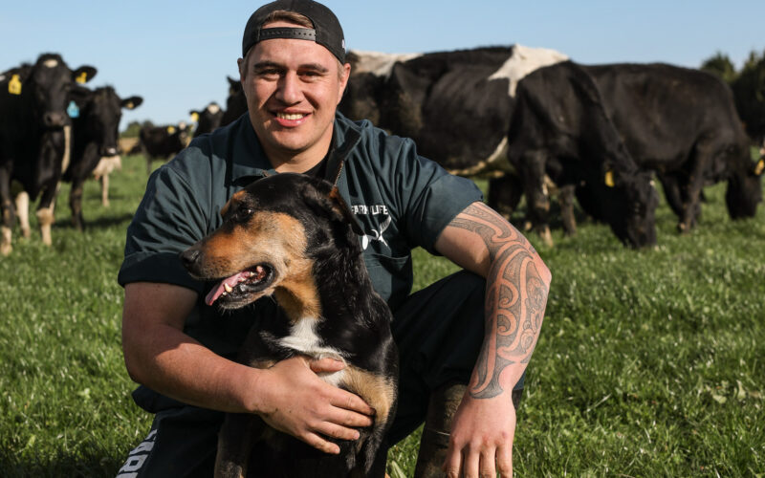
Farmer, author and social media personality Tangaroa Walker has bought a farm near Gore after years of contract-milking. Photo: James Jubb

After several attempts and strong backing from the community, Southland dairy farmer Tangaroa Walker has secured his first farm.
Walker settled on a 130-hectare property near Gore earlier this month for just under $5 million. The purchase includes a herd of 310 mixed cows producing about 112,000kg of milksolids.
The purchase followed a challenging process. Walker initially sought to raise $4m through equity partnerships within a two-week window late last year to secure his preferred property, but the deal fell through when another buyer went unconditional.
The author and social media personality made offers on three further farms before successfully securing his fourth option, ultimately raising $4.3m to complete the purchase.
The acquisition was funded through a mix of equity partnerships, bank lending and Walker’s own capital. Two equity partners, comprising two couples, invested in the farm, with returns linked to milksolids production.
Walker said he had been in discussions with four different banks over the past few months, before being granted lending approval.
​“It has been quite a journey with them, but we were fortunate enough to get the green light,” he said.​
Interest from potential investors was strong, with between 100 and 200 inquiries coming through his Farm4Life platform, alongside broader media attention.
Walker ultimately opted for a simpler ownership structure, selecting a smaller group of equity partners with larger stakes.
“We’ve got the same shared vision, same shared values, and [they are] very, very supportive of myself and my family and where we’re wanting to hit,” he said.
While the farm wasn’t his initial preference, it turned out to be the right fit, he said.
​“It has ended up being the right farm for us at this time.”
The handover date for the property is scheduled for June, and Walker said he is “counting down the days already”.
After some time as a contract milker, he said his “family needs some security. We need a farm that I want to sink my teeth into and really give it my all.”
Alongside farming, Walker runs Farm4Life, an online video-based training platform focused on New Zealand dairy farming. The business has recently partnered with Telford and the Southern Institute of Technology to deliver NZQA Level 3 qualifications through the app, set to launch in early June.
Walker said the programme is designed to allow students to complete their training while working on a farm, combining online learning with practical, on-farm assessment.
“I want Farm4Life to be the chosen education platform for all farmers in New Zealand, because it’s by a farmer, for a farmer. You know, I’m living farming every day on farm. So that’s the Farm4Life vision.”
​Looking forward, Walker would like to leverage his recent farm purchase and own another property in a few years’ time.
“The vision for the future in terms of the farm would be to have two farms in three years’ time. And for myself, I want to be big, strong, married, and have another baby.”

Answers

Read the following article and answer the following questions.

- Identify the strategic capital expenditure decision made by Tangaroa Walker in the article. Explain why this purchase constitutes a strategic decision rather than a routine operational expense for his agribusiness?

The strategic capital expenditure decision is the purchase of a 130-hectare dairy farm property near Gore for just under $5 million, which includes a herd of 310 mixed cows.

Explanation:
- A strategic decision requires significant long-term capital investment and shapes the overall trajectory of the business, rather than handling day-to-day running costs (operational/routine decisions).
- Buying the farm represents a major, long-term commitment that provides long-term stability and security for Tangaroa Walker's family after years of contract milking.
- It directly aligns with his broader agribusiness strategy: to own and operate his own land, leverage his Farm4Life platform on an active working farm, and position himself to scale to two farms within three years.

- Tangaroa Walker funded the farm purchase using a combination of financing sources.
  - Identify the specific financing options used to fund the purchase.
  - Describe the differences between the equity funding structure and the debt funding structure used in this scenario.
a) Financing Options Used:
- Equity partnerships (equity capital)
- Bank lending / mortgage (debt capital)
- Owner's personal capital (retained equity)

b) Distinction Between Equity and Debt Funding:
- Equity Funding Structure: Tangaroa Walker brought in two external couples as equity partners who purchased shares/stakes in the business. Equity partners do not charge interest; instead, their return on investment is directly linked to business performance (specifically, milksolids production outputs). This introduces shared risk and reward without adding forced debt-repayment stress.
- Debt Funding Structure: Tangaroa Walker obtained bank loan approval after discussions with four lending institutions. Debt financing requires fixed or variable interest payments and principal repayments over time regardless of production levels or payout prices. The farm asset typically serves as bank security.

- Evaluate the financial and non-financial consequences of Tangaroa Walker choosing a smaller group of equity partners with larger stakes over a crowdfunded/syndicated structure with 100–200 smaller investors.

Financial Consequences
- Setting up legal framework, financial disclosures, and dividend payouts for two couples is far cheaper and less complex than managing 100 to 200 micro-investors through the Farm4Life network.
- Returns for the two equity partners are directly linked to milksolids production (~112,000 kg). Having larger stakes aligns partner profit directly with farm yield and performance, simplifying financial reporting.
- Concentrating equity into just two investment couples means if one investor wishes to exit in the future, Tangaroa Walker must find a significant amount of capital or a new investor to buy out that large stake.

Non-Financial Consequences
- Working with two couples allows Tangaroa Walker to establish a unified management direction. As noted in the article, they share the "same vision and same shared values". Managing 100–200 investors could lead to conflicting priorities and fragmented decision-making governance.
- A smaller group fosters direct, strong personal relationships. The investors are personally supportive of Tangaroa Walker's family goals.
- By opting out of broader community crowdfunding, he missed an opportunity to give hundreds of Farm4Life platform followers direct financial ownership in his journey, though this was traded off for operational simplicity.

- Justify why a blended financing model (Equity Partners + Bank Debt + Personal Capital) was the most suitable strategy for Tangaroa Walker to achieve his long-term strategic goals, compared to relying 100% on bank borrowing. In your answer, consider debt servicing risk, capital requirements, and his future expansion goals.
A 100% bank-financed purchase of a $5 million farm property would carry severe financial risks and structural hurdles:
- Borrowing $5M solely through bank debt would create immense serviceability stress through heavy interest expense and principal repayments, especially during seasons with low milk payout prices or high input costs. By raising $4.3M in equity capital alongside personal funds and bank debt, Tangaroa Walker substantially lowers his debt-to-equity ratio. Equity partners absorb production risk because their returns are tied to milksolids yield rather than fixed interest claims, preserving farm operational cash flow.
- Banks scrutinise high-loan-to-value ratios (LVR). Tangaroa Walker engaged with four banks before receiving lending approval. Securing substantial external equity backing proved to commercial lenders that the business venture was financially sound and well-capitalised, satisfying bank lending criteria.
- Tangaroa Walker’s multi-year plan is to scale up to owning two farms within three years. If he had maxed out his bank borrowing capacity on his first 130-hectare property near Gore, his balance sheet would be over-leveraged, blocking further bank loans for expansion. Equity funding protects his borrowing capacity, keeping his balance sheet healthy enough to secure capital for a second property in the near future.
The blended model balances control, risk management, and borrowing capacity, making it the most viable financial strategy to achieve both immediate farm ownership and long-term business growth.

