Funding flurry as Tangaroa Walker eyes land purchase

Read the following article and / or watch this Country Wide Connect podcast “Unique approach to acquiring first farm” and answer the following questions.

Questions

- Summarise the key points of the article or podcast.

- What are equity partnerships and crowdfunding?

- Compare the key operational features of these two sources of capital.

- Why did Tangaroa Walker decide to pivot away from a general crowdfunding model to purchase his farm?

- What financial strategies and funding sources did Walker combine to back his farm purchase?

- What steps should a buyer take before presenting a farm funding proposal to prospective equity partners?

- How can personal branding or a public presence help in securing agricultural financing?

Funding flurry as Tangaroa Walker eyes land purchase

Written by Isabella Beale
November 13, 2025

Southland dairy farmer is determined to raise $4m within two weeks so he can buy a farm of his own.
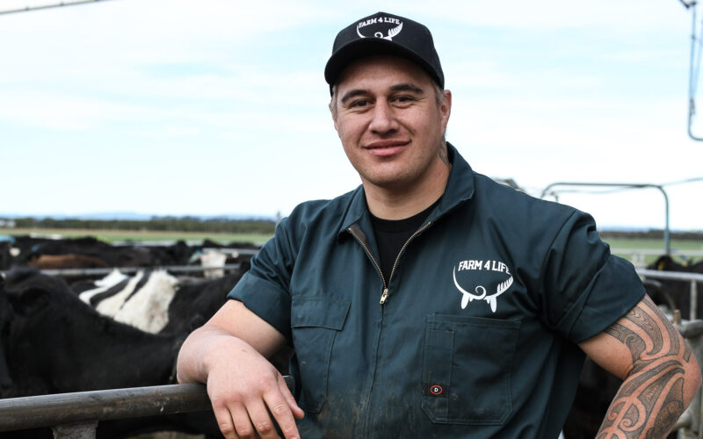
Tangaroa Walker is working with the founder of Milestone Group, to put together a business equity partnership as part of his fundraising efforts. Photo: James Jubb

After moving three times in three years, a Southland dairy farmer, author and social media personality is determined to put down roots. But to buy the farm that will help realise his dream, Tangaroa Walker needs to come up with $4 million in the next two weeks. This is on top of the $2.5m he has already raised.
Walker, who has a following of 247,000 on Facebook and 43,300 on Instagram, grew up around the dairy industry, milking his first cow on his uncle’s lifestyle block as a child. His passion moved to working on the neighbour’s farm during the weekends and holidays, and slowly turned into his full-time career, spanning over a decade.
Now in his 10th year of contract milking, Walker said he’s ready to lock in a farm longer term, both for stability for his kids and family, and to reap the rewards that come from staying on one property.
However, his goal hit a setback one month ago when the farm he was on was sold – just one day after he made a video expressing his interest in buying it. The sale means next year will bring his fourth move in four years.
“I was absolutely gutted,” Walker said.
“But, you know, you think all hopes are lost, and then I’ll just go back to contract milking. But I was like, nah, bugger it, let’s see if we can buy a farm.”
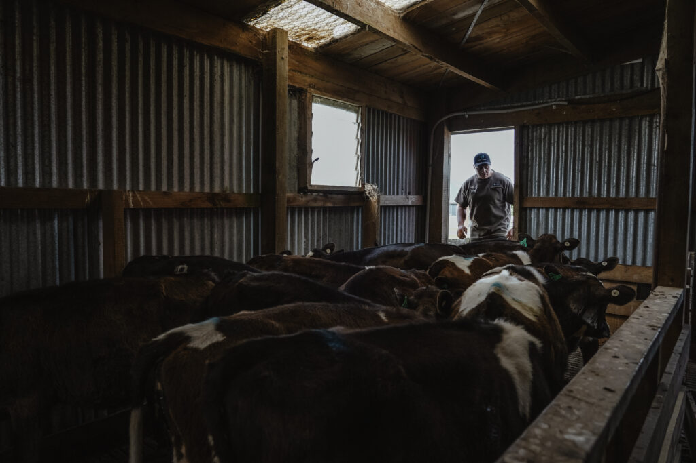
Tangaroa Walker manages his herd for contract milking. Photo: James Jubb

Frustrated by the sale but undeterred, he spent a day looking at six different farms in the Invercargill region with his longtime friend, Culverden dairy farmer Patrick Whittle.
He has since made an offer on a property, which was initially declined in favour of another bidder. However, his counteroffer remains in play; if the first offer conditions are not met in the next 14 days from today, Walker will be next in the queue.
That gives him roughly a fortnight to re-enter the negotiations on that property if the bid conditions are not met by the original bidder, and an additional 20 days until the deadline to finalise the sale.
​Walker said he originally considered a crowd-funding approach to allow individuals to buy shares in the farm, but decided against it after discovering, through legal advice, the complexities of New Zealand’s equity partnership regulations. He said would be open to exploring different ways the community can get involved financially to see a return in the future if there is interest in it.
He is currently working with Tony Miles, the founder of Milestone Group, to put together a business equity partnership. Miles has 20 years’ experience as a Southland dairy farmer, alongside his business coaching and advisory experience.
“Tangaroa is building a pathway and platform connecting urban and rural New Zealand. Milestone Group is guiding him through governance, strategy and building a successful partnership system as he develops his equity partnership, aligning with our purpose to inspire people to reach their potential,” Miles said.
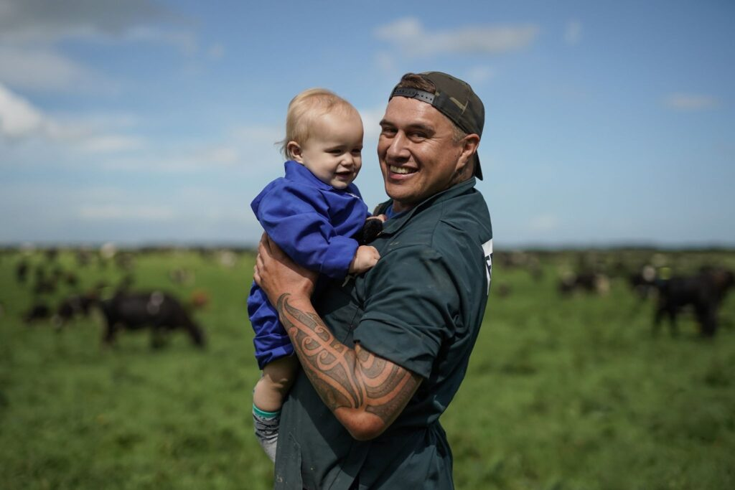
Tangaroa wants to buy a forever farm for himself and his family. Photo: James Jubb

Walker is also working with Southern Institute of Technology (SIT Telford); has established a 50/50 debt-equity partnership with a bank; and has attracted interest from a number of companies wanting to get involved, including a cow-technology firm keen to help back his herd’s ear tag systems.
“​We need another four for this thing to go. And it’s, you know, we’ve done our budgets with our accountant, and it’s looking good,” Walker said.
Looking ahead, he has big plans for the future, especially if this deal goes through. Walker also wants to compete for the NZ Dairy Industry Awards and the prestigious Ahuwhenua Trophy.
Beyond farming, he gives back to the rural community with farm visits from local schools, emceeing the Clash of the Colleges, and through his own app Farm 4 Life. The app is an on-farm learning tool developed alongside SIT Telford, which allows users to earn credits towards NZQA up to Level 3, the first app of its kind in New Zealand.
Businesses wanting to partner with Walker or wanting more information about his venture can message him on Farm 4 Life on Instagram or Facebook.
Watch his full fundraising appeal video here.

Answers

- Summarise the key points of the article or podcast.
Tangaroa Walker, a Southland dairy farmer and social media personality known for his "Farm 4 Life" platform, successfully used a crowdfunding and equity partnership model to secure his own farm in 2025–2026.
Key Points:
- Fundraising Effort: Facing the potential sale of the farm he was contract milking, Walker aimed to raise $4 million to buy the property to ensure stability for his family.
- Method: He utilised his large social media following (over 200k on Facebook) to seek "crowd" investment, creating an equity partnership with different investment levels (platinum, gold, and smaller shares).
- Success: Supported by the Milestone Group and strong community interest, he successfully secured his first farm by March 2026.
- Background: Walker is well-known for creating the "Farm 4 Life" educational social media platform and for his efforts in mentoring young farmers and educating the public about dairy farming.

- What are equity partnerships and crowdfunding?
- An equity partnership involves multiple investors pooling their capital to purchase an asset (like a farm) in exchange for ownership shares and a proportion of the profits or capital growth.
- Crowdfunding, by contrast, raises small amounts of money from a large number of people (the "crowd"), typically via online platforms.

- Compare the key operational features of these two sources of capital.

Feature | Equity Partnership | Crowdfunding
Investor Base | Typically, a small, select group of high-net-worth individuals, business partners, or institutional investors. | A large, broad public audience, often leveraging social media or specialised online platforms.
Capital per Investor | Larger financial commitments per partner (often tens or hundreds of thousands of dollars). | Small individual contributions, ranging from micro-donations to minor share purchases.
Governance and Operations | Active governance model; partners often sit on a board, hold voting rights, or contribute strategic advice. | Generally passive; investors rarely have operational input or significant voting control.
Regulatory and Legal Overhead | Involves formal private partnership agreements, detailed profit-sharing contracts, and traditional banking structures. | Subject to strict public securities regulations, offering prospectuses, and platform compliance rules.
Primary Goal | Direct co-ownership aimed at long-term cash flow, commercial scale, and shared risk management. | Rapid capital mobilisation, proof of concept, or community-backed funding.

- Why did Tangaroa Walker decide to pivot away from a general crowdfunding model to purchase his farm?
Although he initially considered crowdfunding to let individuals purchase small shares, legal advice revealed that navigating New Zealand's equity partnership regulations for a public crowd model was too complex. Instead, he shifted to structuring a formal business equity partnership.

- What financial strategies and funding sources did Walker combine to back his farm purchase?
Walker used a multi-pronged funding approach that included:
- Existing Capital: He had already raised $2.5 million prior to his $4 million fundraising push.
- Business Equity Partnership: Structured alongside Tony Miles, founder of Milestone Group, to bring in business partners.
- Bank Lending: Establishing a 50/50 debt-equity partnership model with a banking institution.
- Corporate Partnerships: Securing interest and support from agri-tech companies (such as a cow-technology firm backing ear tag systems).

- What steps should a buyer take before presenting a farm funding proposal to prospective equity partners?
Based on Walker's experience, essential preparations include:
- Running detailed operational financial projections with an accountant to prove the venture's viability.
- Partnering with experienced industry advisors (like Milestone Group) to guide strategy, governance, and structural setup.
- Seeking early legal counsel to ensure the financial partnership aligns with regional regulatory requirements.

- How can personal branding or a public presence help in securing agricultural financing? Building a strong personal brand provides leverage. Walker utilised his online platform (with over 290k combined followers across Facebook and Instagram) and educational initiatives through the Farm 4 Life app to build trust, generate corporate interest, and create direct pathways for prospective business partners to reach out.

