Asparagus into snacks
Ruinous season for beloved spring vegetable – but here's an idea
Read “Asparagus into snacks Ruinous season for beloved spring vegetable – but here's an idea”.
Watch: Asparagus Farmer's Innovative Solution After Crop Loss!
Then answer the questions.
- How does the concept of value-adding apply to agricultural products, and why is it important in modern agribusiness?
- What factors cause certain asparagus spears to be rejected from the fresh market, and how does this create an opportunity for innovation?
- In what ways did adverse weather conditions affect the quality and marketability of the asparagus crop in this case?
- How did the grower transform lower-grade asparagus into a new value-added product, and what processes were involved in creating the freeze-dried snack?
- What characteristics of the freeze-dried asparagus snack contributed to its success in the market and at the New Zealand Artisan Food Awards?
- How might developing value-added products like freeze-dried asparagus influence the financial resilience, risk management, and future growth of the agribusiness?

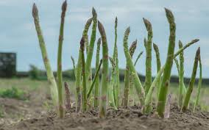

Activity: “From waste to worth – innovate your vegetable”
Objective:
To explore how imperfect or surplus vegetables can be transformed into value-added products through agribusiness innovation.
Instructions:
Task 1: Brainstorming
- In groups, choose one “imperfect” vegetable e.g., bent carrot, misshapen cucumber, knobbly beetroot, wonky cauliflower.
- Discuss why this vegetable might be rejected from the fresh market.
Task 2: Innovation challenge:
- Each group comes up with one new product using the imperfect vegetable.
- Consider health, convenience, sustainability, and market appeal.
Task 3: Design a pitch:
- Draw a simple product label or concept sheet.
- Write a 1–2-minute pitch explaining why the product adds value, who it is for, and why it would sell.
Task 4: Present pitch to class
- Discuss which products are most innovative, sustainable, or marketable.
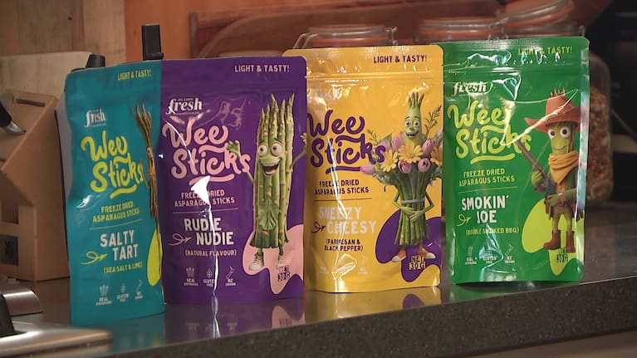

Asparagus into snacks
Ruinous season for beloved spring vegetable – but here's an idea
https://www.1news.co.nz/2025/11/28/ruinous-season-for-beloved-spring-vegetable-but-heres-an-idea/
https://www.youtube.com/watch?v=Cdifl3b0jNM
An asparagus grower who lost more than half his crop amid a spate of bad weather in Canterbury is keeping his head above water thanks to a new side hustle with the long green vegetable.
While harvest was well underway, Dave Marsh told 1News that October was a difficult month.
"It started off a bit wet and cold, and then the winds were really just horrendous," he said.
The wild weather left the Ashburton grower with four of his seven hectares ruined.
"I had to chop everything off because it was all twisted and bent, and not saleable. When you chop it off you basically lose a week’s worth of production."
With overheads and production costs constantly rising, he’d been thinking of doing something new with his crop – and found the perfect market for the asparagus that didn’t make the grade.
My Farm Fresh brand freeze-dried asparagus. (Source: 1News)
"Sometimes it flicks around on the belt and gets the head cut off or it’s short or it’s fat or it’s bent or it’s seedy – all that sort of stuff that has no commercial value in the shops."
Marsh has now created a freeze-dried snack food and taken it to market, winning three silver awards at the New Zealand Artisan Food Awards.
"It gives us something different. It’s a healthy product, it’s not cooked, it’s 100% natural – the nutrients are all in it that asparagus is well known for."
Sample answers
- How does the concept of value-adding apply to agricultural products, and why is it important in modern agribusiness?
Value-adding involves transforming raw agricultural products into a form that has increased market value, either through processing, branding, packaging, or innovation. It is important because it allows farmers to earn higher returns, reduce waste, diversify income streams, and differentiate their products in a competitive market. For example, turning fresh asparagus into freeze-dried snacks increases its shelf life, convenience, and market appeal, creating new revenue opportunities beyond the fresh vegetable market.

- What factors cause certain asparagus spears to be rejected from the fresh market, and how does this create an opportunity for innovation?
Asparagus can be rejected from the fresh market if it is bent, twisted, seedy, short, overly thick, or damaged by machinery. These imperfections mean the spears do not meet strict retail standards, even though they are still edible and nutritious. This creates an opportunity for innovation by transforming these “unsellable” spears into products like freeze-dried snacks, allowing the farmer to use more of the crop and reduce waste while tapping into niche markets.

- In what ways did adverse weather conditions affect the quality and marketability of the asparagus crop in this case?
Unseasonably wet, cold, and windy weather damaged a large portion of the asparagus crop, causing spears to twist, bend, and break. This led to a loss of approximately four out of seven hectares of harvestable asparagus, directly reducing the quantity suitable for fresh sales. Such conditions highlight the vulnerability of crops to climate and the need for alternative strategies to maintain income when quality is compromised.

- How did the grower transform lower-grade asparagus into a new value-added product, and what processes were involved in creating the freeze-dried snack?
The grower, Dave Marsh, identified that asparagus spears that were bent, short, thick, or mechanically damaged could still be used. He turned them into a freeze-dried snack, a process that removes water while retaining nutrients, flavour, and texture. By packaging the snack as a healthy, natural product, he added value to asparagus that otherwise had no commercial market, creating a new revenue stream and reducing waste.

- What characteristics of the freeze-dried asparagus snack contributed to its success in the market and at the New Zealand Artisan Food Awards?
The snack’s success can be attributed to several factors:
- Health appeal: It is 100% natural, uncooked, and retains the nutrients of fresh asparagus.
- Convenience: Freeze-drying makes it lightweight, portable, and long-lasting.
- Innovation: It transforms a typically wasted product into a premium snack, showing creativity.
- Recognition: Winning awards provided credibility, visibility, and marketing advantage.

- How might developing value-added products like freeze-dried asparagus influence the financial resilience, risk management, and future growth of the agribusiness?
Value-added products diversify income sources, reducing reliance on the volatile fresh produce market. They allow the farm to monetise crops that might otherwise be lost due to quality issues or weather damage, improving financial resilience. Innovation also opens access to new markets and customer segments, strengthens the brand, and can support sustainable growth by making the farm more adaptable to climate challenges and market trends.

