Tahi: Restoring Biodiversity and Ecosystems
Tahi is an ecosystem restoration project in Northland, New Zealand. The property covers about 800 acres (324 hectares) and is described as a “living eco-lab” where science is used to restore native ecosystems and increase biodiversity.

Watch Tahi project and read “Tahi: Restoring a thriving, native and biodiverse ecosystem” and answer the questions
- What is biodiversity, and why is it important for a healthy ecosystem?
- Tahi's native bird species increased from 20 to 71. What does this change tell us about the results of ecosystem restoration?
- How can planting native trees and other plants increase biodiversity at Tahi? Give two examples.
- Explain how birds can help native plants regenerate naturally and describe why this is important for the ecosystem?
- Tahi has restored forests, wetlands, dune systems and soil. Why is it important to restore different parts of an ecosystem rather than focusing only on planting trees?
- Tahi shows a connection between biodiversity and business. Explain how products such as mānuka honey and skincare could help support ongoing ecosystem restoration.

Tahi: Restoring a thriving, native and biodiverse ecosystem
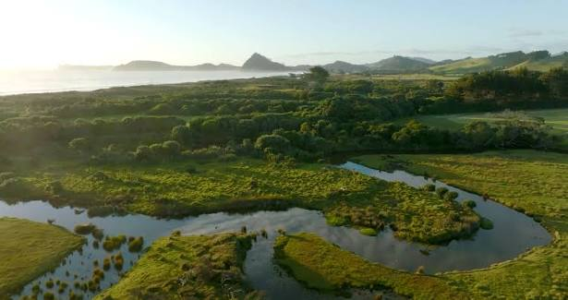

What is biodiversity?
Biodiversity is the variety of life in an area. It includes plants, animals, fungi, microorganisms and the ecosystems they form.
A healthy native ecosystem can contain:
- native trees and plants
- birds and insects
- fungi and bacteria
- earthworms and other soil organisms
- wetlands and waterways
- healthy soils
These organisms are connected. For example, plants provide food and shelter for animals, while birds can spread seeds that help plants regenerate.

Biodiversity is important because healthy ecosystems help provide clean water, fertile soils, pollination, food and protection from erosion. Diverse ecosystems are also more able to cope with environmental change.

Restoring the ecosystem
Tahi began its restoration project in 2004. The aim is not simply to plant trees, but to rebuild a functioning and diverse ecosystem.
Tahi plants a range of native species that create different forest layers:
- Canopy – the tallest trees
- Sub-canopy – smaller trees
- Understorey – shrubs and smaller plants
- Ground layer – plants, leaf litter and soil organisms

Tahi also works to restore wetlands, dune systems and soil health. These different habitats provide food and shelter for many species.

What has happened at Tahi?
The restoration has produced measurable changes in biodiversity.

More native birds
When restoration began in 2004, Tahi had 20 native bird species. Today, it has 71 native bird species, including 25 rare and endangered species. This increase is linked to the restoration of native vegetation, which provides birds with food, shelter and nesting habitat.

Native plants → food and shelter → more birds → greater biodiversity

Birds can also spread seeds, helping native plants regenerate naturally.

8.8 million native trees
Tahi reports that 8.8 million native trees have been planted or regenerated through its restoration programme. As native vegetation grows, it provides habitat for more organisms and helps:
- stabilise soil
- improve water systems
- store carbon
- cycle nutrients
- provide food and shelter for wildlife
Some plants also regenerate naturally, meaning they grow and spread without being planted by people.

Biodiversity and business
Tahi also connects environmental restoration with business. It has developed products including Tahi Mānuka Honey and Kaea Skincare. Tahi states that profits from these businesses are reinvested into biodiversity restoration.
This creates a cycle:
Products → income → restoration → healthier ecosystems → greater biodiversity

Why is Tahi important?
Tahi shows that restoring an ecosystem involves much more than planting trees. It involves rebuilding the connections between plants, animals, soil, water and people.
The Tahi project demonstrates that restoration can:
- increase native biodiversity
- provide habitat for rare and endangered species
- restore native vegetation
- improve soil and water systems
- encourage natural regeneration
- support sustainable business

Answers
- What is biodiversity, and why is it important for a healthy ecosystem?
Biodiversity is the variety of living things in an area, including plants, animals, fungi and microorganisms. It is important because different organisms interact with each other and help ecosystems function. Biodiversity can also make ecosystems more resilient, helping them cope with environmental changes.

- Tahi's native bird species increased from 20 to 71. What does this change tell us about the results of ecosystem restoration?
The increase from 20 to 71 native bird species shows that restoration has created better habitat and food sources for birds. It is evidence that biodiversity at Tahi has increased. The project now supports 25 rare and endangered bird species.

- How can planting native trees and other plants increase biodiversity at Tahi? Give two examples.
Planting native plants can:
- provide food and shelter for birds, insects and other animals.
- create different habitats and forest layers, allowing more species to live in the area.

- Explain how birds can help native plants regenerate naturally and describe why this is important for the ecosystem.
Some birds eat fruit and then spread the seeds to different locations through their droppings. This helps native plants grow and spread without people having to plant them. Natural regeneration helps rebuild native vegetation and provides more food and habitat for other organisms, increasing biodiversity.

- Tahi has restored forests, wetlands, dune systems and soil. Why is it important to restore different parts of an ecosystem rather than focusing only on planting trees?
Different parts of an ecosystem provide different habitats and functions. Forests provide food and shelter, wetlands provide water habitats and help regulate water, dunes help protect coastal areas, and healthy soils support plants and soil organisms. Restoring all these parts helps rebuild a connected and functioning ecosystem.

- Tahi shows a connection between biodiversity and business. Explain how products such as mānuka honey and skincare creams could help support ongoing ecosystem restoration.
Products such as mānuka honey and skincare creams can generate income for the business. Tahi states that profits are reinvested into biodiversity restoration. This creates a cycle where business income helps fund restoration, which improves the ecosystem and supports the long-term sustainability of the project.

