**10 Commandments For the Safe Handling of Agrichemicals**

Chemicals like pesticides are used to kill pests, such as insects or weeds, to protect plants. These chemicals must be strong enough to harm the pests, but if not used correctly, they can also harm people, animals, or other plants. Pesticides include weedkillers, insecticides (for bugs), and fungicides (for fungi). If pesticides are not handled properly, they can cause serious harm or even death. However, when used safely, they can be effective without causing harm.

There are ten commandments for the safe use and handling of agrichemicals:

**Commandment 1 - *Always read the label on any agrichemical, such as sprays, powders, or granules, before you use them*.**  
Pay attention to any warnings or safety instructions each time you open the container. The label has important information on how to use the pesticide safely. Make sure to read the label carefully before opening the container. This helps you use the agrichemical the right way.

**Commandment 2 - *Keep sprays, powders, and granules away from children and pets. Store pesticides outside your home in a locked place.***Children are curious and might not know how to stay safe with chemicals. So, it’s important to keep pesticides away from them and pets. Always store pesticides in a locked, safe place to prevent accidents.

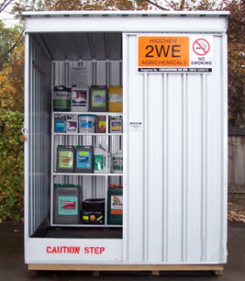

**Commandment 3 - *Always store pesticides in their original containers and keep them tightly closed.***Never put pesticides in other containers like jars or bottles, especially ones used for food or drinks, like drink bottles. Always keep pesticides in their original container until they are all used up.

**Commandment 4 - *Wear protective clothing and masks when the label tells you to. Don’t breathe in dust or sprays and never smoke while spraying or dusting.***Pesticides can be harmful if they get into your body through your mouth, nose, or skin. Breathing in or swallowing pesticides is especially dangerous because they can get into your blood quickly. If pesticides touch your skin, it’s still dangerous, but you have time to wash it off. Always wear the right protective gear, like masks, gloves, and overalls, if the label tells you to. Even if the pesticide seems safe, it's best to wear protective clothing to stay safe.

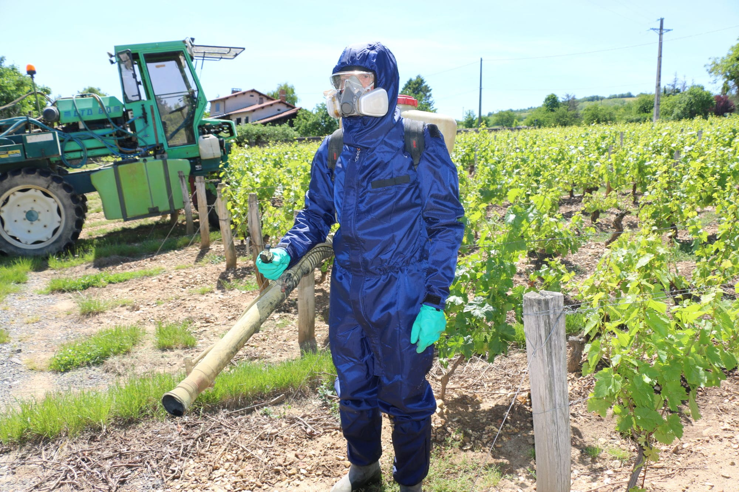

**Commandment 5 - *Always wash your hands and face after spraying pesticides and change into clean clothes.***

Wash your clothes every day before wearing them again. Never let pesticides touch your skin or clothes. If you spill pesticides, remove the contaminated clothes and wash your skin and clothes right away.  
Don’t eat, smoke, or do anything before washing your hands and face. After spraying, take a shower and put on clean clothes.

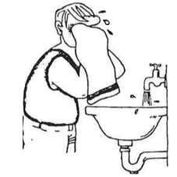

**Commandment 6 - *Keep pesticides away from food and animal feed. Cover food and water containers when spraying near homes, animals, or pets. Don’t let pesticides get into waterways.***  
Never store pesticides near food or animal feed. Leftover pesticides or rinse water should never be poured where it can cause puddles or get into waterways. These can harm animals, wildlife, and the environment.

**Commandment 7 - *Always check and adjust your equipment before using pesticides. This helps keep you, your crops, livestock, and the environment safe.***Use separate equipment for applying hormone-type herbicides (weedkillers) to avoid harming other plants. If you don’t have separate equipment, clean it thoroughly before using a different type of herbicide. After finishing, clean all parts of the equipment before storing it.  
Be careful with hormone-type herbicides because they can easily damage sensitive plants like vegetables and trees.

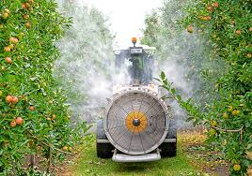

**Commandment 8 - *Always dispose of empty containers in a way that won’t harm people, animals, or plants.***There are different ways to dispose of pesticide containers:

1. **Container return:** Some containers can be returned if the label is still readable.
2. **Recycle:** Some metal and plastic containers can be recycled, like through Agrecovery.
3. **Public landfill:** Punch holes in containers to make them unusable. Check with your local council for rules before throwing them away.
4. **Private landfill:** If using a private landfill, check with your council to make sure it’s allowed. Make containers unusable by crushing or breaking them before burying them.

Agrecovery offers a safe way to collect and dispose of unwanted or expired pesticides. Contact them to arrange a pickup.



**Commandment 9 - *Follow the label instructions carefully to keep pesticide levels safe on edible plants.***Before using pesticides, check the label to make sure you're using the right chemical and the correct amount for the crop and pest you're dealing with. Make sure the timing is right for when it’s safe to apply the pesticide and that it matches the plant’s growth stage. Apply pesticides in the morning or evening, when the air is still and before bees are active. This will help you apply the pesticide properly and avoid wasting it or accidentally affecting nearby crops, animals, or waterways.

**Commandment 10 - *If you feel sick during or after spraying, call the Poison Information Service right away.***The Poison Information Service is free and available 24/7. Call **0800 764 766 (0800 POISON)** or ask a healthcare professional for help.



**Bonus Commandment**  
*Remembering these 10 commandments when using pesticides can save lives and protect people, animals, plants, and the environment.*

*Anyone using pesticides should know what they’re using and be careful with it. Some chemicals that kill pests can also harm you, so always be cautious.*

***Exercise.***

1. *Why is it important to read the label on pesticides before using them?*
2. *Where should you store pesticides to keep them safe from children and pets?*
3. *What should you do if you spill pesticides on your clothes or skin?*
4. *What type of clothing should you wear when handling pesticides?*
5. *Why should you not store pesticides in old food or drink containers like drink bottles?*
6. *What is the right way to dispose of empty pesticide containers?*
7. *How can you make sure you are applying the right amount of pesticide to crops?*
8. *Why is it important to wash your hands and face after using pesticides?*
9. *What should you do if you feel sick after spraying pesticides?*
10. *What is the best time to apply pesticides to avoid harming bees or nearby plants?*

***Bonus Question:*** *11. How can pesticides affect the environment if not used properly?*

***Answers***

1. ***Why is it important to read the label on pesticides before using them?*** *The label gives important information about how to use the pesticide safely, what precautions to take, and the correct amount to use.*
2. ***Where should you store pesticides to keep them safe from children and pets?*** *Pesticides should be stored in a locked place, outside the home, to keep children and pets safe.*
3. ***What should you do if you spill pesticides on your clothes or skin?*** *If you spill pesticides, you should remove the contaminated clothes and wash your skin and clothes right away.*
4. ***What type of clothing should you wear when handling pesticides?*** *You should wear protective clothing, like gloves, masks, and overalls, especially if the label says you should.*
5. ***Why should you not store pesticides in old food or drink containers like soda bottles?*** *Pesticides should never be stored in old food or drink containers because it can be dangerous if someone mistakes it for food or drink.*
6. ***What is the right way to dispose of empty pesticide containers?*** *Pesticide containers should be disposed of by returning them if possible, recycling them, or punching holes in them before throwing them away. Always follow local disposal rules.*
7. ***How can you make sure you are applying the right amount of pesticide to crops?*** *You should read the label carefully to know the correct amount of pesticide to use and make sure you apply it at the right time and growth stage.*
8. ***Why is it important to wash your hands and face after using pesticides?*** *Washing your hands and face helps remove any pesticide that may have accidentally touched your skin, preventing harm.*
9. ***What should you do if you feel sick after spraying pesticides?*** *If you feel sick, you should immediately call the Poison Information Service at 0800 764 766 (0800 POISON) or get help from a healthcare professional.*
10. ***What is the best time to apply pesticides to avoid harming bees or nearby plants?*** *The best time to apply pesticides is in the morning or evening when the air is still, and before bees are active.*

***Bonus Question:*** *11.* ***How can pesticides affect the environment if not used properly?*** *If pesticides are not used properly, they can harm wildlife, contaminate water, and damage other plants and crops.*