Balance Points, Key to Direction
Movement
Position and movement are keys to moving cattle effectively. The location of a person or dog will determine where cattle will won’t go, and movement into and out of working distance will determine speed of movement. Using body position and movement will help determine where cattle can move.
Cattle have two lines of balance that control the direction in which they move when responding to a handler. One line is across the shoulders and the other is along the length of the backbone.
Whichever way people move through these lines, the beast will go the other way. Moving backwards through the shoulder balance line stimulates the animal to move forward. Moving forward through the shoulder balance line towards the head stimulates it to move backwards or to turn and move away.
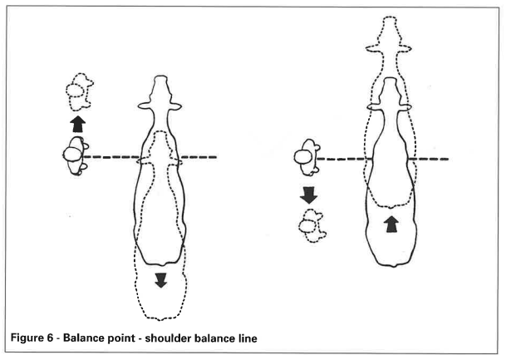

Moving to the left of the backbone balance line stimulates the cattle beast to move to the right and vice versa. This happens regardless of whether the handler is to the animal’s front or rear.
It is easier to get cattle to move if the handler moves through the balance points. In the yards, handlers on a catwalk walking from the front to the rear of a race of cattle, go through each animal’s shoulder balance line and stimulate them to move forward.
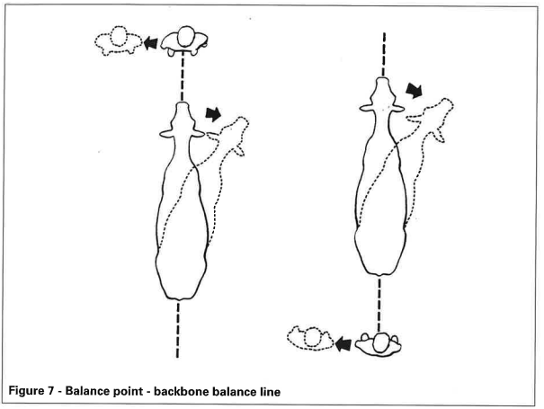
Balance points are most effective if a handler moves through them. The balance lines of the animals closest to the handler are important when mustering. Knowing the factors influencing arousal and movement will increase the handler’s ability to predict what cattle will do.
Exercise
- What are the two balance lines that control the direction cattle move in?
- How does the position of a person or dog affect how cattle move?
- If a handler moves through the shoulder balance line, what direction will the cattle move?
- How does moving through the backbone balance line influence where the cattle go?
- Why is it easier to move cattle if the handler moves through the balance points?
- How does a handler’s position on a catwalk help move cattle forward?
- Why is it important to know the balance lines of cattle closest to the handler when mustering?
- How does understanding balance points help a handler predict what cattle will do?
- What happens when a handler moves forward or backward through the shoulder balance line?
- How do the balance points help handlers move cattle more effectively during mustering or in races?

