Cattle Working Distance
Key to controlled movement
The working distance or zone is an important concept in cattle handling. It is the distance at which cattle start to move away from people.
Dairy cows have a short working distance, usually less than five metres. They may have a zero working distance and allow people to touch them without moving away. Tame animals may confidently approach people. Beef cows, which are handled less frequently, have longer working distances, and wild beef cattle may have working distances of more than 100 metres.
The working distance is reduced by frequent gentle handling. This allows the animal to get used to people and recognise that they are not especially unpleasant.
Cattle handlers move in and out of the working distance when mustering and driving cattle. Moving inside the working distance will move cattle away; the further in, the higher the arousal and the faster the movement.
Going too far inside the working distance will cause cattle to scatter: the mob may break up or individuals break away.
Moving out of the working distance will slow cattle down and they will become less aroused. You can use the working distance like an accelerator pedal.
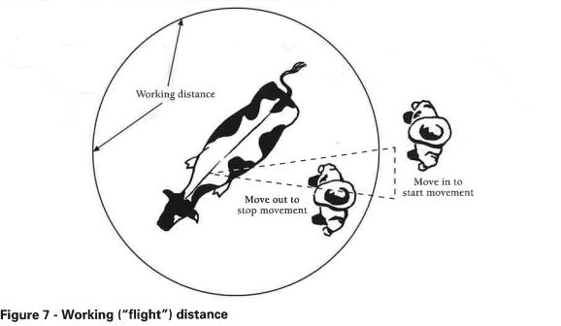

Individual distance
Each beast has an individual distance, which may be imagined as a bubble around their head. Cattle like to keep other cattle and people outside their individual distance. Dairy beef bulls going through a gate will try to maintain their individual distance (about six metres); when another animal enters it, they turn to fight.
The individual distance is invaded during any human activity around the animal’s head, such as drenching and ear tagging. This significantly increases the animal’s arousal level.
A person looking down on an animal’s head in a race may stimulate the animal to lift its head quickly and cause facial injuries. Cattle handlers should not bend down under a cross-tie to treat or examine an animal – if it jerks its head upwards, they may be caught between the beast and the cross-tie.
Social distance
The social distance is the maximum distance an animal will move from its herd mates before it turns and moves to rejoin them. It is best to stand back and allow it to do so.
When drafting cattle, it is recommended to separate the two mobs by a good fence, through which they can see and remain close to one another. The two mobs will eventually drift away and start grazing. Moving cattle some distance away from each other immediately after drafting may stimulate them to rejoin their herd mates through fences and gates.

Exercise
- What is the "working distance" for cattle, and why is it important?
- How does the working distance differ between dairy cows and beef cows?
- What happens if a person moves inside a cattle’s working distance?
- What happens if a person moves outside the cattle’s working distance?
- How can frequent gentle handling affect a cattle’s working distance?
- What is "individual distance," and how does it differ from working distance?
- Why do cattle try to maintain an individual distance around their head?
- How can a person's actions around a cattle's head affect its behaviour?
- Why is it dangerous for a person to bend down near a cattle’s head in a race?
- What is "social distance" in cattle, and why do they maintain it?
- How does separating cattle with a fence help them maintain their social distance?
- Why is it important to allow cattle to rejoin their herd mates after being separated?

