Cattle do not see, hear or smell the world as people do.
Sight
The eyes of cattle are located on the side of their head. This allows them to see through almost 360 degrees (°). Wild cattle were prey for wolves, so they needed to see in a wide arc to locate predators.
Cattle have binocular vision for a small angle (25 to 50°) in front of them, this is where both eyes focus and perceive depth, distance and speed. However, they have monocular vision (use of only one eye) to the side, which only allows them to see movement. Any sudden movement in this zone may frighten the animal. If it is confident, it will turn to identify the movement and move towards it for closer investigation, using its eyes, nose and ears.
Cattle have a blind zone to their rear. Its size depends on whether the head is up or down.
Cattle see some colour but not nearly as much as people. They tend to move from dimly lit to more brightly lit areas but will avoid very bright lights. Indoors, diffused lighting is best, and dull colours are usually recommended.
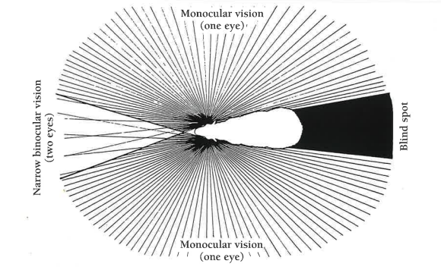 Visual field (sight)

When grazing, cattle have virtually 360° vision. When they are alarmed, they raise their heads to look around and can no longer see the ground binocularly. Things like a shadow or a piece of piping on the ground may frighten them, causing them to baulk (stop moving).
When their head is down in a race, cattle cannot see anything clearly around the tip of their nose and may baulk because of a shadow. Given time, they will identify whatever it is and move on. When they are moving along a race they may baulk at shadows, drains or changes in flooring texture because they cannot identify these as harmless.
Cattle look through the rails of yards, forcing pens and races and what they see will influence their behaviour. Good yards have boarding at a height so that cattle are blinkered. However, cattle may settle more quickly if they can see relaxed animals in adjacent pens.
Cattle follow the leader and will baulk if they lose sight of them. For this reason, right angle turns are inappropriate in a race, which should curve gradually if animals are to keep the preceding animal in sight. Alternatively in parallel races cattle are drawn into a race when they see cattle moving out of the adjacent race.

Hearing
Cattle are sensitive to high-frequency noises that people cannot hear. Sometimes cattle may be aroused by noises we cannot hear.
Steel yards are noisier than wooden yards and may be more irritating to cattle, causing their arousal level (a measure of cattle activity) to increase. As any noise may cause cattle to baulk, it is important to pad where steel hits steel.
Music is used in dairy sheds and is believed to improve cattle (and human) behaviour. By maintaining a background noise, music may reduce the startling effect of sudden loud noises.

Smell
Cattle have a better sense of smell than people. Some types of blood and bone meal have been identified as causing wild behaviour in cattle. Blood on the ground after dehorning or castration may cause cattle to become aroused and baulk at entering a crush or head bail.

Touch
Cows groom their calves, an important activity in establishing and maintaining the relationship. Initial contact with a beast using a light rod to scratch its chest area and withers is a technique used to train show animals.
When first making contact, it is a good idea to touch an animal with a stick or an outstretched hand from a safe distance. Its reaction will give an idea of how it is likely to react to closer contact. Talking to the beast will instil confidence in both human and animal.
Rubbing dairy replacement heifers in the udder area, as calves and when they are being trained in the dairy shed, is a comfortable contact that should reduce their fear when milked for the first few times. However, it has been suggested that less fearful heifers may kick more during the first few milkings.
It is important that cattle know where handlers are, as they are less likely to be startled and to kick out in fear or self-defence. Cattle handlers should stay in the animal’s vision area, avoid the blind spot and make some sort of noise. Talking helps cattle to locate the handler more effectively.

Exercise
- Where are a cattle's eyes located and how does this affect their vision?
- What is the difference between binocular and monocular vision in cattle?
- What might make cattle afraid when they are moving around?
- How do cattle behave when they see something they can't clearly identify, like a shadow or a piece of piping?
- How do cattle react to changes in light and colours?
- Why are right-angle turns not good in cattle races?
- What types of sounds are cattle sensitive to that humans might not hear?
- How can noise affect cattle, and what can be done to reduce its impact?
- How can music help cattle behave better?
- How does a cattle’s sense of smell compare to a human’s?
- What types of smells might make cattle behave in a wild or frightened way?
- How do cattle react when they lose sight of the leader in a race or pen?
- What’s a good way to make cattle feel more comfortable when humans first approach them?

