Lifting Sheep
Sheep farmers lift sheep for various reasons related to their health, care, and overall management. Lifting sheep allows farmers to examine them for signs of illness, injury, or parasites, ensuring they receive treatment if needed. Farmers may lift sheep when crutching or shearing. They may also lift them to move them between different areas on the farm or in a race or shearing shed.
However, regularly lifting sheep can cause significant strain on a farmer’s back, especially when the animals are heavy or awkward to handle. Repeated bending, twisting, or lifting without proper technique can lead to back injuries. To minimize the risk of injury, farmers should avoid lifting sheep if possible. They should use gates and ramps where available. If a sheep must be lifted, farmers should use their legs, not their back.
Some sheep can weigh almost 100kg. Only people with enough strength should lift sheep. Don’t try and lift a sheep if you cannot physically do it.
The diagram below shows the correct technique for lifting sheep.

Diagram
Swing the sheep towards the top of the fence, boosting it with your leg.
Using the rail for support, take the strain off your back and pull the sheep onto its hind legs.
Hold the sheep against the rail and straddle its rump. Put one hand on the rail, the other under the sheep’s neck.
With a slight rolling movement, let the sheep fall onto its feet.
Crouch behind the sheep, bend your knees, take the weight on your knees and hold the sheep firmly
Stand up using your legs, not your back, and lift the sheep off the ground.
Move your other hand from the neck and firmly grasp the fold of skin between the belly and hind leg
Put the sheep on top of the rail and let it see the ground.
Move your hand, from the rail, under the sheep’s nearest leg and grasp the opposite front leg.
Match the letter to the correct statement
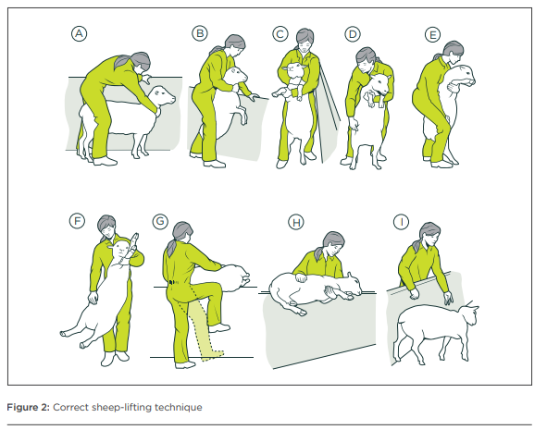
Answers
Diagram
G | Swing the sheep towards the top of the fence, boosting it with your leg.
B | Using the rail for support, take the strain off your back and pull the sheep onto its hind legs.
A | Hold the sheep against the rail and straddle its rump. Put one hand on the rail, the other under the sheep’s neck.
I | With a slight rolling movement, let the sheep fall onto its feet.
E | Crouch behind the sheep, bend your knees, take the weight on your knees and hold the sheep firmly
F | Stand up using your legs, not your back, and lift the sheep off the ground.
D | Move your other hand from the neck and firmly grasp the fold of skin between the belly and hind leg
H | Put the sheep on top of the rail and let it see the ground.
C | Move your hand, from the rail, under the sheep’s nearest leg and grasp the opposite front leg.

