# **Classes of cattle**

Cattle are divided into several classes by which they are commonly known and referred to by farmers and other people in the farming industry. These classes are:

* calves
* weaners
* steers
* heifers
* cows, and
* bulls.

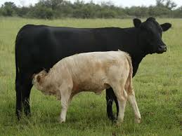**Calves**  
The term calves is used to describe young animals of both sexes from the time they are born until they are weaned. The timing of weaning varies depending on the method of rearing. In dairy farming, where calves are reared on milk artificially using a "calfeteria," they are usually weaned from milk onto pasture at about 8-10 weeks of age. However, beef calves from traditional beef breeding cows are not weaned from their mothers until they are about 4-6 months of age.  
Calves that are not reared for replacements or dairy beef on a dairy farm are generally slaughtered as bobby calves when they are about 4 days old.

**Weaners**  
This term is used to describe calves after they have been weaned from milk. Once weaned, the animals' future depends on the type of farm they have been raised on.

**Steers**  
Steers are castrated male bulls. After weaning, steers on a farm with a traditional beef breeding herd are either sold to other farmers who have better quality land to finish the animals to slaughter weight, or they are kept as store animals on the farm to be sold at a later date or finished if sufficient feed is available.  
Most dairy farmers who raise male calves don’t castrate them but leave them entire as dairy beef bulls. These bulls are kept on the farm and grown to a size suitable for slaughter or are sold shortly after weaning to other farmers who specialize in finishing bulls to slaughter weight.

**Heifers**  
Heifers are female calves. Heifers raised on a dairy farm will generally be kept as future replacements. They may stay on the home farm or be sent to a run-off block, if the farmer has one. Some farmers arrange for their replacements to be grazed on another farm under a contract arrangement until they are ready to calve as 2-year-olds.  
Weaner heifers born on a farm with beef breeding cows may be selected at weaning. Those needed for replacements will be kept on the farm, while those that are surplus to requirements may be sold as weaners in the autumn sales or kept until a later date when they will be sold.

**Cows**  
A cow is an adult female, generally one that has had at least one calf. The cow may remain in the herd for a varying length of time, but the longer the productive life of the cow, the more profitable she will be for the farmer.

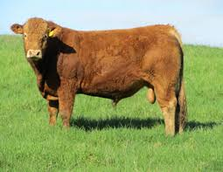**Bulls**  
The term bull refers to male cattle of any age. Farms running a beef breeding herd will typically have several adult bulls used as sires, usually about one bull for every 30-40 cows.  
Dairy farmers tend to use artificial insemination (AI) for mating their cows. Over 96% of all dairy cows are mated by AI each year. As a result, dairy farmers only use bulls for mating cows that do not get pregnant during the first part of the mating season, as well as for mating their replacement heifers.

***Exercise***

1. *How does the weaning process differ between dairy calves and beef calves?*
2. *What happens to calves that are not raised for replacements or dairy beef?*
3. *Why do most dairy farmers leave male calves entire instead of castrating them?*
4. *What is the role of a steer on a beef farm, and how does it differ from a bull?*
5. *What is a heifer, and what typically happens to heifers raised on a dairy farm?*
6. *How do dairy farmers usually mate their cows, and why is AI used more than bulls in dairy farming?*