Monogastric animal

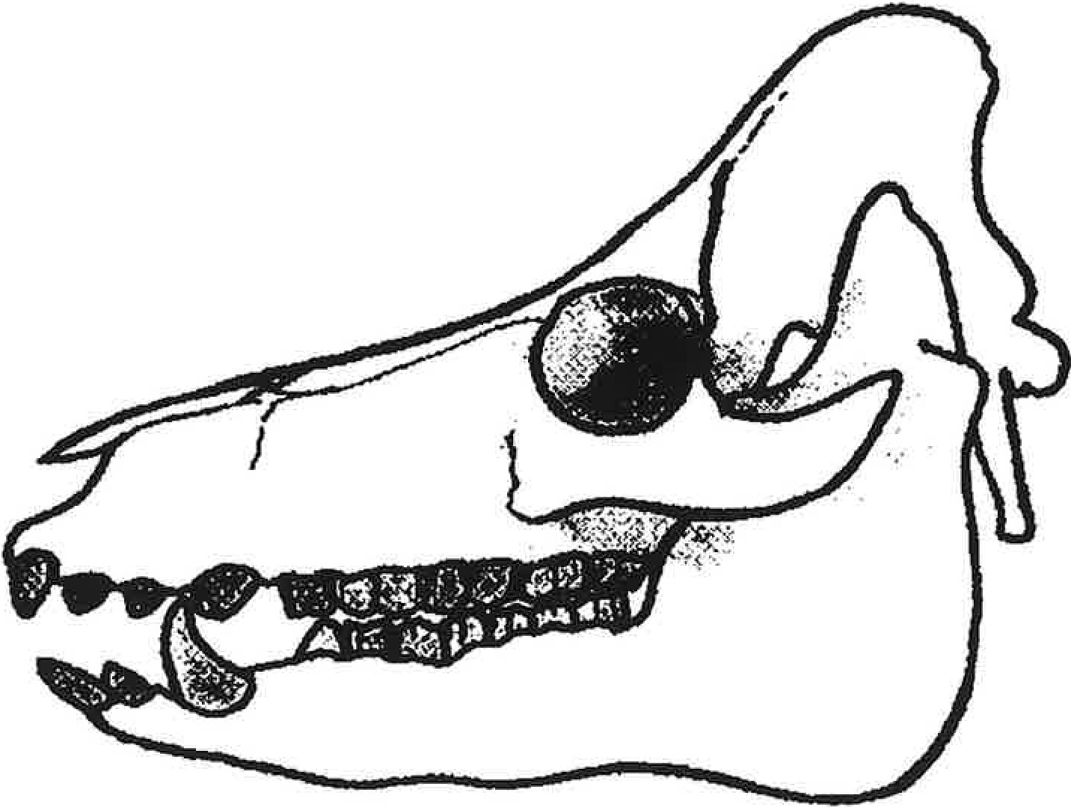

A

Ruminant animal

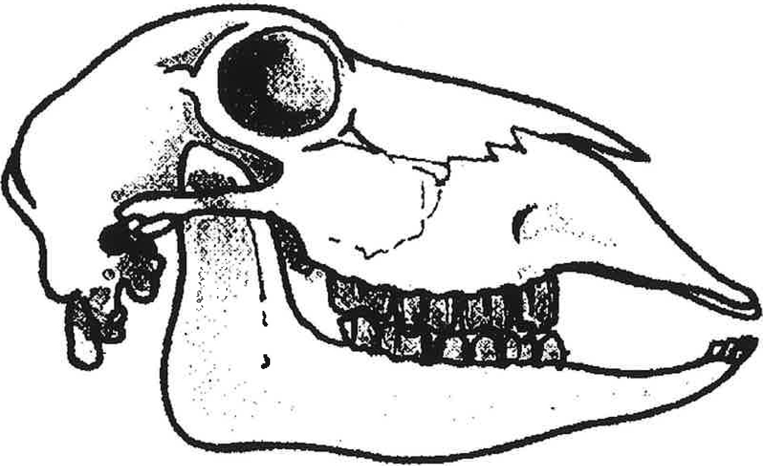

B

