**Digestive Systems**

Animals can be divided into groups depending on their type of digestive system, either monogastric or ruminant.

**Monogastric** (non-ruminant) animals have one stomach, examples include pigs, horses, and rabbits.

**Ruminant** animals have four parts to their stomach, examples include cattle, sheep, deer and goats.

The stomach of ruminant is much larger than in monogastric animals.

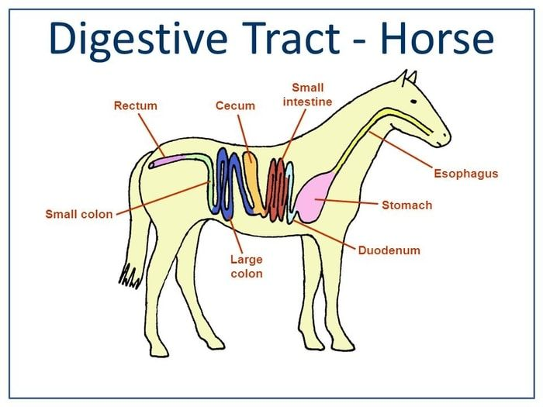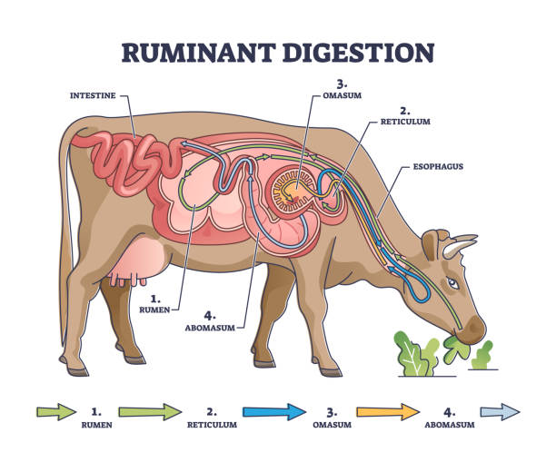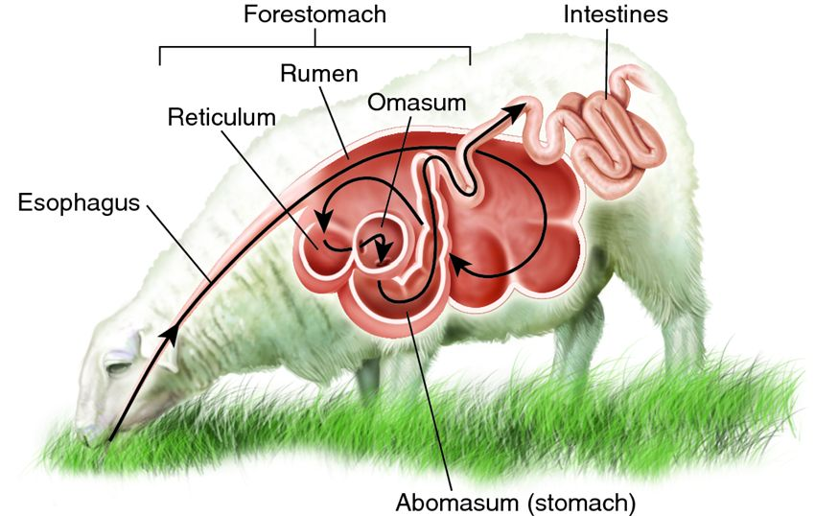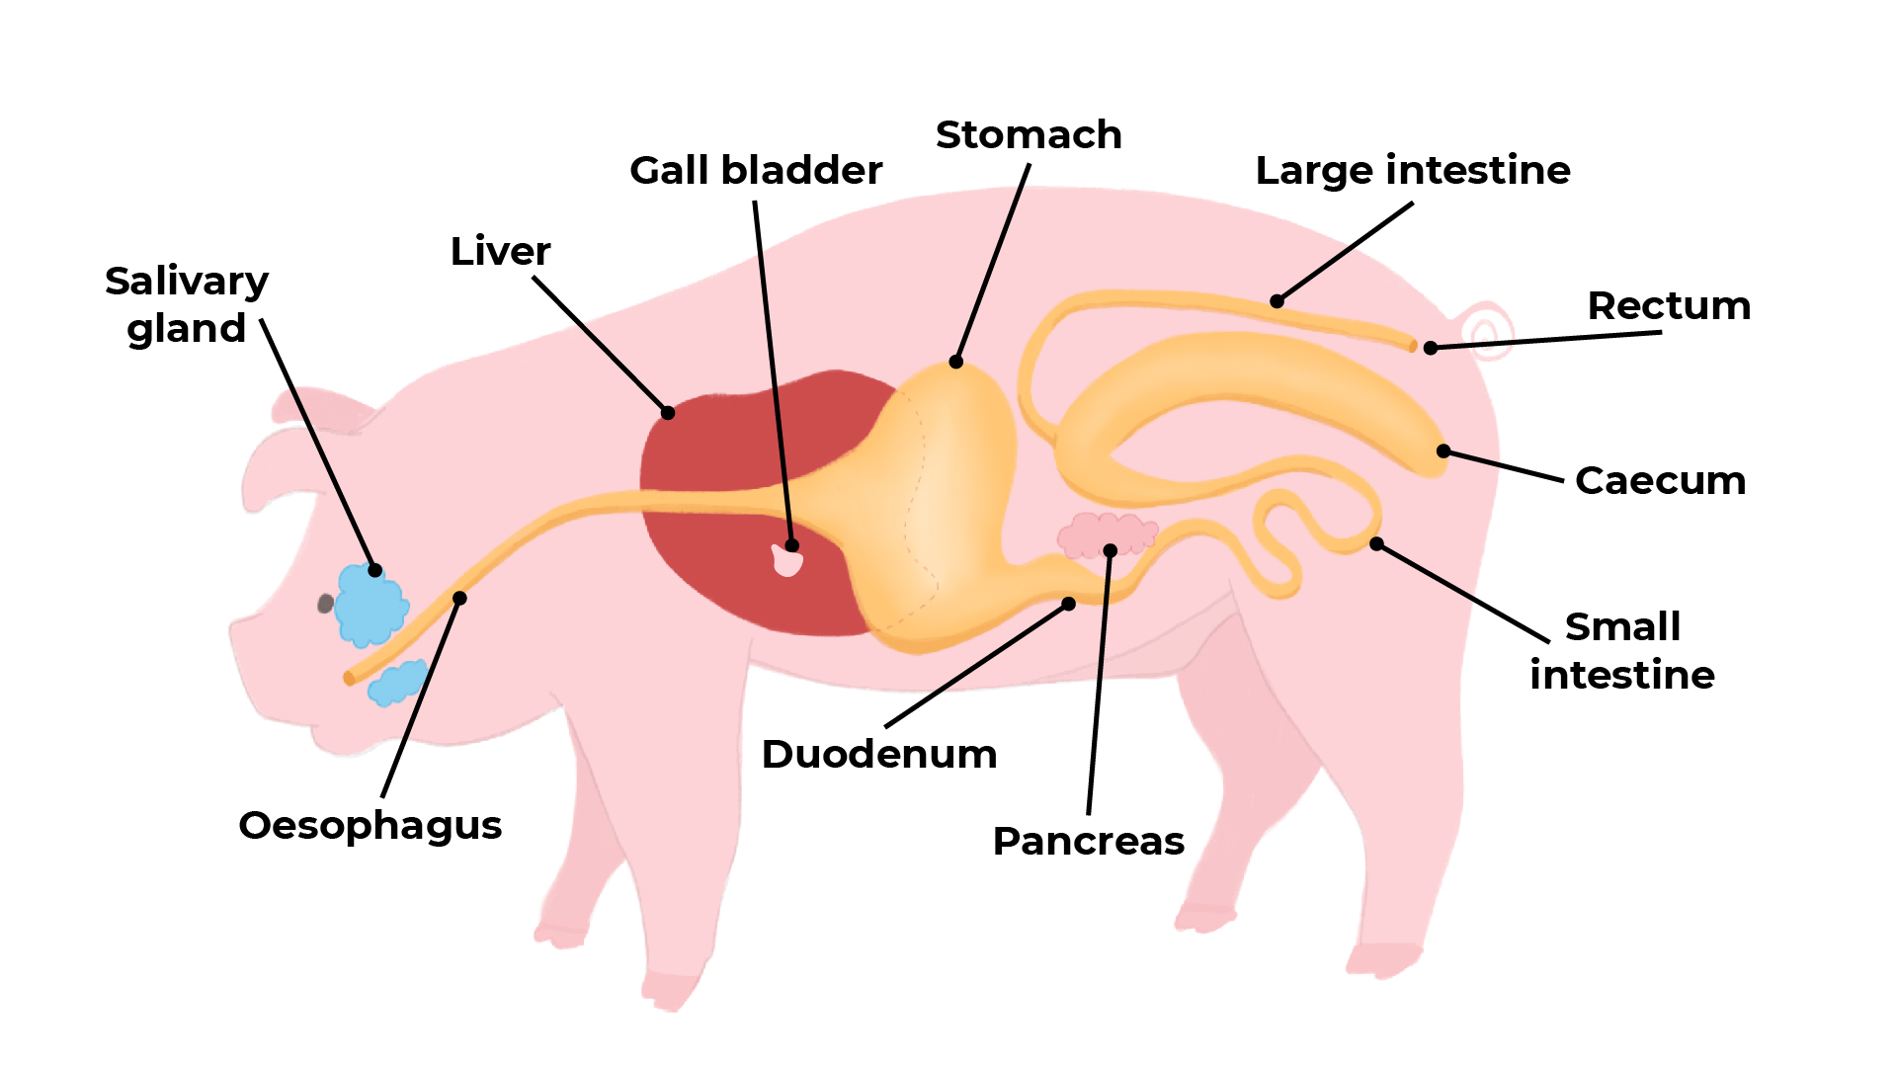

***Exercise***

1. *What is meant by the terms, monogastric and ruminant?*
2. *Name two monogastric animals you could find on a New Zealand farm.*
3. *Name four ruminant animals found in New Zealand.*
4. *Explain why ruminant stomach are bigger than monogastric stomachs?*