**Differences between monogastric and ruminant digestive systems.**

**Monogastric digestion**

Functions or parts of the digestive tract in a monogastric animal.

|  |  |
| --- | --- |
| **Teeth** | Chew food to break it down into smaller pieces. |
| **Saliva** | Lubricates food for swallowing. Enzymes start the digestive process. |
| **Oesophagus** | Food moves along the oesophagus and other parts of the gut by muscular process called "**peristalsis**". |
| **Stomach** | Lining secretes “gastric juices" containing enzymes and Hydrochloric acid (HCl). Muscular contractions mix the food with the gastric juices. |
| **Small Intestine** | More juices containing enzymes are added to continue the digestion. Bile is secreted from the gall bladder; this changes the pH to alkaline for. The wall is lined with finger like projections called" **villi**". These increase the surface area for absorbing digested products. |
| **Large Intestine** | Water is absorbed. Undigested food is excreted. |
| **Caecum** | No function in humans, but in monogastric herbivores (horses, rabbits, pigs) it contains microorganisms that breakdown cellulose. This is not an efficient method of digestion, as the cellulose does not stay in the caecum long enough for complete digestion. |

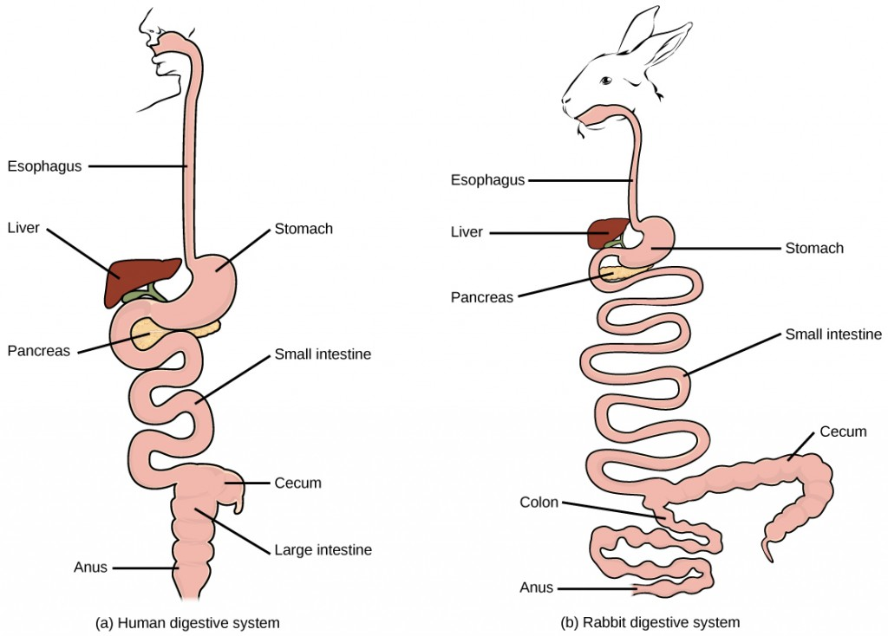

**Ruminant Digestion**

Functions or parts of the digestive tract in a ruminant animal.

|  |  |
| --- | --- |
| **Mouth** | Pasture is torn off, briefly chewed with molar teeth. Large amounts of saliva is secreted.   * sheep 6-10 l/day * cattle 50-80 l/day |
| **Oesophagus** | Food moves along the oesophagus and other parts of the gut by muscular process called "**peristalsis**". |
| **Chewing Cud** | 8hr/day is spent ruminating coarse material. This is brought up and re-chewed to  increase the surface area for rumen microbes to work on and start digestion. |
| **Rumen** | Largest of the four stomachs. Its inner lining is covered with numerous small  projections called **"papillae"**. These increases the surface area. The rumen contains  millions of microbes that:   * digest cellulose * increase the amount of protein * make vitamin B * waste gases are produced CO2, CH4 and NH3 * Volatile Fatty Acids are absorbed through the rumen wall - providing energy. |
| **Reticulum** | Small second stomach. The inner surface is **"honeycombed"**. Microbial digestion continues. |
| **Omasum** | Third stomach. The inner surface has many leaf like structures and is called the "**bible**". Microbial digestion continues and water is removed from the rumen liquor. |
| **Abomasum** | Fourth stomach (**true stomach).** Here, HCl and enzymes are secreted in the gastric juices. Digestion of microbes and proteins takes place. |
| **Small Intestine** | Has finger-like structures called "**villi**". These increase the surface area for adsorption of digested food. |
| **Caecum** | In herbivores, the caecum is greatly enlarged and serves as a storage organ that  permits bacteria and other microbes time to further digest cellulose. |
| **Large Intestine** | Water is absorbed. Undigested food is excreted through anus. |

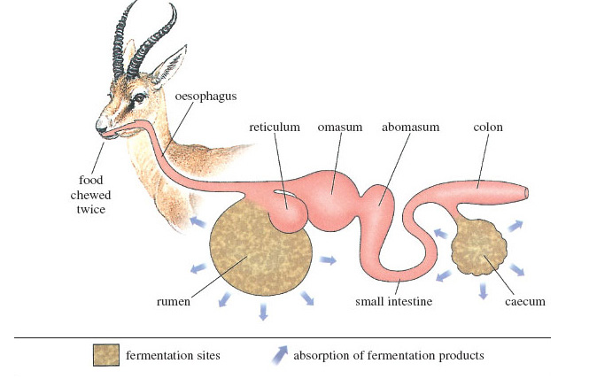

.

# **Rumination (chewing the cud)**

**Purpose of rumination**: to break food down into smaller particles to speed up digestion.

Ruminant regurgitates food

Food chewed (remastication)

Saliva is mixed with the feed (resalivation)

Food swallowed

New cud bought up (process starts again)

*Exercise*

1. *Describe the differences between a ruminant and non- ruminant digestive tract.*
2. *Describe “chewing the cud” and explain why ruminant animals chew the cud?*
3. *Explain why the rumen is a large chamber?*
4. *Where does microbial digestion occur in ruminant animals?*
5. *Where does chemical digestion take place in ruminant animals?*
6. *Eructation is the belching of gases produced from the breakdown of food. Where does eructation occur and what gases are belched out?*
7. *Explain what can happen to cattle if they cannot belch out gases?*
8. *Where in the ruminant digestive tract are volatile fatty acids absorbed?*
9. *What do fatty acids provide ruminant animals?*
10. *Explain how a monogastric herbivore digests plant fibre?*