Monogastric mouthparts
Herbivorous monogastrics have three types of teeth found in non-ruminants, which are incisors, premolars and molars. The incisors are present in both the upper and lower jaws.
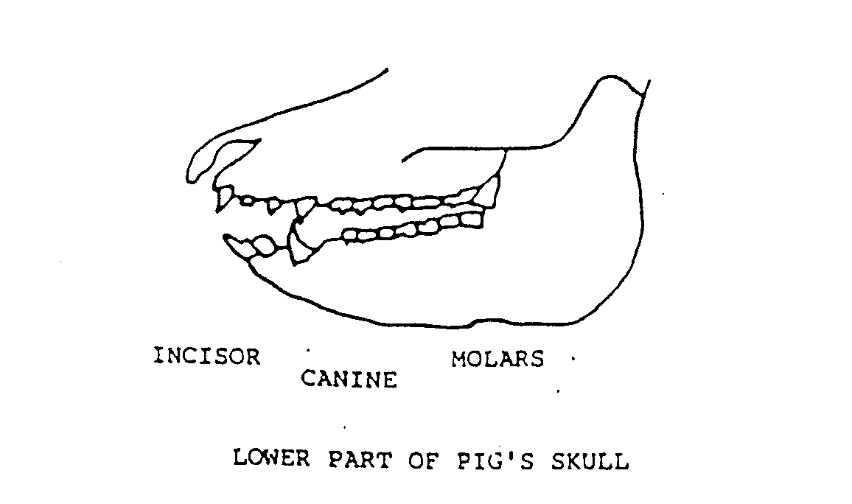 | In omnivorous and carnivorous monogastrics a fourth type of tooth, the canines, are present between the incisors and premolars. The diagram shows their position. These teeth help to tear flesh and in the case of pigs to tear roots as well.

Ruminant mouthparts
Sheep and cattle have three types of teeth, starting at the front of the jaw, these are:
Incisors - For cutting and tearing (on the lower jaw only; the upper jaw has a bony pad).
Premolars
- For crushing and grinding
}
Molars
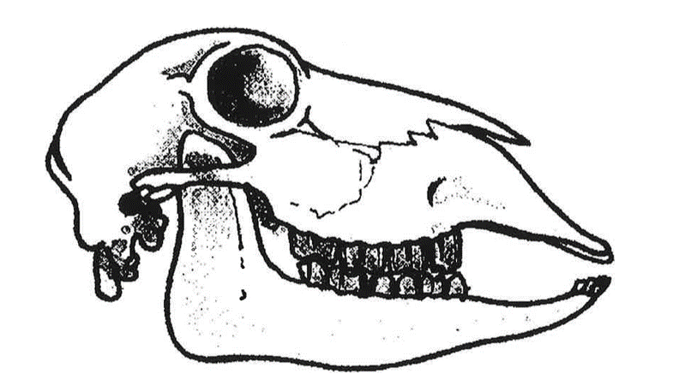

Dental pad

Incisor

Molars

Part of sheep’s skull, showing teeth.
The sheep tears off grass by gripping it between its lower incisors and the bony pad. The upper lip is divided, allowing the teeth to graze very closely to the ground. Cattle prefer to eat longer pasture than sheep because they wrap their tongue around a bunch of pasture and break it off between the pad and lower incisors.

Exercise
- What are the three types of teeth found in herbivorous monogastrics?
- How do the teeth of omnivorous and carnivorous monogastrics differ from herbivores?
- What is the purpose of the canines in omnivorous and carnivorous monogastrics?
- Which type of teeth do sheep have in their upper jaw?
- How does a sheep tear off grass?
- Why do cattle prefer longer pasture compared to sheep?
- How does the structure of a sheep’s mouth help it graze very closely to the ground?
- What role do premolars and molars play in the teeth of ruminants like sheep and cattle?

