# **Vaccination**

Animals may be vaccinated to protect them from some diseases. A vaccination is an injection of substances, which produces immunity or resistance to disease. A vaccination is generally a dead version of the disease to help the body to make its own antibodies to fight the disease.

Preventable infectious diseases can have a severe economic and welfare impact on livestock. A complete vaccination programme is the best form of protection.

**Steps involved in vaccinating.**

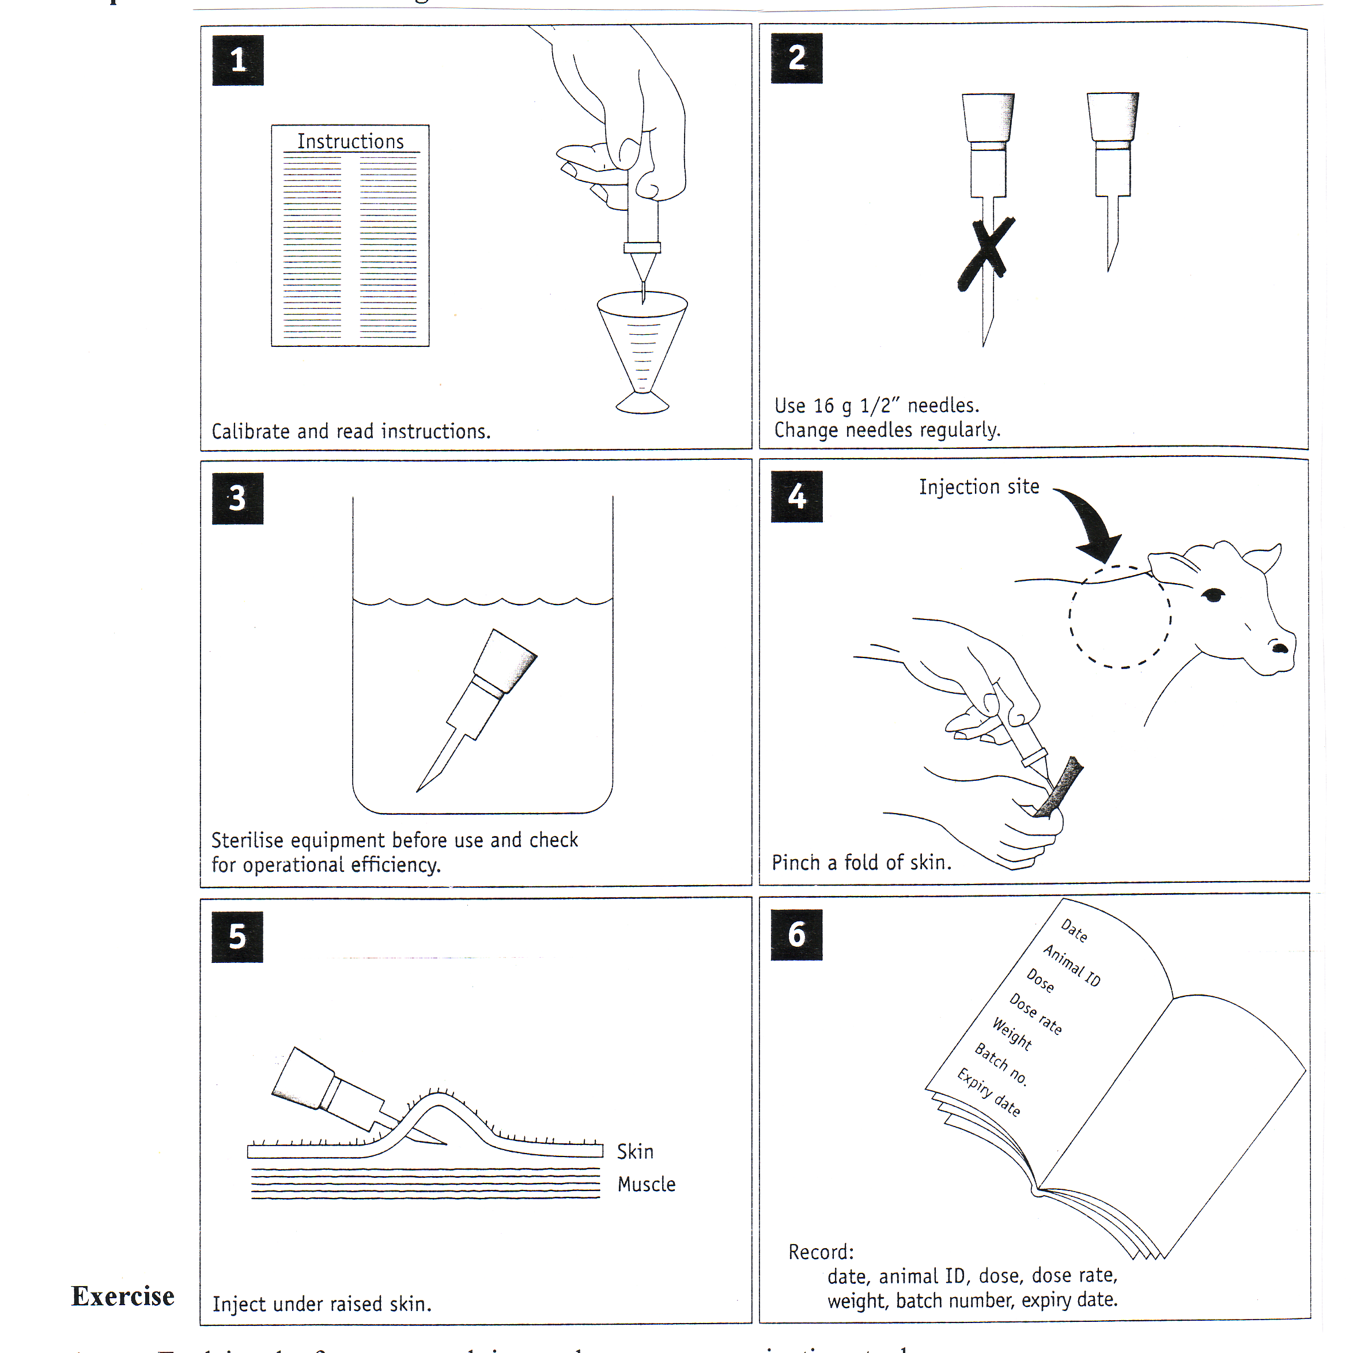

**Vaccination Programs**

When farming cattle, the cows and calves can be vaccinated for a number of different diseases or illnesses such as, Leptospirosis, salmonella. Some farmers give the calves a 7 in 1 vaccination to protect them against leptospirosis and the 5 major clostridial diseases.

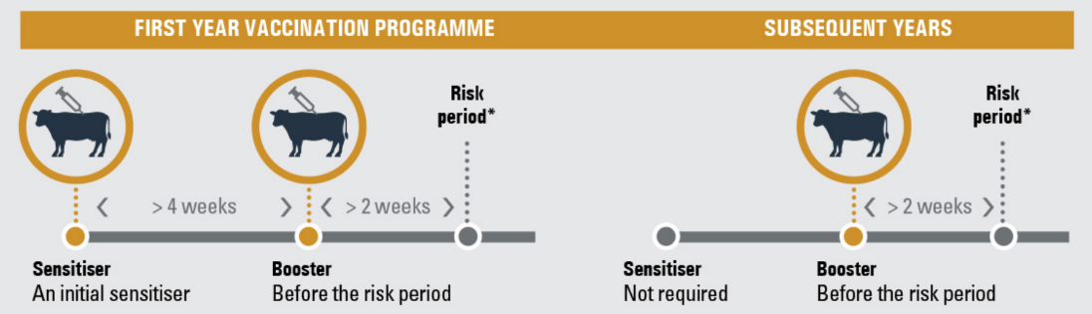

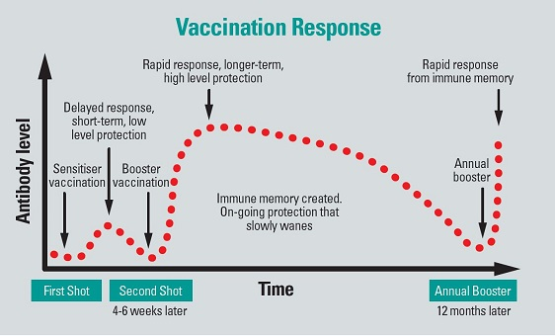

***Exercise***

1. *What is meant by a sensitising vaccination?*
2. *What is meant by a booster vaccination?*
3. *Explain why vaccinations are given in the neck of beef cattle?*
4. *Explain why farmers spend time and money on vaccinating stock?*
5. *Describe the steps involved in vaccinating stock and explain why each step is carried out?*

*.*

