**Name:**

# Dairy Cattle

|  |  |  |  |  |  |  |  |  |  |  |  |  |  |  |  |  |  |
| --- | --- | --- | --- | --- | --- | --- | --- | --- | --- | --- | --- | --- | --- | --- | --- | --- | --- |
| B | C | I | U | G | C | P | N | X | S | C | O | U | R | V | M | W | H |
| Z | O | N | D | F | U | R | B | I | N | C | Z | S | O | A | M | C | H |
| R | L | S | L | E | L | E | A | W | O | A | Z | I | E | C | A | S | E |
| Z | O | E | Q | E | L | G | L | B | U | L | L | L | S | C | S | B | I |
| B | S | M | E | D | H | N | A | X | H | F | R | A | T | I | T | L | F |
| J | T | I | R | V | M | A | G | D | V | Z | W | G | R | N | I | O | E |
| N | R | N | W | W | E | N | E | C | O | W | B | E | U | A | T | A | R |
| W | U | A | S | N | P | C | Q | U | D | D | E | R | S | T | I | T | D |
| E | M | T | M | Q | E | Y | T | Y | M | I | J | G | S | I | S | P | W |
| A | Y | O | D | L | L | A | C | T | A | T | I | O | N | O | Z | L | H |
| N | I | R | A | L | V | E | O | L | U | S | U | H | H | N | O | W | Y |
| Q | B | N | G | E | S | T | A | T | I | O | N | T | X | Z | S | R | V |

Find the following words in the puzzle. Words are hidden and .

INSEMINATOR VACCINATION GESTATION PREGNANCY LACTATION COLOSTRUM MASTITIS ALVEOLUS

OESTRUS SILAGE HEIFER BALAGE SCOUR UDDER BLOAT BULL

WEAN FEED CALF CULL COW

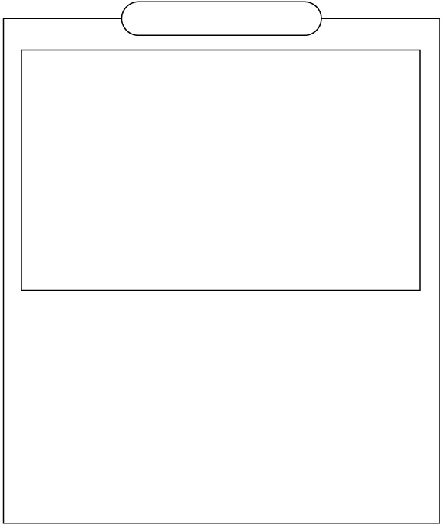

Created by HATA using Word Search Generator on

Super Teacher Worksheets ([www.superteacherworksheets.com](https://www.superteacherworksheets.com/))

**SOLUTION**

# Dairy Cattle

|  |  |  |  |  |  |  |  |  |  |  |  |  |  |  |  |
| --- | --- | --- | --- | --- | --- | --- | --- | --- | --- | --- | --- | --- | --- | --- | --- |
| . C | | I | . . C | P | . . S C O | | | | | U | R | V | . . . | | |
| . O | | N | . F U | R | B . . C . | | | | | S | O | A | M . H | | |
| . L | | S | . E L | E | A . . A . | | | | | I | E | C | A . E | | |
| . O | | E | . E L | G | L B U L L | | | | | L | S | C | S B I | | |
| . S | | M | . D . | N | A . . F . | | | | | A | T | I | T L F | | |
| . T | | I | . . . | A | G . . . . | | | | | G | R | N | I O E | | |
| . | R | N . . . N | | | E | C | O | W | . | E | U | A | T | A | R |
| W | U | A . . . C | | | . | U | D | D | E | R | S | T | I | T | . |

E M T . . . Y . . . . . . . I S . . A . O . . L A C T A T I O N O . . .

N . R A L V E O L U S . . . N . . .

. . . G E S T A T I O N . . . . . .

Word directions and start points are formatted: (Direction, X, Y)

INSEMINATOR (S,12,1) VACCINATION (E,6,12) GESTATION (S,16,1) PREGNANCY (S,15,1) LACTATION (SE,2,1) COLOSTRUM (S,4,3) MASTITIS (SE,4,1) ALVEOLUS (S,17,2)

OESTRUS (S,18,1) SILAGE (S,13,2) HEIFER (E,5,11) BALAGE (E,4,2)

SCOUR (SE,6,4)

UDDER (S,3,5)

BLOAT (S,2,4)

BULL (S,1,3)

WEAN (E,6,1)

FEED (E,13,11)

CALF (E,1,12)

CULL (E,14,10)

COW (E,1,11)



Created by HATA using Word Search Generator on

Super Teacher Worksheets ([www.superteacherworksheets.com](https://www.superteacherworksheets.com/))