# Flystrike

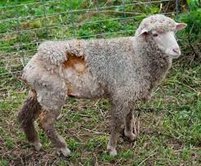

Sheep blowfly is a significant pest to sheep. It is an external parasite and sheep that are infested are said to have ‘flystrike’. It is estimated flystrike costs the New Zealand sheep industry approximately $37 million per year in mortality, lost production, and treatment costs. Research has shown than even relatively small strikes can cause a marked reduction in feed intake and weight loss.

Use the words from the box below to complete the paragraph below.

maggots, crutch area, adult flies, eggs, urine, dung,

After mating and the formation of zygotes the female adult blowfly lays _________ on a patch of wool. A sheep is usually struck on the ______. The wool here is often dirtied with _________ and ________. The eggs hatch into larvae that are called _________ that feed on the flesh until fully grown. The maggots then fall to the ground and burrow into the soil. Here they pupate then emerge as ____________.

**Answer**

After mating and the formation of zygotes the female adult blowfly lays eggs on a patch of wool. A sheep is usually struck on the crutch area. The wool here is often dirtied with dung and urine. The eggs hatch into larvae that are called maggots that feed on the flesh until fully grown. The maggots then fall to the ground and burrow into the soil. Here they pupate then emerge as adult flies.