# Vaccination

Animals may be vaccinated to protect them from some diseases. A vaccination is an injection of substances, which produces immunity or resistance to disease. A vaccination is generally a dead version of the disease to help the body to make its own antibodies to fight the disease.

Preventable infectious diseases can have a severe economic and welfare impact on livestock. A complete vaccination programme is the best form of protection

**Watch**: Vaccination Technique for Sheep | [PGG Wrightson Tech Tips](https://www.youtube.com/watch?v=h95WlzA8A10)

**Vaccination Programmes**

Common Clostridial diseases sheep vaccinated against

Subcutaneous Injection

* Pulpy kidney
* Tetanus
* Blackleg
* Malignant oedema
* Black disease

The standard vaccine protocol for sheep to protect them against clostridial disease is: - adult sheep vaccinated as lambs require an annual booster. Introduced adult sheep with no vaccination history must be given 2 vaccinations 4 to 6 weeks apart, then an annual booster. The annual booster for ewes should be given 2 to 6 weeks pre-lambing.

Vaccination programme: - Protect ewes and their lambs against clostridial diseases 5-in-1 pre-lamb vaccine.

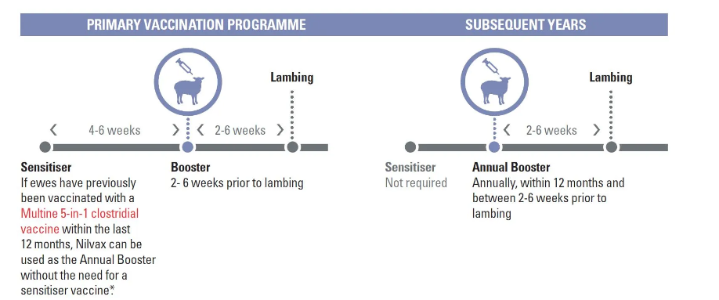

|  |  |  |  |  |  |  |  |  |  |  |  |
| --- | --- | --- | --- | --- | --- | --- | --- | --- | --- | --- | --- |
| **Jan** | **Feb** | **Mar** | **Apr** | **May** | **June** | **July** | **Aug** | **Sept** | **Oct** | **Nov** | **Dec** |
|  | Sensitise and boost hoggets. this begins year-round protection  Sensitise unvaccinated two-tooth ewe replacements | |  |  |  | Booster vaccinate for ewes and two-tooths, 2-4 weeks prior to lambing | | Lambs protected by colostrum for up to 12 weeks after lambing | | | |

**Note:**

1. When ewesreceive two vaccinations as hoggets they do not need to be vaccinated again until pre-lamb as two-tooths.
2. When ewes receive only a single vaccination as a hogget, they should receive a further sensitizing dose pre-tup as a two-tooth and a pre-lamb booster.

***Exercise***

1. *What is a vaccination?*
2. *What is meant by a sensitising vaccination?*
3. *What is meant by a booster vaccination?*
4. *In sheep, which group should be given a sensitizing vaccination and when should it be given?*
5. *Explain why ewes are given a booster vaccination in July or August?*
6. *List five diseases sheep should be vaccinated against.*
7. *Explain why vaccinations are given to livestock.*
8. *Explain why farmers spend time and money on vaccinating stock?*
9. *Describe the steps involved in vaccinating stock and explain why each step is carried out?*