**Flower Parts**

Use the words in the box to label the flower diagram

**Note:** Some words will be used again for the bottom diagram

Anther, receptacle style petal stigma pistil

filament ovary sepal nectary stamen ovule

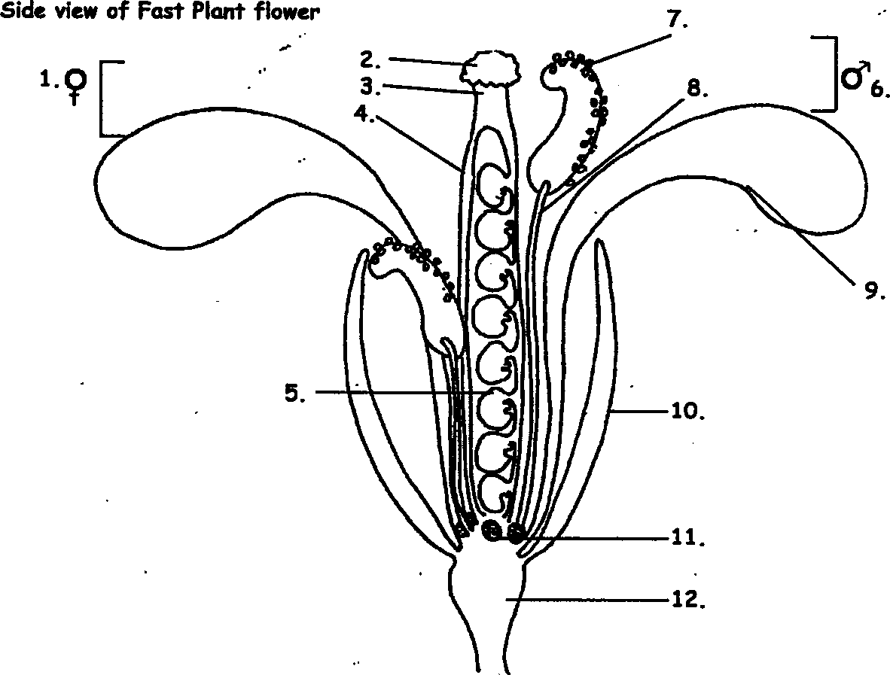

**13**

**14**

**16**

**15**

**Answers**

|  |  |
| --- | --- |
| 1 | Pistil |
| 2 | Stigma |
| 3 | Style |
| 4 | Ovary |
| 5 | Ovules |
| 6 | Stamen |
| 7 | Anther |
| 8 | Filament |
| 9 | Petal |
| 10 | Sepal |
| 11 | Nectary |
| 12 | Receptacle |
| 13 | Petal |
| 14 | Stigma |
| 15 | Anthers |
| 16 | Sepal |