Internal Leaf Structure Crossword

Complete the crossword puzzle below

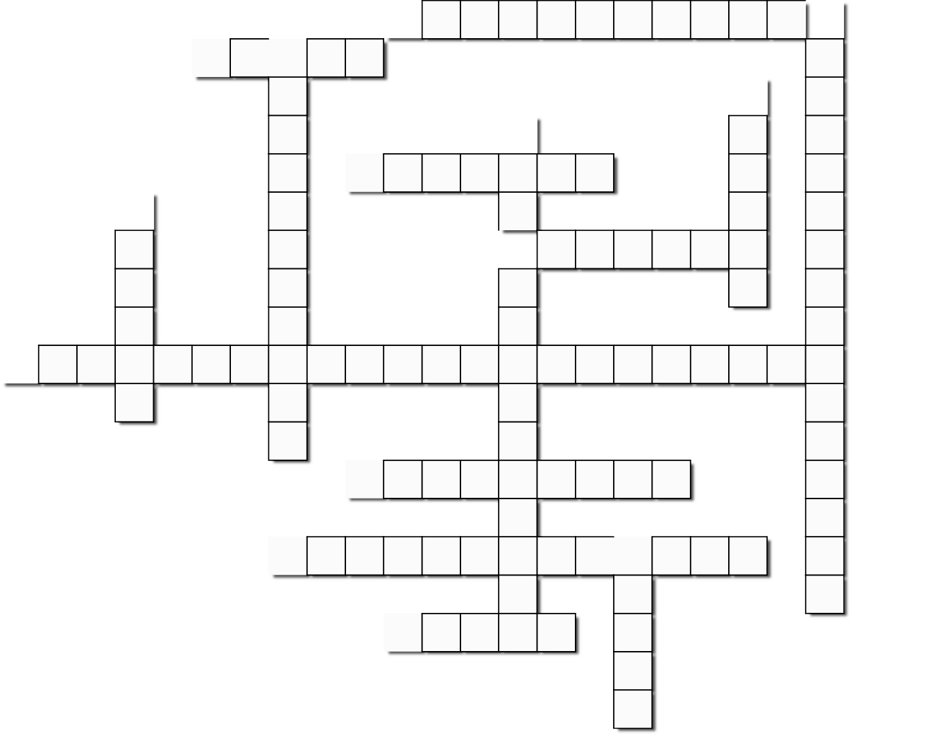

14

13

12

11

10

9

8

7

6

5

4

3

2

1

# Across

1. In a mesophyll cell chlorophyll is contained inside

**3.** Epidermal cells lack chloroplasts to allow the penetration of this

**7.** There are more in the lower surface than the upper surface of the leaf

1. This is waxy and keeps water in the leaf
2. These allow the passage of gases to and from the mesophyll cells
3. The physical process responsible for the movement of gases into and out of the leaf
4. More of this gas passes into the leaf than comes out

**14.** Escapes as vapour from the leaf via the stomata

# Down

1. These cells are irregularly shaped and contain chloroplasts
2. These cells have irregularly thickened walls, contain chloroplasts and move in pairs
3. A gas produced in photosynthesis and used respiration
4. Phloem and xylem combined form a vein or this

**8.** Tissue responsible for the translocation of sugar

1. Dead tissue that transports water