

Name the parts of the leaf

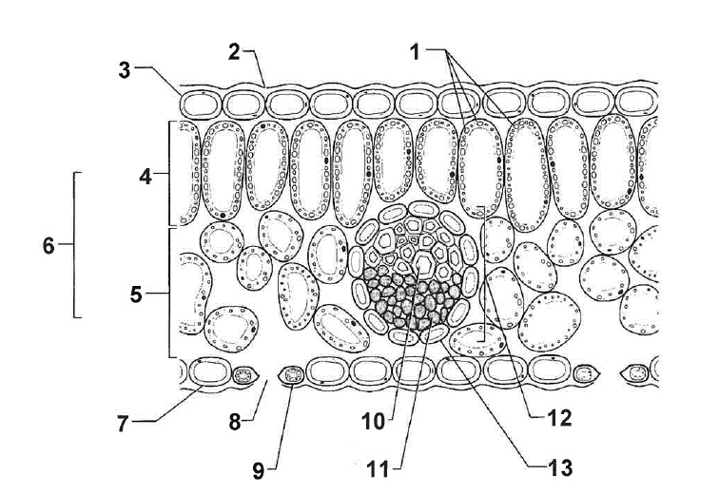

Answers
No | Name | Function
1 | chloroplasts | Organelles that contain chlorophyll
2 | waxy cuticle | Makes leaf water- and air-tight
3 | upper epidermis | Transparent protective layer, covered in wax
4 | palisade cells | Site of photosynthesis
5 | spongy cells | Allow gases to move through
6 | mesophyll | The inner of the leaf, spongy cells and palisade cells
7 | lower epidermis | Like upper epidermis but has stomata
8 | stoma | Pores for gas exchange (carbon dioxide goes in, oxygen comes out)
9 | guard cell | Close stoma when it is too hot to prevent water vapour loss
10 | xylem | Supplies water to the palisade cells
11 | phloem | Transports the glucose to the rest of the plant
12 | vascular bundle | The grouped pipelines of xylem and phloem
13 | bundle sheath | Holds pipelines together

