**Plant Form and Function Test**

**a**

**b**

**c**

**e**

**f**

**g**

**fruit**

**Root hairs**

**Lateral bud**

**Mid rib**

**d**

1. Name the plant parts.

a.______________________

b.______________________

c ______________________

d.______________________

e. _____________________

f. _____________________

g. ______________________

1. State two function of plant roots.

1._________________________________________________________________________

2. _________________________________________________________________________

3. State two function of leaves.

1._________________________________________________________________________

2. _________________________________________________________________________

4. State two function of stems.

1._________________________________________________________________________

2. _________________________________________________________________________

5. State a function of flowers.

1._________________________________________________________________________

6. Name the parts of the flower.

**a**

**b**

**e**

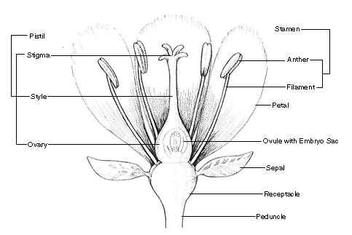

a._________________________

b.________________________

**c**

c ________________________

**d**

d.________________________

e. _______________________

7. List the **four** things a plant needs to photosynthesis.

1._________________________________________________________________________

2. _________________________________________________________________________

3._________________________________________________________________________

4. _________________________________________________________________________

8. Where does respiration take place in a plant?

________________________________________________________________________

9. Explain the meaning of the following terms.

A Transpiration.____________________________________________________________

___________________________________________________________________________

b. Pollination. ______________________________________________________________

___________________________________________________________________________

c. Fertilisation. _______________________________________ ______________________

___________________________________________________________________________

d. Phloem._________________________________________________________________

___________________________________________________________________________

e. Xylem __________________________________________________________________

___________________________________________________________________________

f. Annual __________________________________________________________________

___________________________________________________________________________

g. Perennial ________________________________________________________________

___________________________________________________________________________