**DIAGRAM OF A DEVELOPING ROOT**

.. '

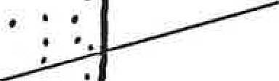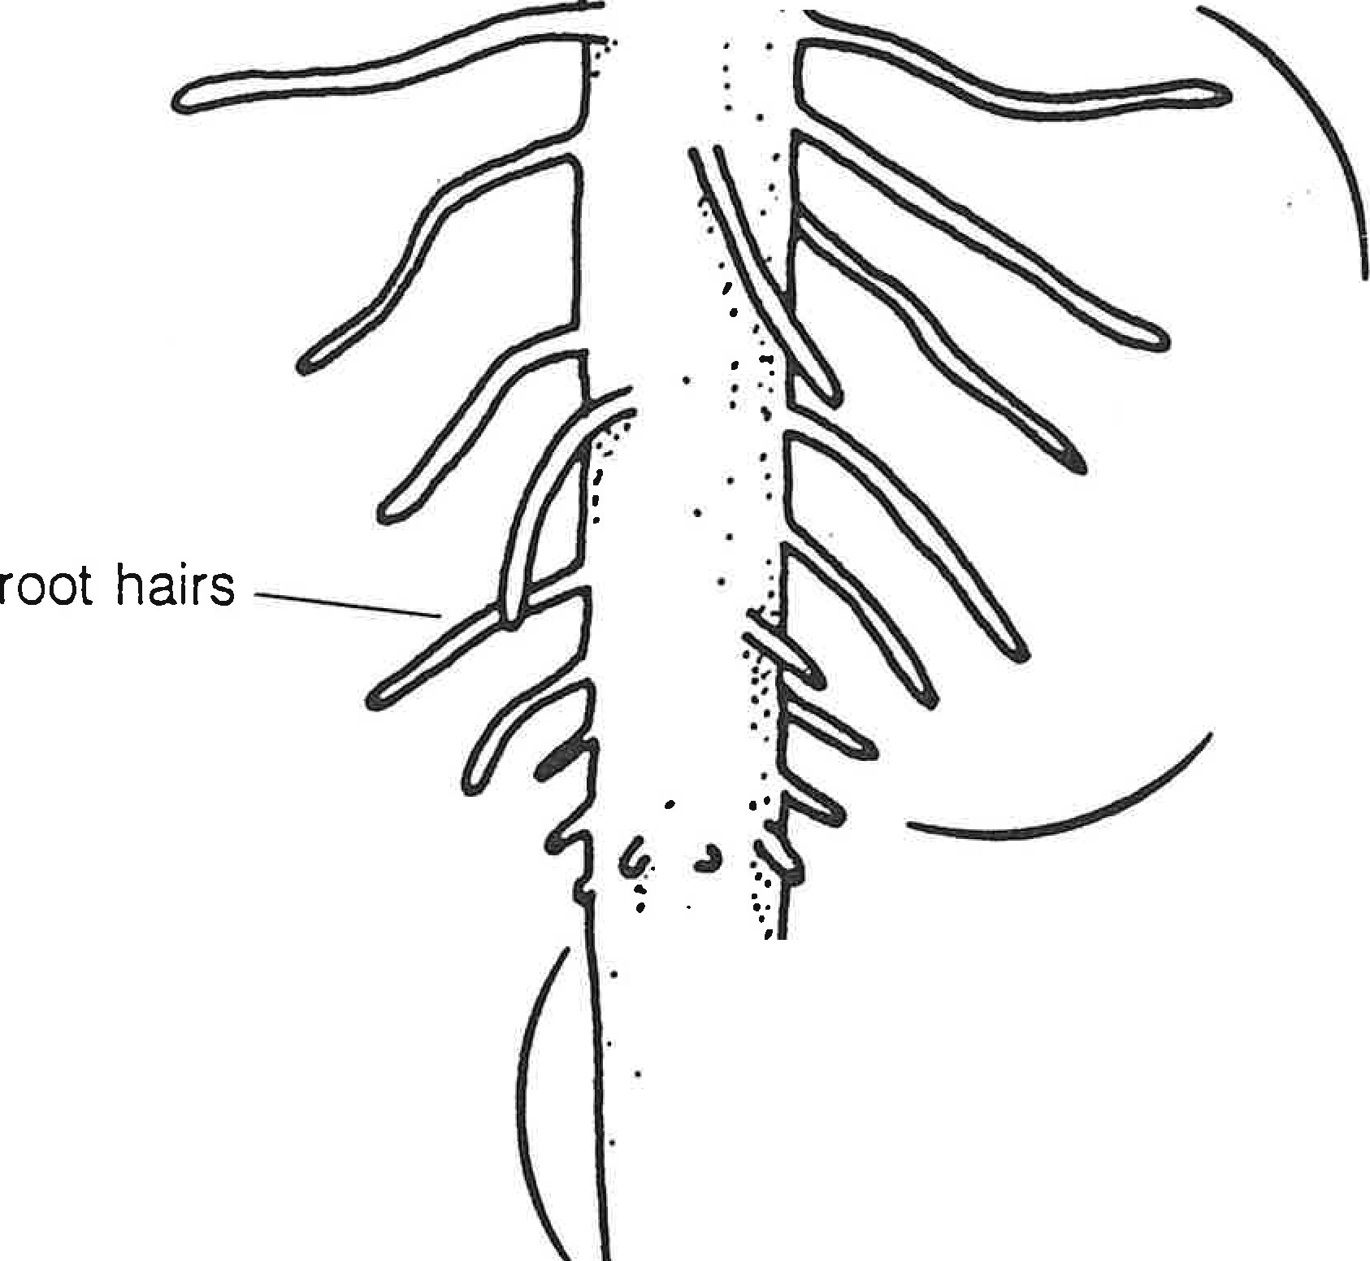

...

.

mature part of root

maturing and absorbing

area

zone of elongation

. .•.

...

:.. / root cap

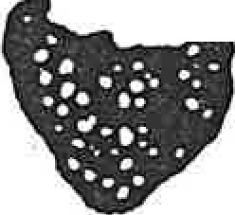

*·::.•* /

(meristematic area)

..,

. .

# PRIMARY AND SECONDARY ROOTS

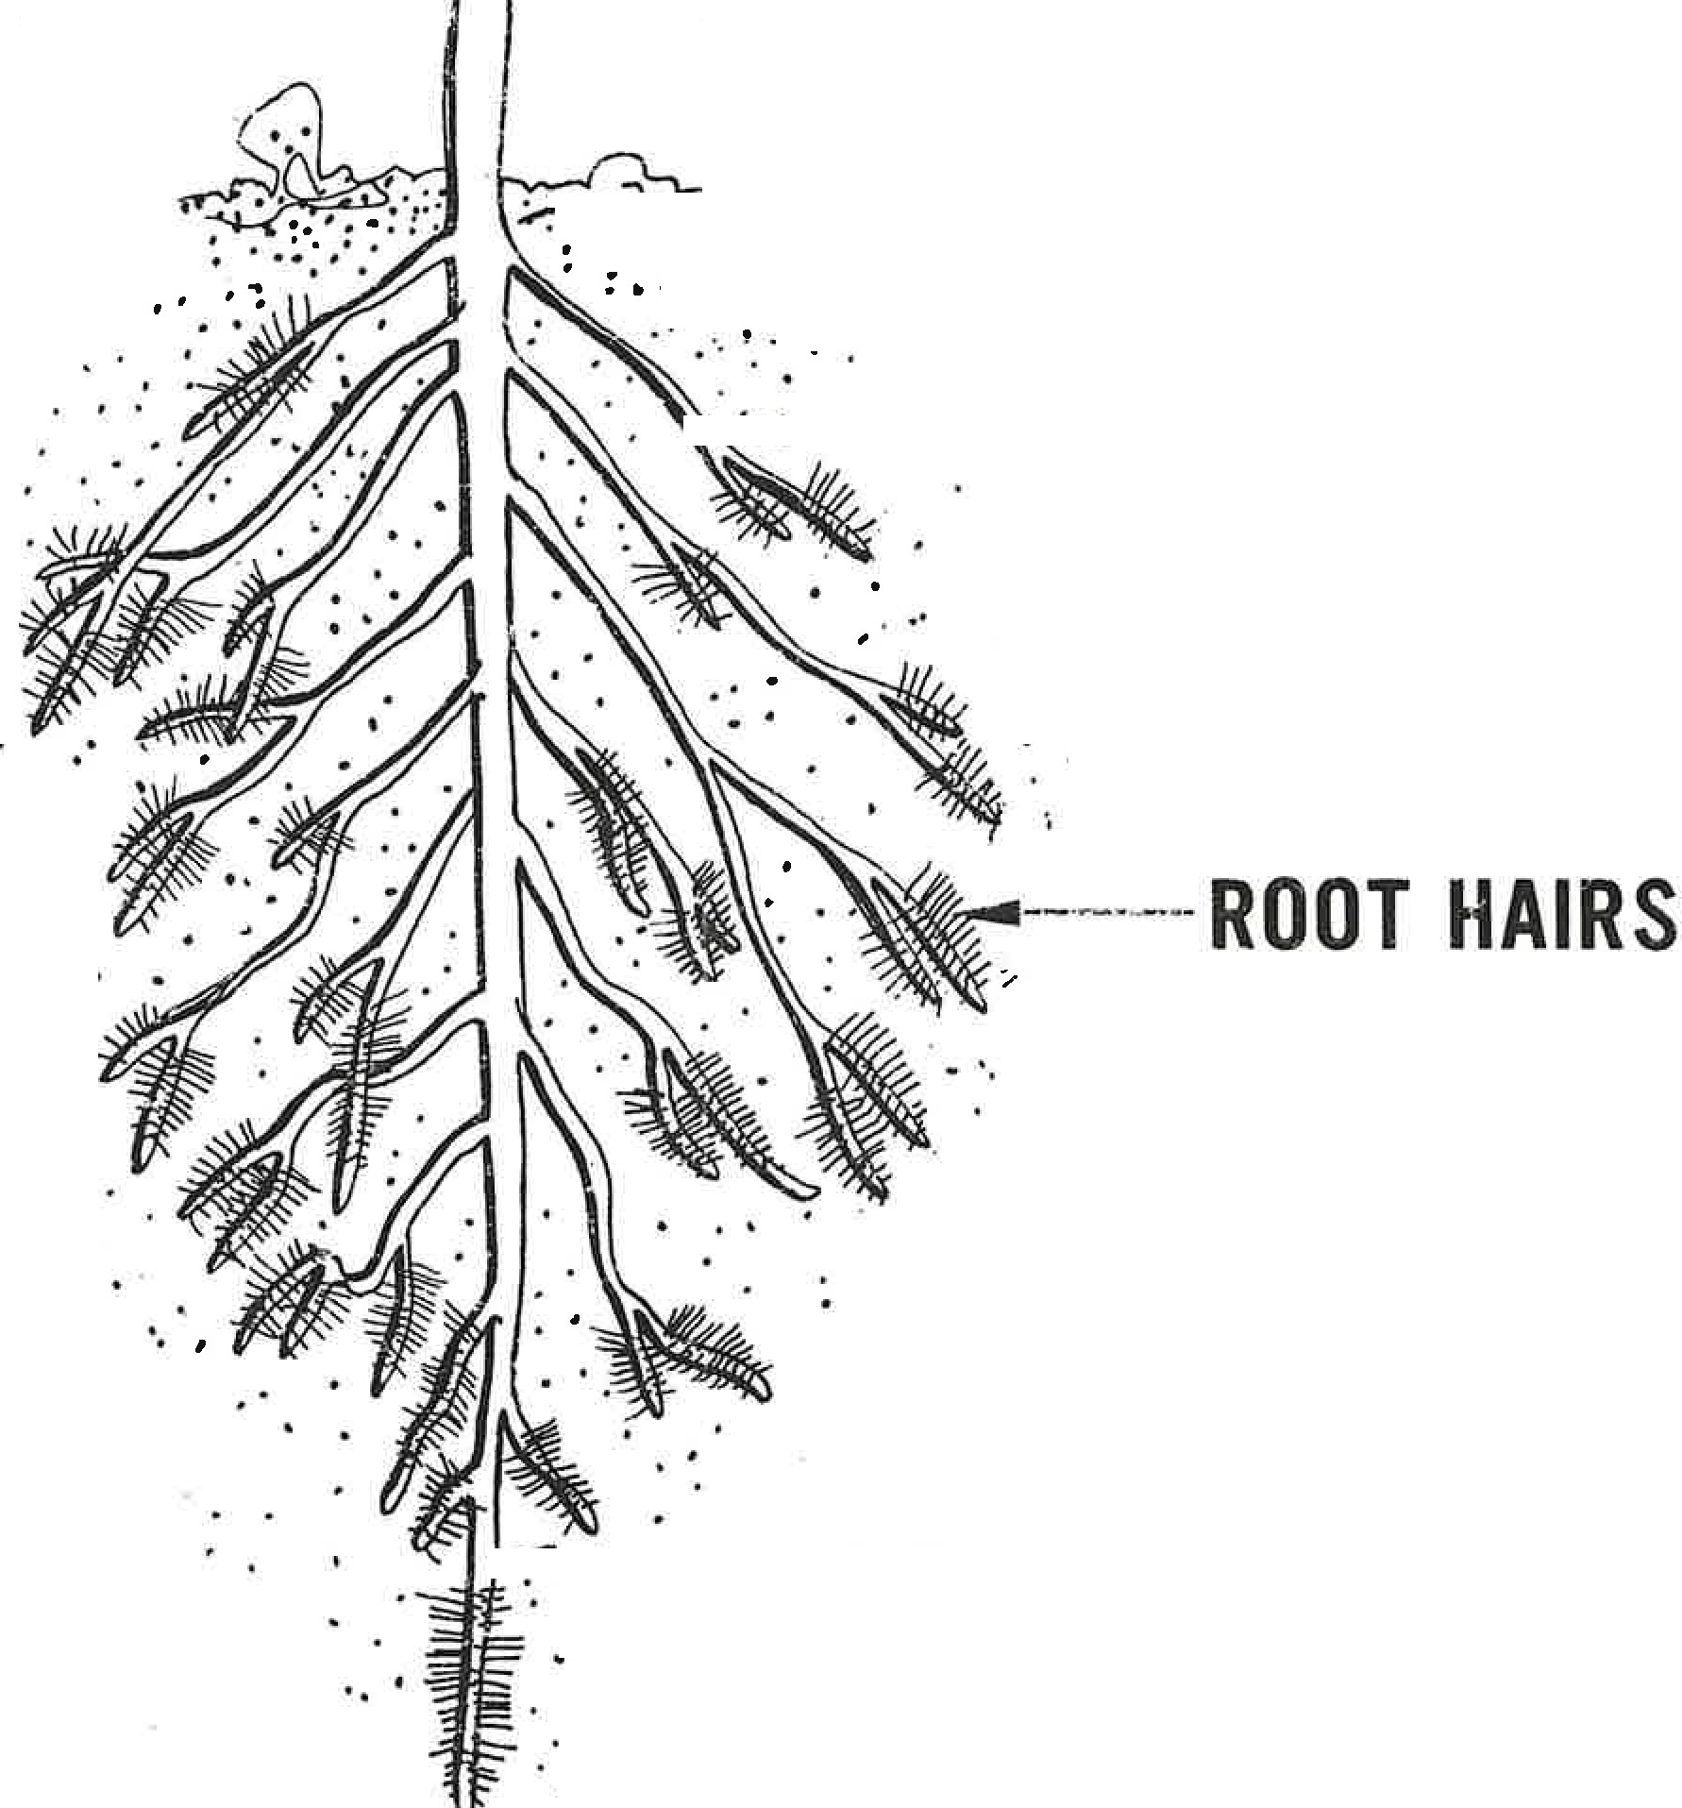*·:* . *,.*.*".:*.*. -*.. . .

. ..... . ..

... -

. ..

".......,.._·_**-· -----SECONDARY ROOT**

..

..

. .

------·- **PRIMARY ROOT**

**TAPROOT AND FIBROUS SYSTEMS.**

*',:.*.

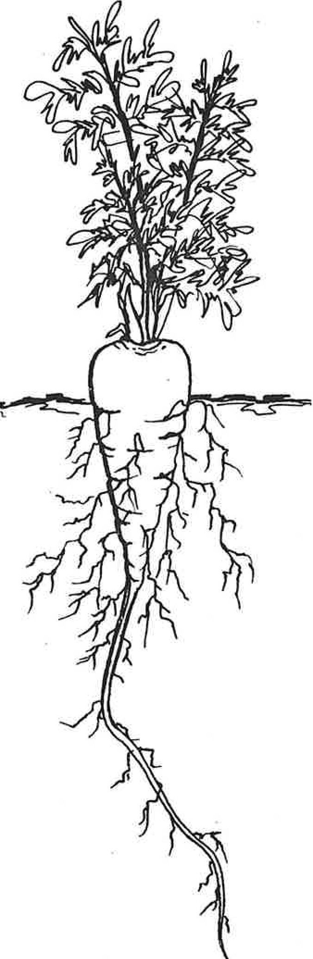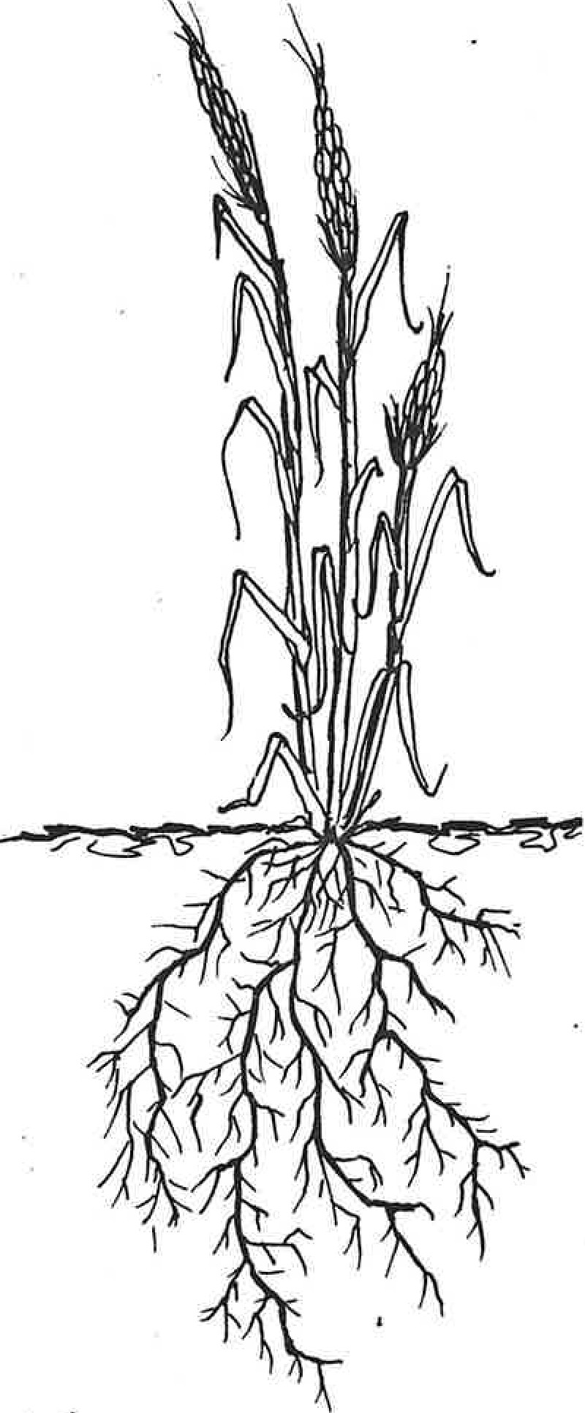

# ADVENTITIOUS ROOTS

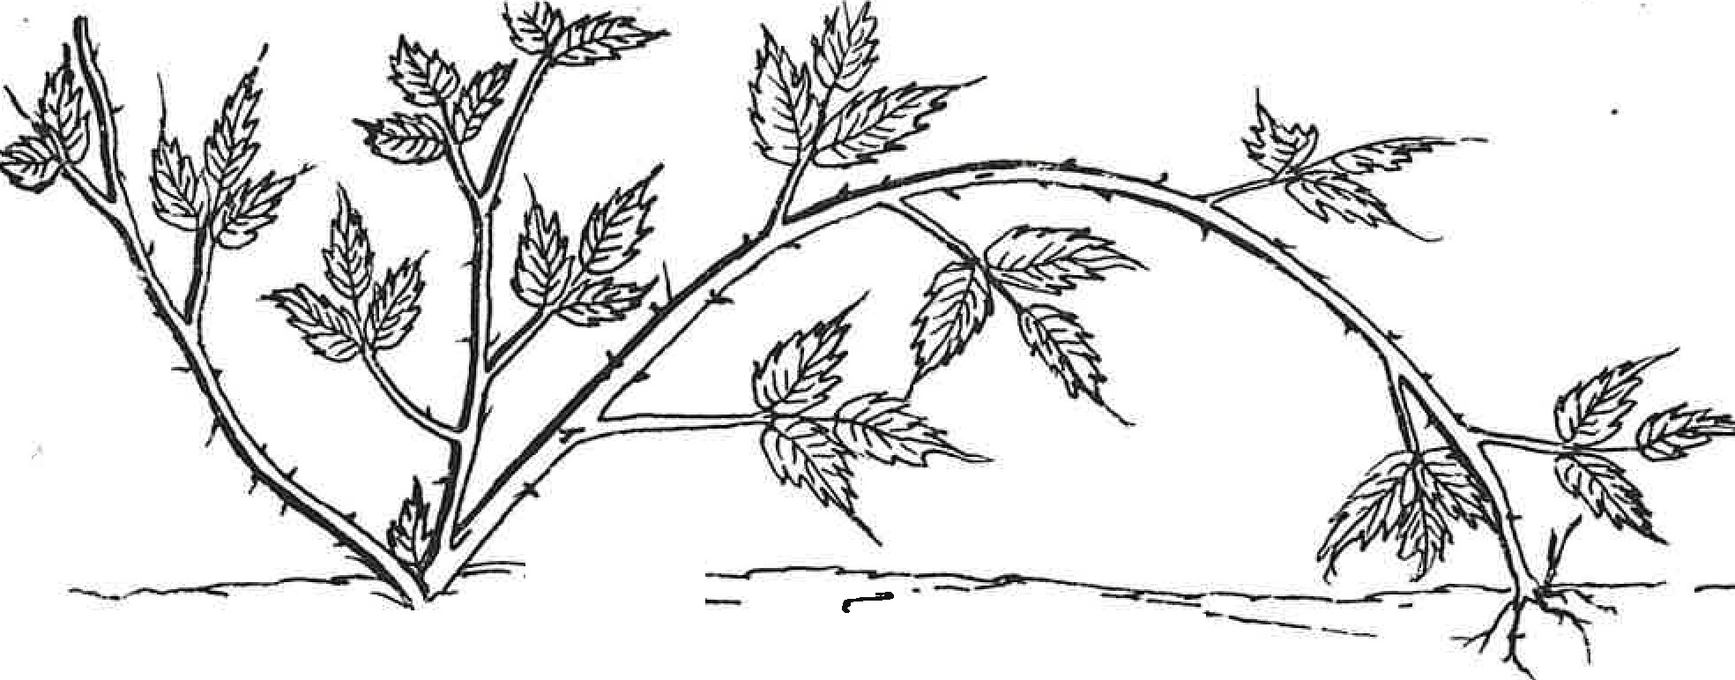

-----=

**TIP LAYERING-RASPBERRY**

. .._

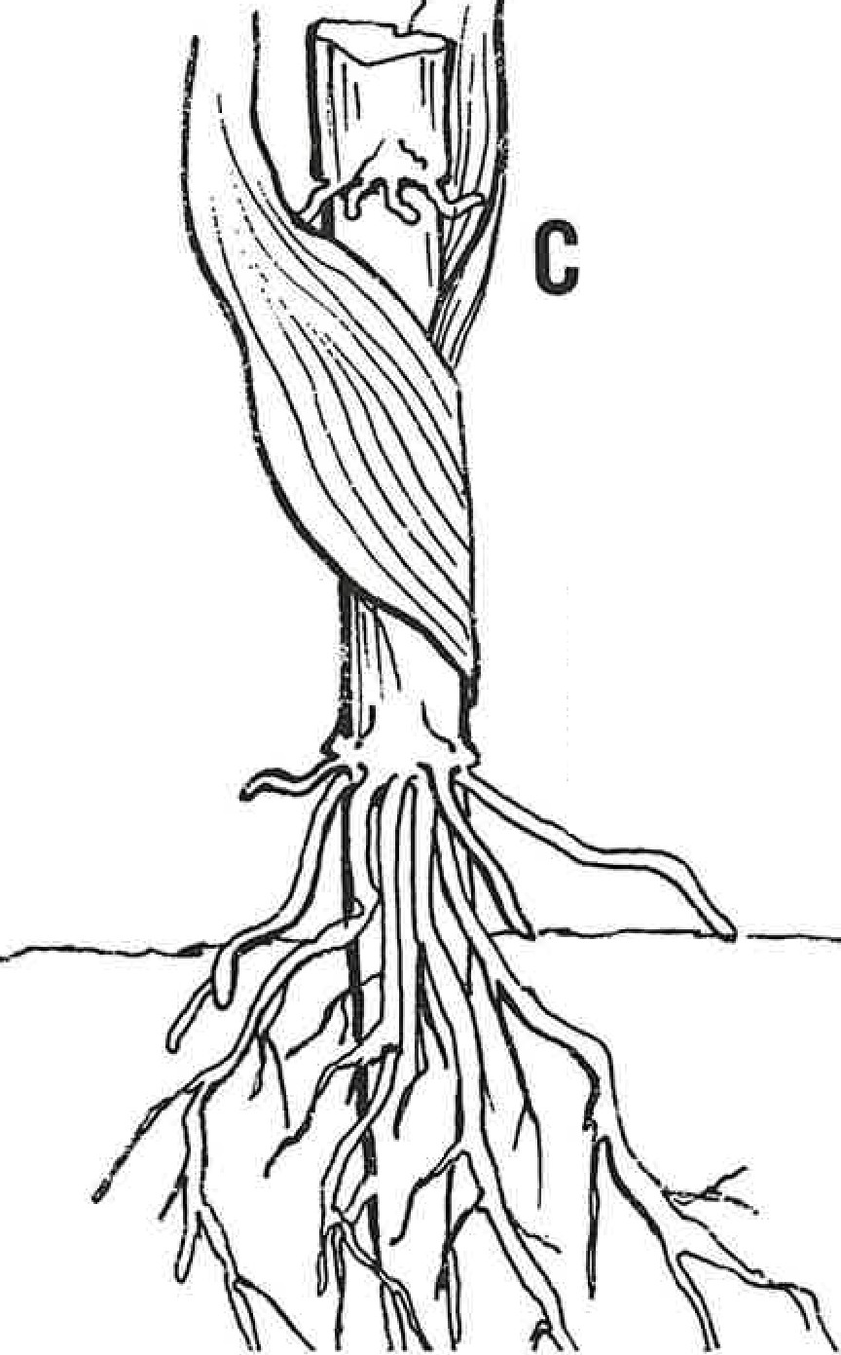

**ORN**

**BRACE**

**ROOTS**

**CLIMBING**

**ROOTS**