**Common pasture and crop weeds**

1. Select a common pasture weed from the list below. Using information from  <https://www.massey.ac.nz/weeds> answer the following questions in your own words.
2. Describe the type of weed it is
3. Describe at least one characteristic that allow the weed to grow well.
4. Describe why this weed is a problem
5. Describe how a farmer could prevent and or control this weed.

Broad-leaved plantain

Broad-leaved dock

Ragwort

Californian thistle

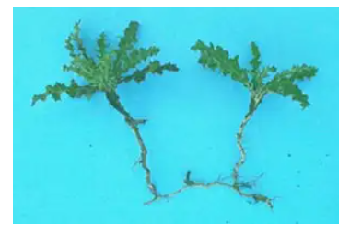

Scoth thistle

Creeping buttercup

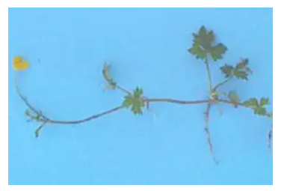

1. Select a common weed found in arable and forage crops from the list below. Using the information from  <https://www.massey.ac.nz/weeds> answer the following questions in your own words.
2. Describe the type of weed it is
3. Describe at least one characteristic that allow the weed to grow well.
4. Describe why this weed is a problem
5. Describe how a grower could prevent and or control this weed.

Sow thistle

Black night shade

Fathen

