**ASSESSMENT OF STRUCTURE**

##### **A Degree of Development**

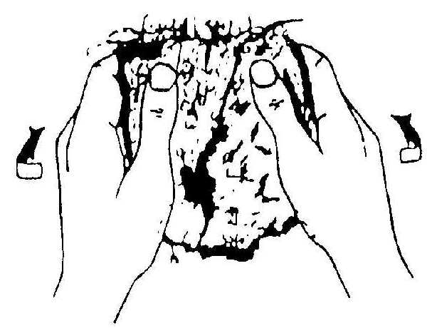

<10 mm very fine

10 – 20 mm fine

20 – 50 mm medium

50 – 100 mm coarse

> 100 mm very coarse

< 5mm very fine

5 – 10 mm fine

10 – 20 mm medium

20 – 50 mm coarse

> 50 mm very coarse

< 1 mm very thin

1 – 2 mm thin

2 – 5 mm medium

5 – 10 mm thick

> 50 mm very coarse

Does the prism have a rounded ‘cap’ or top?

1. Take a soil sod. Break open using gentle hand pressure exposing a natural cleavage plane. Observe the number of distinctive peds and the degree of ped separation.
2. Disturb the soil more and observe the proportions of whole and broken aggregates, and unaggregated material

Is there any observable aggregation?

Are there few distinguishable peds initially, and when disturbed a mixture of a few entire peds, many broken peds and much unaggregated material?

Are the peds evident but not prominent initially and when disturbed a mixture of many entire peds, some broken peds, and little unaggregated material?

Isolate an individual ped and observe its general form

Is it rectangular in form with length approximately >2 times width?

Is it cube-like in form or makes up part of a cube?

Is it flattened and layered in form?

Is the form generally rounded?

Are there many prominent peds weakly adhering to one another, and when disturbed mainly entire peds, few broken peds, and little or no unaggregated material?

YES NO NO

NO YES YES YES

WEAKLY MODERATELY STRONGLY

STRUCTURELESS DEVELOPED DEVELOPED DEVELOPED

##### B Form

NO NO NO

YES YES YES YES

PRISMLIKE BLOCKLIKE PLATELIKE SPHEROIDAL

Does the block have sharp, angular edges that interlock tightly?

Do the shapes look porous like a breadcrumb?

YES NO YES NO YES NO

COLUMNAR PRISMATIC BLOCKY NUTTY PLATEY CRUMB GRANULAR

##### C Size

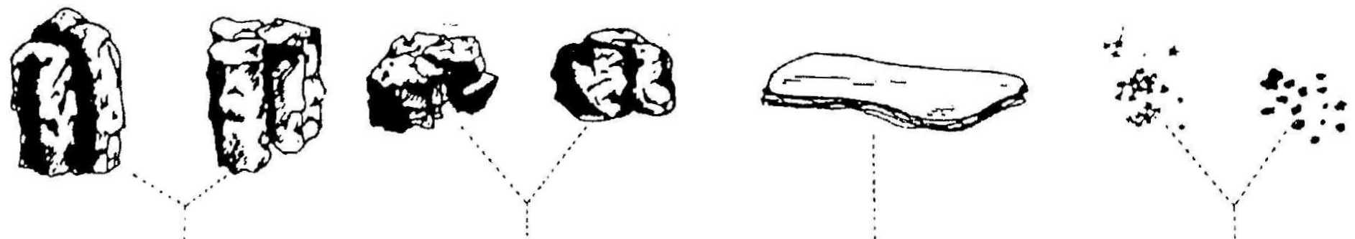

< 1 mm very fine

1 – 2 mm fine

2 – 5 mm medium

* 5 – 10 mm coarse

* > 10 mm very coarse

* Granular only

***Exercise***

*The following diagram shows some common types of soil structures.*

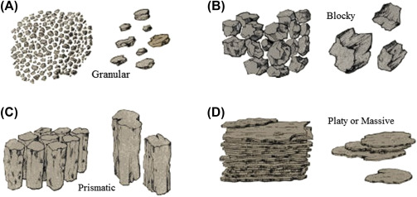

*1.(a) Draw the soil profile represented by the following description.*

Soil profile

**A horizon** 0 – 25 cm; dark brown silt loam; **granular** structure; many fine roots at 20cm; no clear

boundary between A and B horizon.

**B horizon** 25 – 50 cm; pale brown clay loam; **blocky** structure; clear boundary between B and C

horizon.

**C horizon** 50 – 70 cm; pale grey clay loam; **platey** structure.

*(b) Explain the drainage characteristics of this soil profile.*

*(c) How could a farmer improve the soil above?*