**Questions with Answers for junior tests**

**Topics**

* Animal Digestion
* **Beef Farming**
* Dairy Farming
* Pasture
* Pig farming
* Primary Industry
* Plant Production
* Plant Propagation
* Plant Structure
* Plant propagation
* Sheep Farming
* Soil Science

If you are planning an assessment for your junior classes here are some questions you can select from and adapt to develop an assessment to suit your class. Most questions a scaffolded with easy simple questions to ones that require more thought and detailed answers.

**What you need to do?**

* Select relevant questions.
* Add lines or develop an answer sheet so the test can be used multiple times
* Allocate marks

The answers are provided for each question.

**Note:** there may also be other answers to these questions.

**Beef Cattle Questions**

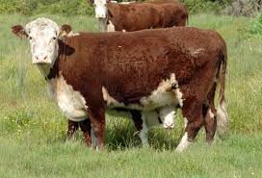

**Question One:** Main beef breeds

1. Angus and Hereford cattle are the main cattle breeds found on many New Zealand hill country farms. Describe two reasons why.
2. Introduced or exotic beef breeds are often breed with Angus or Hereford cows. Describe two benefits of crossing Angus and Hereford cows with an exotic bull such as a Charolais.

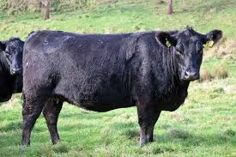

1. When Hereford bulls are crossed with other cattle breeds, what do the calves usually inherit?
2. Describe three qualities a beef farmer would look for in when buying a Beef bull to breed with high producing beef cows.

**Question Two:** Friesian bull calves

Dairy farms have surplus Friesian bull calves. These calves are sold as bobby calves or reared to 100kg weaners and sold to beef finishing farms that grow them for bull beef.

1. What is a bobby calf?
2. What is a beef finishing farm?
3. Describe why beef finishing farms buy 100kg weaned Friesian bull calves.
4. Describe 2 advantages and 2 disadvantages of growing bull beef over steers.
5. Explain why over 90% of beef produced in New Zealand is exported.
6. Where does most of New Zealand’s bull beef get exported to. Explain why?

**Question Three:** Beef Farming Terminology

The following terms were found in a magazine on beef. Explain the meaning of each term.

1. Steer
2. Gestation
3. Vaccinate
4. Weaning
5. Prime cattle
6. Dairy Beef
7. Drench
8. Heifer

# Question Four: Safe handling of cattle

# Describe two safety procedures a farmer should do when working with cattle in a yard.

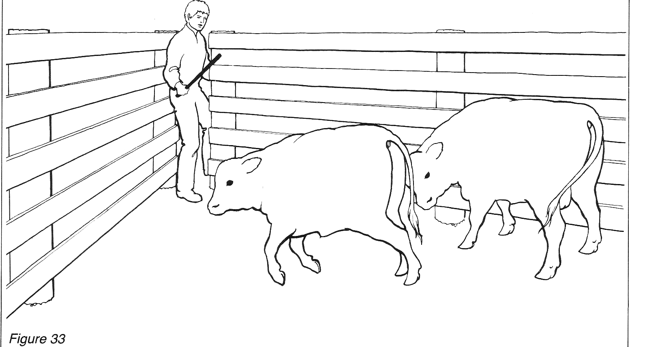

Answers

**Beef Cattle Questions**

**Question One:** Main beef breeds

1. Angus and Hereford cattle are the main cattle breeds found on many New Zealand hill country farms. Describe two reasons why.

Answers include:

* mature early- ready to have a calf
* calve easily without help
* high calving rate (one calf per cow each year
* good mothers
* hardy and do well on hill country (good forages)
* produces high quality meat.

1. Introduced or exotic beef breeds are often breed with Angus or Hereford cows. Describe two benefits of crossing Angus and Hereford cows with an exotic bull such as a Charolais.

Answers include: Offspring have

* Fast growth rates
* Produce leaner meat
* Higher dressing out percentage.

1. When Hereford bulls are crossed with other cattle breeds, what do the calves usually inherit?

Answer: White face

1. Describe three qualities a beef farmer would look for in when buying a Beef bull to breed with high producing beef cows.

Answers include: Genetics that will pass on

* High growth rate
* Carcass quality- good muscling, marbling (Intra-muscular fat) leaness
* High fertility
* Short gestation
* Strong feet and legs
* Quiet temperament
* Disease free

**Question Two:** Friesian bull calves

Dairy farms have surplus Friesian bull calves. These calves are sold as bobby calves or reared to 100kg weaners and sold to beef finishing farms that grow them for bull beef.

1. What is a bobby calf?

Answer: A bobby calf is an unwanted calf on a dairy farm, 4-7 days old, not kept for rearing for replacements

1. What is a beef finishing farm?

Answer: A beef finishing farm grow beef from store to prime. They add weight and fat cover to cattle for 12-18 months to meet prime carcass weight and meat quality.

1. Describe why beef finishing farms buy 100kg weaned Friesian bull calves.

Answers include

* Friesian bull calves, have fast growth rates are lean and can be sold between 18-24 months for the manufacturing beef market.
* There is a good supply of Friesian bull calves.
* There is a strong market demand for bull beef.

1. Describe two advantages and two disadvantages of growing bull beef over steers.

|  |  |
| --- | --- |
| Advantages | Disadvantages |
| * Bulls grow 10–20% faster than steers due to testosterone. * Bulls are more efficient at turning grass into meat * Bulls typically reach higher carcass weight at 18-14 months than steers * Bulls have a higher dressing out percentage than steers. * Bulls have leaner meat than steers. | * Bulls are more aggressive, harder to handle than steers. * Require strong, secure fencing and separate paddocks to prevent fighting or injury. |

1. Explain why over 90% of beef produced in New Zealand is exported.

* New Zealand has a small population, and more beef is produced than can be consumed.
* There is a high demand for grassfed beef by importing countries which earns export revenue for NZ.

1. Where does most of New Zealand’s bull beef get exported to. Explain why?

The main market for bull beef is the USA beef manufacturing market. NZ bull beef is mixed with USA beef to meet the health and flavour requirements for the burger market.

**Question Three:** Beef Farming Terminology

The following terms were found in a magazine on beef. Explain the meaning of each term.

1. Steer- castrated bull
2. Gestation- length of pregnancy
3. Vaccinate- injection to increase immunity against diseases
4. Weaning- weaned of milk/ separated permanently from mother
5. Prime cattle- An animal at a saleable weight, with the right covering of fat required by the market.
6. Dairy Beef- animal from a dairy cow crossed with a beef bull.
7. Drench- Chemical given to animals to kill internal parasites.
8. Heifer- Young female cattle beast having or just had her first calf. She has no more than 6 permanent teeth.

# Question Four: Safe handling of cattle

# Describe two safety procedures a farmer should do when working with cattle in a yard.

Answers include

* No stone in yards
* Suitable foot wear
* Not too many in yards
* Tie dogs up