**Questions with Answers for junior tests**

**Topics**

* Animal Digestion
* Beef Farming
* **Dairy Farming**
* Pasture
* Pig farming
* Primary Industry
* Plant Production
* Plant Propagation
* Plant Structure
* Plant propagation
* Sheep Farming
* Soil Science

If you are planning an assessment for your junior classes here are some questions you can select from and adapt to develop an assessment to suit your class. Most questions a scaffolded with easy simple questions to ones that require more thought and detailed answers.

**What you need to do?**

* Select relevant questions.
* Add lines or develop an answer sheet so the test can be used multiple times
* Allocate marks

The answers are provided for each question.

**Note:** there may also be other answers to these questions.

**Dairy Farming Questions**

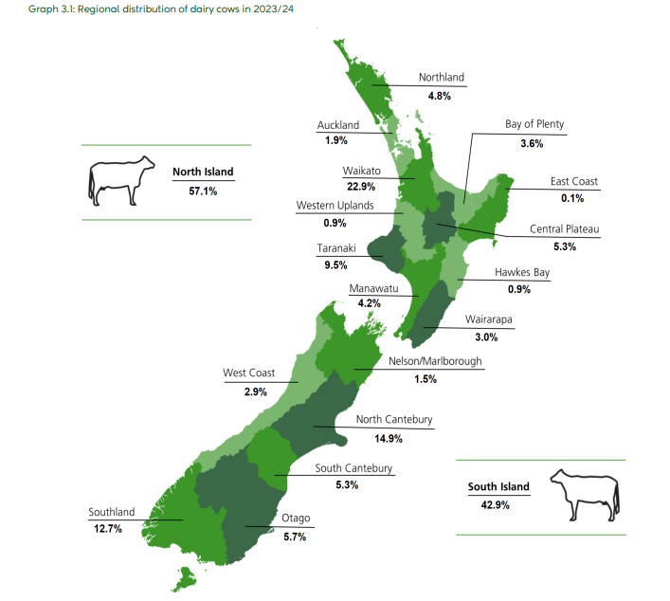

**Question one:** Dairy farming in New Zealand

1. Name the **three** main dairy cattle breeds in New Zealand.
2. Give two reasons why there are more dairy farms in the North Island than the South Island.
3. Select a dairy farming region and describe why the region is suitable for dairy farming.

**Question Two:** Milk

1. Milk is made up of **five** components. List these.
2. Describe how a cow lets milk down.
3. Describe how digested food is carried to the udder.

#### **Question Three:** Herd testing

#### Herd testing is a common practice on New Zealand dairy farms. Give two reasons why



1. List three things that “**herd**-**testing**” tests for.
2. How is milk production in dairy cows recorded?
3. Explain two ways a farmer can use herd test results to improve farm production.

**Question Four:** Oestrus detection

**Examine the chart below and use it to answer the following questions.**

1. Describe two ways a farmer can tell if a cow is coming on heat.
2. If a farmer was sure that a cow was on heat, how many hours would the farmer have to successfully inseminate her?

**Question Five:** Artificial Insemination

The diagram below shows an AI technician demonstrating the technique of artificial insemination. The technician places the semen through the cervix into the uterus.

1. Give two reasons why nearly 100% of dairy farmers use artificial insemination (AI) for at least 4-6 weeks of mating.
2. Explain why the semen is placed through the cervix into the uterus.

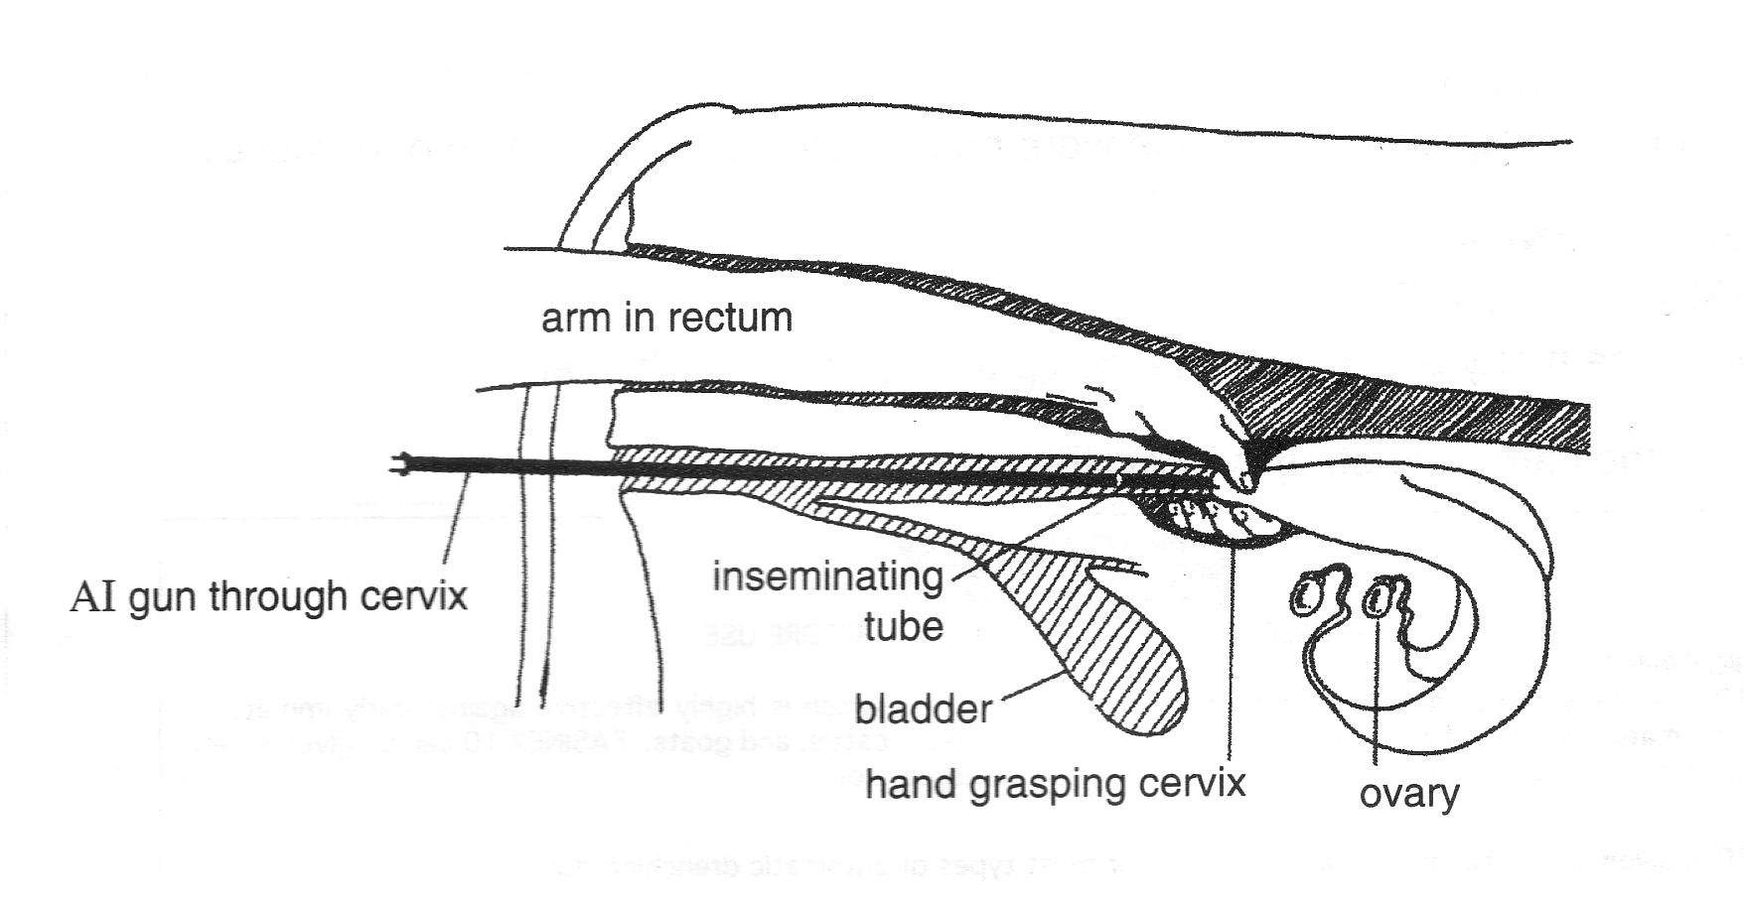

**Question Six:** Animal Health

1. Match these common diseases of dairy cattle with the cause of the disease

**Grass staggers, Bloat , Milk fever, Mastitis**

|  |  |
| --- | --- |
| **Name of disease** | **Cause of disease** |
|  | Bacterial infection of the udder |
|  | Buildup of gas in the rumen trapped in pasture foam. This is caused by the animal eating lots of young fresh pasture with lots of clover in it. |
|  | Caused by low blood magnesium. It is common in spring when fast growing pasture is low in magnesium and the cow requirements in early lactation are high. |
|  | Caused by low blood calcium. Common in high producing dairy cattle in late pregnancy and early lactation. |

**Question Seven:** Dairy Farming terminology

1. Lactation
2. Drying off
3. Oestrus
4. Dry cow
5. Break feeding

**Question Eight:** Mastitis

Mastitis is a common disease in dairy cows in New Zealand. It happens when a cow’s udder becomes swollen and sore. This usually happens because of bacteria getting into the udder. Mastitis costs the New Zealand dairy industry about $180 million every year.

1. Describe two management practices a farmer can carryout to minimise the risk of mastitis in the dairy herd.
2. Describe how a farmer can test a cow for mastitis.

**Question Nine**: Dairy Exports

NZ exports 95% of its dairy products to approximately 170 countries in the world.

1. Explain why New Zealand exports 95 % of the dairy products produced.
2. How does New Zealand benefit from being able to export so much to so many countries?
3. What are the issues exporters can face with selling dairy to other countries?

**Question Ten:** Infrastructure on a dairy farm

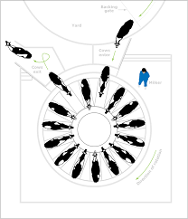

1. Explain two advantages of a rotary milking shed over a herringbone?
2. Explain why having a well-maintained laneway system is so important on a dairy farm?
3. How is dairy effluent (waste from the dairy shed) used by farmers to save money?

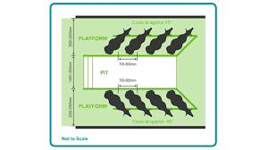

**Dairy Farming - Answers**

**Dairy Farming Questions**

**Question one:** Dairy farming in New Zealand

1. Name the **three** main dairy cattle breeds in New Zealand.

Answer: Friesian, Jersey, Friesian Jersey cross

1. Give two reasons why there are more dairy farms in the North Island than the South Island.

Answer: Milder weather conditions for growing pasture all year round especially without irrigation.

1. Select a dairy farming region and describe why the region is suitable for dairy farming.

Student answers will vary depending on the region.

**Question Two:** Milk

1. Milk is made up of **five** components. List these.

Answer

* Lactose/carbohydrate/milk sugar
* Protein
* Fat
* Water
* minerals

1. Describe how a cow lets milk down.

Answer- When a calf suckles or cups are put on a message is sent to the brain to release oxytocin. This causes the alveoli to contract and let milk down

1. Describe how digested food is carried to the udder.

Answer- Nutrients needed for milk production are carried to the udder in the blood

#### **Question Three:** Herd testing

#### Herd testing is a common practice on New Zealand dairy farms. Give two reasons why?

Answers include:

* identify poor producing cows, which should be culled.
* provide a checking system on the quality of the bulls being used.
* provide information on which to base herd management decisions e.g. drying off date.
* identify cows with mastitis that need treatment, drying off or culling.
* provide a check on milking efficiency and milking machine performance.

1. List three things that “**herd**-**testing**” tests for.

Answers include:

* volume
* milkfat
* protein
* lactose
* somatic cell count.

1. How is milk production in dairy cows recorded?

Answer- KgMS

1. Explain two ways a farmer can use herd test results to improve farm production.

Answers include:

* High producing cows can be identified and breed to high performance bulls to keep replacements from.
* Improving the herd genetics will increase production /cow increasing farm profit.
* Poor producing cows, are identified, replacement heifers are not kept from these cows,
* Poor producing cows identified can be culled from the herd
* Cows with mastitis can be treated or culled to prevent grades and reduce animal health costs
* Higher producing cows identified have a higher Breeding worth and farmer can get a higher price for these cows.

**Question Four:** Oestrus detection

1. Describe two ways a farmer can tell if a cow is coming on heat.

Answers include:

* Cows will stand to be ridden/bulling
* Clear mucus discharge from the vagina
* Tail paint is rubbed off
* Kmar heat detector has changed colour

1. If a farmer was sure that a cow was on heat, how many hours would the farmer have to successfully inseminate her?

Answer: 22 hours

**Question Five:** Artificial Insemination

The diagram below shows an AI technician demonstrating the technique of artificial insemination. The technician places the semen through the cervix into the uterus.

1. Give two reasons why nearly 100% of dairy farmers use artificial insemination (AI) for at least 4-6 weeks of mating.

Answers include:

* Semen from genetically superior bulls is used increasing the production potential of the herd to produce more milk.
* The production ability of the herd increases quicker using AI than natural mating
* Overseas semen can be introduced into the country without bring in live animals which is expensive.

1. Explain why the semen is placed through the cervix into the uterus.

Answer- Semen is placed into the uterus to increase the chance of sperm fertilising the egg

**Question Six:** Animal Health

1. Match these common diseases of dairy cattle with the cause of the disease

|  |  |
| --- | --- |
| **Name of disease** | **Cause of disease** |
| **Mastitis** | Bacterial infection of the udder |
| **Bloat** | Buildup of gas in the rumen trapped in pasture foam. This is caused by the animal eating lots of young fresh pasture with lots of clover in it. |
| **Grass staggers** | Caused by low blood magnesium. It is common in spring when fast growing pasture is low in magnesium and the cow requirements in early lactation are high. |
| **Milk fever** | Caused by low blood calcium. Common in high producing dairy cattle in late pregnancy and early lactation. |

**Question Seven:** Dairy Farming terminology

1. Lactation- producing milk
2. Drying off- gradually reducing the amount of milk produced until the cow is dry
3. Oestrus- in heat, the female is sexually active.
4. Dry cow- a cow that is not lactating
5. Break feeding- Splitting a paddock of pasture or crop into smaller sections using and electric fence.

**Question Eight:** Mastitis

Mastitis is a common disease in dairy cows in New Zealand. It happens when a cow’s udder becomes swollen and sore. This usually happens because of bacteria getting into the udder. Mastitis costs the New Zealand dairy industry about $180 million every year.

1. Describe two management practices a farmer can carryout to minimise the risk of mastitis in the dairy herd.

Answers include

* Teat spray after milking
* Reduce stress during handling and milking.
* Keep her teat ends as clean and dry as possible to reduce bacteria at the teat ends.
* Use an efficient milking technique and maintain milking equipment to prevent teat end damage.

1. Describe how a farmer can test a cow for mastitis.

Answers include;

* Stripping each quarter to check the milk is normal and there are no clots or blood in the milk.
* Use a mastitis test
  + Squirt milk from each quarter into the four paddles of the **tray**.
  + Add an equal amount of **reagent** (detergent solution).
  + Gently swirl the tray.
  + **Interpret the reaction:**
  + **No change = negative** (low SCC)
  + **Thickening or gel = positive** (high SCC → likely infection)

**Question Nine**: Dairy Exports

NZ exports 95% of its dairy products to approximately 170 countries in the world.

1. Explain why New Zealand exports 95 % of the dairy products produced.

Answer- NZ has only about 5 million people, which isn’t enough to consume all the dairy products it produces as NZ can produce over 21 billion litres of milk

1. How does New Zealand benefit from being able to export so much to so many countries?

Answer- dairy is NZ’s largest export sector earning over $25 billion which provides export revenue for New Zealand, rural communities and employment.

1. What are the issues exporters can face with selling dairy to other countries?

Answers include-

* Prices fluctuate due to supply and demand from other countries.
* Many importing countries have trade barriers to protect their dairy industry limiting the amount NZ can sell to these countries.
* The cost of maintaining a high quality traceable system.
* Cost of freight.
* Environmental and ethical pressures from global buyers e.g. Reduced nitrogen use, animal welfare assurances

**Question Ten:** Infrastructure on a dairy farm

1. Explain two advantages of a rotary milking shed over a herringbone?

Answers include-

* Rotary sheds can milk up to 2 times more cows per hour than herringbone, improving efficiency on large farms.
* Cows enter and exit continuously, reducing waiting times and handling stress for animals.
* Requires fewer staff per cow milked because the platform moves cows past the milkers, reducing walking movement.
* Rotary sheds can be easily fitted with automatic cup removers, teat spraying and drafting systems.

1. Explain why having a well-maintained laneway system is so important on a dairy farm?

Answers-

* reduces the incidence of lameness
* Allows ease of farm vehicles
* Safer for employees.

1. How is dairy effluent (waste from the dairy shed) used by farmers to save money?

Answer- Land applied effluent returns nutrients to the soil reducing the cost of artificial fertiliser.