**Questions with Answers for junior tests**

**Topics**

* Animal Digestion
* Beef Farming
* Dairy Farming
* **Pasture**
* Pig farming
* Primary Industry
* Plant Production
* Plant Propagation
* Plant Structure
* Plant propagation
* Sheep Farming
* Soil Science

If you are planning an assessment for your junior classes here are some questions you can select from and adapt to develop an assessment to suit your class. Most questions a scaffolded with easy simple questions to ones that require more thought and detailed answers.

**What you need to do?**

* Select relevant questions.
* Add lines or develop an answer sheet so the test can be used multiple times
* Allocate marks

The answers are provided for each question.

**Note:** there may also be other answers to these questions.

Pasture Production

**Question One:** Pasture plants

1. Name the main grass plant in improved pasture and explain why it is the main pasture plant.
2. Describe the benefits of having clovers in pasture?
3. Describe two reasons why pasture is the main feed for ruminant animals in New Zealand?

#### Explain why most grasses are suited to grazing?

#### Name two common pasture weeds and explain why farmers do not want weeds in pasture.

**Question Two**: Grazing systems

1. Name the **two** types of grazing systems in the diagrams below and describe the differences between them.
2. Explain why on a sheep farm set stocking is used at tupping and lambing times.
3. Describe two ways livestock affect pasture growth and explain the impact on pasture production.

**A**

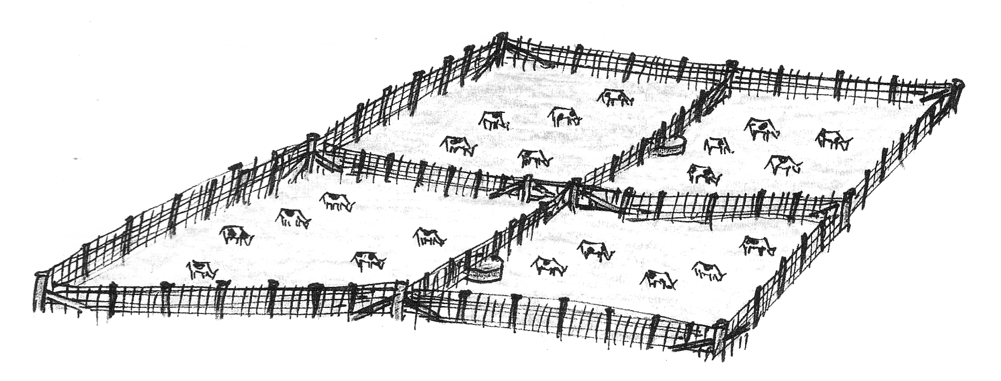

**B**

1. A paddock was sub-divided into two equal halves. One half (A) was grazed by cattle to 2cm while the other half (B) was grazed to 5cm. Which half would reach a grazing height of 20cm first. Explain your answer.

# Question Three: Pasture Growth Curve

A farmer has provided the pasture growth data below.

|  |  |  |  |  |  |  |  |  |  |  |  |  |
| --- | --- | --- | --- | --- | --- | --- | --- | --- | --- | --- | --- | --- |
| Month | J | J | A | S | O | N | D | J | F | M | A | M |
| Pasture Growth(kg DM/Ha/day | 16 | 16 | 32 | 56 | 70 | 51 | 30 | 15 | 12 | 21 | 26 | 25 |

The graph below shows the feed required by18 ewes per hectare.

1. Plot the pasture growth data above on to the graph. Label the left axis and fill in key A.
2. Shade any areas on the graph where there is surplus pasture growth. Shade in key B
3. In another colour, shade any areas on the graph where pasture does not meet the feed requirements of the breeding ewes (deficit) Shade in key C.
4. Explain how a farmer could use the surplus pasture in spring and early summer.

**Answers**

**Question One:** Pasture plants

1. Name the main grass plant in improved pasture and explain why it is the main pasture plant.

Answer includes

* Perennial Ryegrass
* Grows well under a range of soil and climatic conditions
* Has a reasonable growth rate throughout the year
* Growing point is close to the ground so very tolerant of grazing

1. Describe the benefits of having clovers in pasture?

Answer includes

* Clovers fix nitrogen and increase nitrate levels in the soil improving pasture growth.
* Clover is a very palatable and highly nutritious feed. Animals fed on clover grow very fast.

1. Describe **two** reasons why pasture is the main feed for ruminant animals in New Zealand?

Answer includes

* Grows all year round
* Cheap due to low labour requirements
* Sole diet of adult ruminant animals
* Grasses have a low growing point so tolerate grazing and will regrow

#### Explain why most grasses are suited to grazing?

Answer:- Grasses have a low growing point so tolerate grazing and will regrow

#### Name **two** common pasture weeds and explain why farmers do not want weeds in pasture.

Answer includes

* Ragwort
* Dock
* Thistle
* Gorse etc
* Weeds compete for light, water and nutrients so reduce pasture growth. They can also damage and devalue animal products, taint milk, damage hides etc.
* Some weeds such as ragwort are poisonous and kill stock.

**Question Three**: Grazing systems

1. Name the **two** types of grazing systems in the diagrams below and describe the differences between them.

Answer

A: rotational grazing

B: set stocking

Set stocking- a few animals are in each paddock while rotational grazing a large number of animals are in a paddock at one time and are moved regularly onto fresh pasture.

1. Explain why on a sheep farm set stocking is used at tupping and lambing times.

* Tupping- ensure ewes have time to find the ram
* Lambing – to minimise risk of mismothering

1. Describe two ways livestock affect pasture growth and explain the impact on pasture production.

Answers include

* treading/pugging damage or kill the growing point, plant dies and leaves room for weeds to grow

Return of dung and urine- returns/recycles nutrients back to the soil. These nutrients can be absorbed by the plant for growth.

* stock eats the leaves- slows pasture growth until leaf grows back to intercept light increasing the rate of photosynthesis and therefore plant growth.

1. A paddock was sub-divided into two equal halves. One half (A) was grazed by cattle to 2cm while the other half (B) was grazed to 5cm. Which half would reach a grazing height of 20cm first. Explain your answer.

Answers

* B
* If pasture is grazed too heavily it takes longer to grow back than if lightly grazed. Less leaf means less photosynthesis so less growth