**Questions with Answers for junior tests**

**Topics**

1. Animal Digestion
2. Beef Farming
3. Dairy Farming
4. Pasture
5. Pig farming
6. Primary Industry
7. **Plant Production**
8. Plant Propagation
9. Plant Structure
10. Plant propagation
11. Sheep Farming
12. Soil Science

If you are planning an assessment for your junior classes here are some questions you can select from and adapt to develop an assessment to suit your class. Most questions a scaffolded with easy simple questions to ones that require more thought and detailed answers.

**What you need to do?**

1. Select relevant questions.
2. Add lines or develop an answer sheet so the test can be used multiple times
3. Allocate marks

The answers are provided for each question.

**Note:** there may also be other answers to these questions.

**Plant Production**

**Question One:** Tools

1. Name the tools **A-D** shown below.

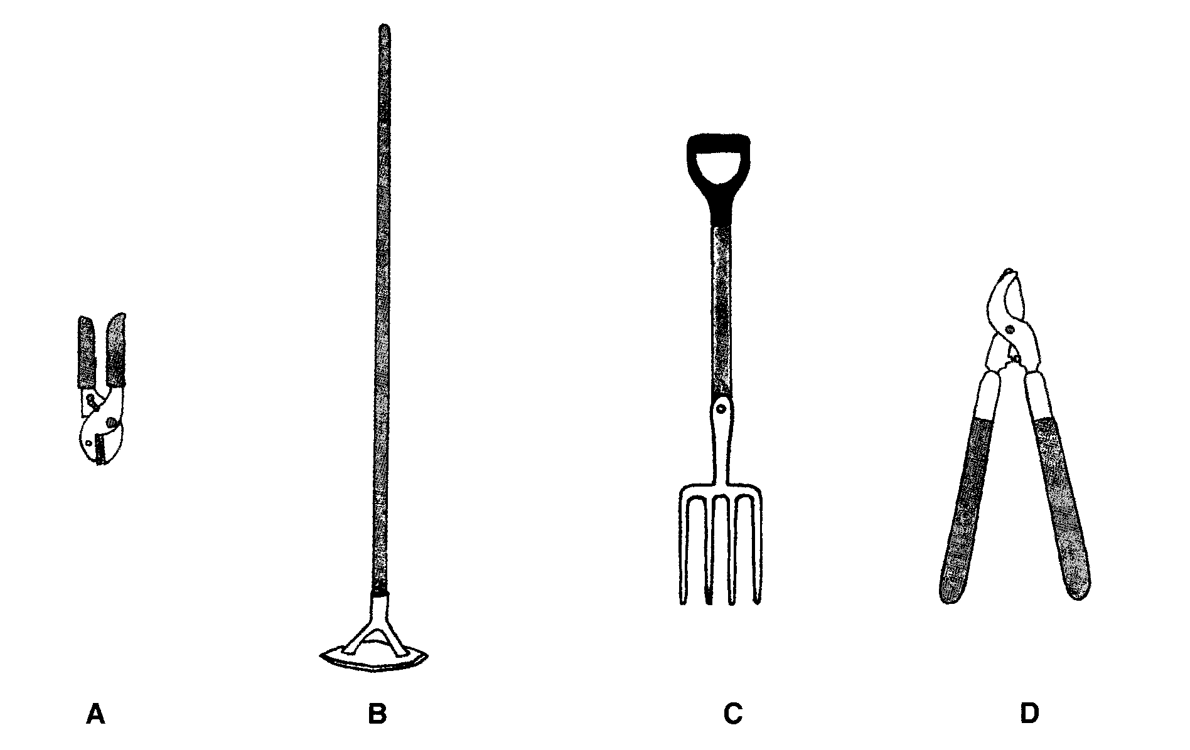

1. Describe what you would use tool **C** for.
2. Describe **two** different things which should be done to the tools after use, before they are stored.
3. Describe **one** way in which tools should be carried safely around the garden.

**Question Two:** Gardens

Two students were experimenting with growing plants in a raised bed as shown in the diagram.

1. Describe the advantages of growing plants in raised beds.

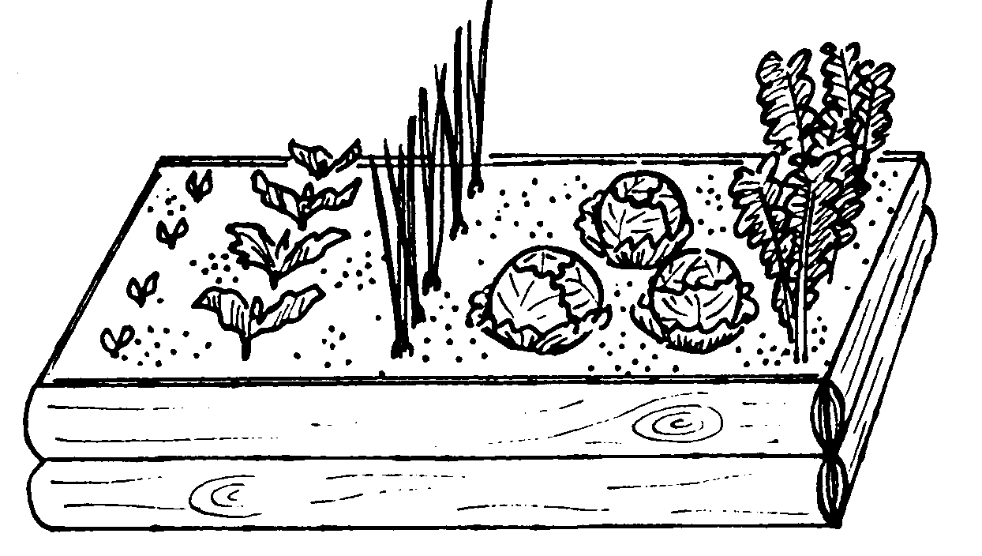

**Question Three**: Crop Rotations

The diagram is an example

of a crop rotation on an arable farm.

1. Explain why arable farmers and market

gardeners should use a crop rotation.

**Question Four:** Sowing seeds

1. Students were planting carrots seeds directly into their raised gardens. Describe the steps the students should carryout so the carrots seeds germinate successfully.
2. Students planted cucumber and courgettes seeds which are large seeds into individual pots. Explain why?

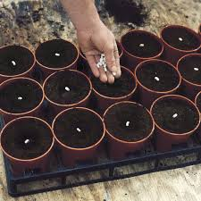

**Question Five:** Thinning out

A student was thinning out radish seedlings as shown in the diagram

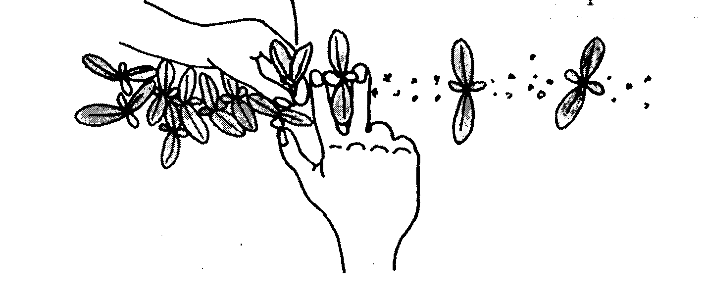

1. Explain why the student is thinning the radish seedlings.

**Question Six**: Pricking out seedlings

The diagram below shows the right and wrong way to hold seedlings when pricking out.

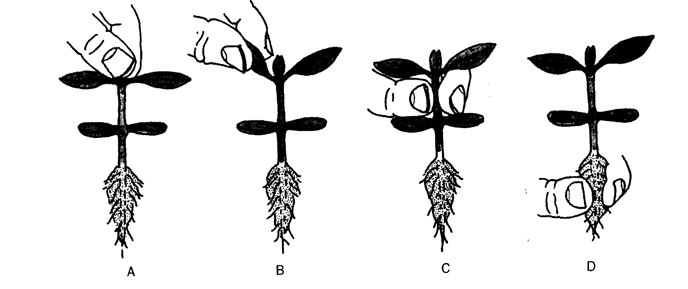

1. Which diagram is showing the right way?
2. Explain why this is the right way to hold a seedling when pricking out.

**Question Seven:** Transplanting

[Grab your reader’s attention with a great quote from the document or use this space to emphasize a key point. To place this text box anywhere on the page, just drag it.]

A group of year students have been told to transplant their hardened-off seedlings.

1. Describe what hardened off means and explain why seedlings are hardened off before being transplanted.
2. Describe **four** steps in the correct order involved in transplanting seedlings.

**Answers**

**Question One:** Tools

1. Name the tools **A-D** shown below.

A: secateurs

B: push hoe

C: fork

D: loppers

1. Describe what you would use tool **C** for.

Student answers will vary could include-

* Digging over soil
* Lift crops like potatoes

1. Describe **two** different things which should be done to the tools after use, before they are stored.

Student answers will vary could include-

* Cleaned and oiled
* Sharpened
* Stored in dry place

1. Describe **one** way in which tools should be carried safely around the garden.

Student answers will vary could include-

* Do not run of swing tools
* Carry at waist height with blades/tines pointing down

**Question Two:** Gardens

1. Describe the advantages of growing plants in raised beds.

Student answers will vary could include

* Good drainage
* Can fertiliser just the area you are using
* Easier to weed and plant as you don’t have to bend as far

**Question Three**: Crop Rotations

1. Explain why arable farmers and market gardeners should use a crop rotation

Answers include-

* Crop rotation is growing different crops in the same ground over time
* This prevents the build-up of soil borne pests and disease and the depletion of the same nutrients
* Which ensures a better crop yield

**Question Four:** Sowing seeds

1. Describe the steps the students should carryout so the carrots seeds germinate successfully.

Answer includes:

1. Cultivate and rake over the soil to form a fine seedbed.
2. Stretch out a string line to make a straight row for the seeds.
3. Make a V –shaped drill using a hoe or rake. The drill should twice as deep as the size (diameter) of the seed.
4. Water the bottom of the drill and sprinkle or place seeds evenly along the drill.
5. Cover the seeds with fine soil using a rake or hoe and tap the soil lightly down with the rake.
6. Label each row with the name of the plant and the sowing date.
7. Students planted cucumber and courgettes seeds which are large seeds into individual pots. Explain why?

Answer includes:

* cucumber and courgette plants all have large tap roots and do not like having their roots disturbed when being transplanted.
* When the cucumber and courgettes seedlings are transplanted the whole contents of the pot is placed in the hole so that roots are not disturbed

**Question Five:** Thinning out

* To reduce competition between the plants and so yield is increased

**Question Six**: Pricking out seedlings

* B
* The seedling can grow new leaves but will not grow a new stem of terminal bud if it is damaged

**Question Seven:** Transplanting

* Harden off- placing seedlings into a semi protected area such as a shade house
* to get used to outside conditions so that when they are planted they do not get stressed/ stop growing or die.

Student answers will vary could include-

* weed garden, rake smooth
* string line
* place/space seedlings evenly
* use a trowel to dig a hole to fit the whole root system
* firm seedling
* water