**Questions with Answers for junior tests**

**Topics**

* Animal Digestion
* Beef Farming
* Dairy Farming
* Pasture
* Pig farming
* Primary Industry
* Plant Production
* Plant Propagation
* **Plant Structure**
* Plant propagation
* Sheep Farming
* Soil Science

If you are planning an assessment for your junior classes here are some questions you can select from and adapt to develop an assessment to suit your class. Most questions a scaffolded with easy simple questions to ones that require more thought and detailed answers.

What you need to do?

* Select relevant questions.
* Add lines or develop an answer sheet so the test can be used multiple times
* Allocate marks

The answers are provided for each question.

Note: there may also be other answers to these questions.

**Plant Structure and life processes**

**Question One:** Plant Parts

1. Name the plant parts **A-D**

The words in the shaded box below are functions carried out by the plant parts **A-D**.

1. Match the correct function with the parts **A-D**.

**photosynthesis, growth, transport, absorption,**

**Question Two**: Photosynthesis

Plants can make their own food by a process called photosynthesis shown in the diagram below.

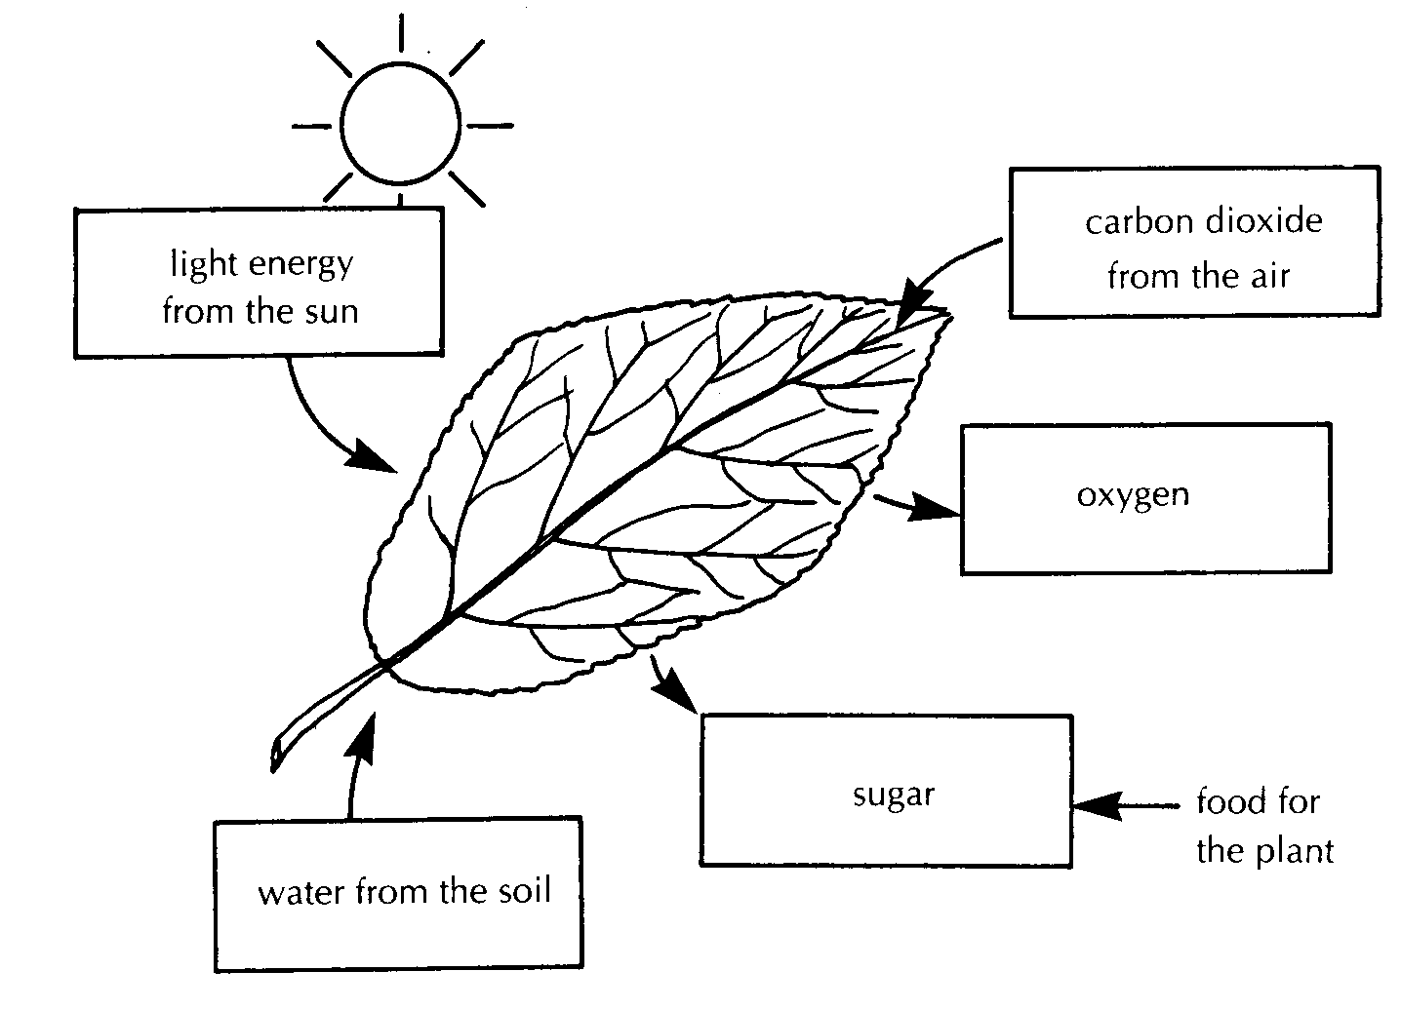

**Z**

**Y**

**X**

1. Some labels have been left off the diagram. Complete the diagram by labelling boxes **X, Y,** and **Z.**

A variegated leaf, part white and part green was tested for starch after the plant it was growing on had been left in the sun for several hours. It was found that only part of the leaf had starch in it.

**Green**

**White**

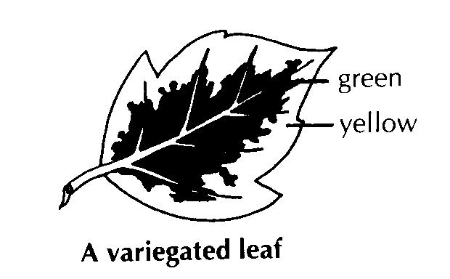

1. In which part of the leaf would you expect to find starch.
2. Explain why you would expect to find starch in this part of the leaf.

**Question Three:** Transpiration

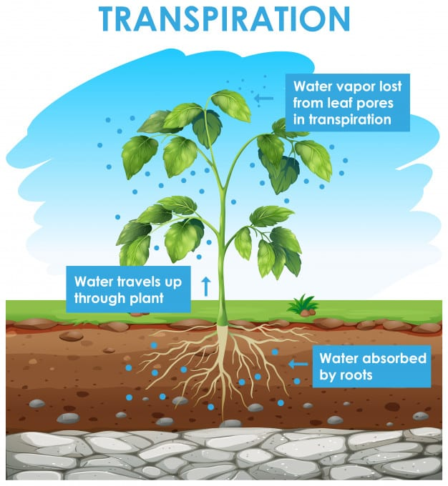

Plants transpire through their leaves.

1. Name the water carrying vessels in a plant
2. Describe why transpiration is important.
3. Explain why transpiration is usually higher in summer than in winter.

**Question Four:** Flowers

1. Use the words in the box to name the parts of the flower 1-8.

Anther, Filament, Petal, Ovary, Stem, Sepal, Stigma, Style

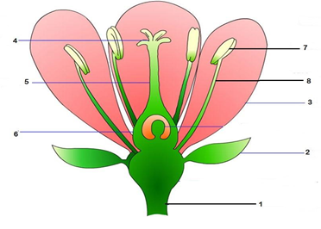

1. Using the words in the box above match the flower part to the function

|  |  |
| --- | --- |
| Flower Part |  |
|  | Usually brightly coloured to attract pollinators |
|  | Protects the flower bud |
|  | Male sex organ that contains the pollen |
|  | Holds the flower up to attract pollinators |
|  | Holds up the stigma to pollinators and the pollen tube grows down it |
|  | Sticky so that the pollen sticks to it |
|  | Holds the anther up to pollinators |
|  | Contains the ovules and becomes the fruit after fertilisation |

1. Explain why a plant has flowers?
2. Describe **two** differences between wind and insect pollinated flowers.
3. Discuss the difference between pollination and fertilisation.
4. Discuss the difference between cross-pollination and self-pollination.

**Question Five:** Plant parts

1. Label the plant parts 1-12
2. Describe the function of parts 5 and 10 on the diagram.

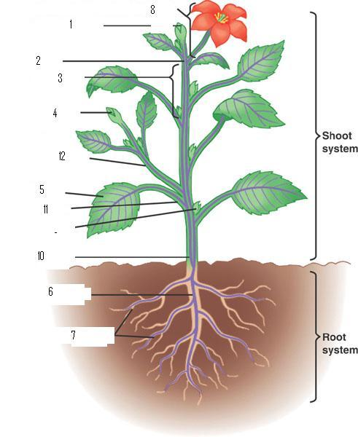

9

(c) The root hairs of a plant:

a. Anchor it in the ground

b. Reduce infection by organisms such as fungal bacteria

c. Provide a large surface area for the uptake of water

d. Help the plant to absorb food from the soil.

1. Flowering plants that flower, seed and die within 2 years are known as:
2. annuals
3. biennials
4. perennials
5. centennials

**Answers**

**Question One:** Plant Parts

1. Name the plant parts **A-D**

A: leaf

B: node/bud

C: stem

D: roots

(b) Match the correct function with the parts **A-D**.

A: photosynthesis

B; growth

C: transport

D: absorption

**Question Two**: Photosynthesis

1. Some labels have been left off the diagram. Complete the diagram by labelling boxes **X, Y,** and **Z.**

X: H2O

Y: O2

Z: CO2

1. In which part of the leaf would you expect to find starch.

Answer- Green

1. Explain why you would expect to find starch in this part of the leaf.

Answer- Chlorophyll is green and traps sunlight for photosynthesis while the white part of the leaf has no chlorophyll, so no photosynthesis takes place

**Question Three:** Transpiration

1. Name the water carrying vessels in a plant

Answer- xylem

1. Describe why transpiration is important.

Answer-

Keeps plant cool

Keeps plant absorbing water

1. Explain why transpiration is usually higher in summer than in winter

Answer- Hot dry summer conditions increase loss of water from leaves. In cooler conditions less water is lost

**Question Four:** Flowers

1. & (b)

|  |  |  |
| --- | --- | --- |
|  | Flower Part |  |
| 1 | Stem | Holds the flower up to attract pollinators |
| 2 | Sepal | Protects the flower bud |
| 3 | Petal | Usually brightly coloured to attract pollinators |
| 4 | Stigma | Sticky so that the pollen sticks to it |
| 5 | Style | Holds up the stigma to pollinators and the pollen tube grows down it |
| 6 | ovary | Contains the ovules and becomes the fruit after fertilisation |
| 7 | Filament | Holds the anther up to pollinators |
| 8 | Anther | Male sex organ that contains the pollen |

1. Explain why a plant has flowers?

Answer- Plant have flowers for sexual reproduction

1. Describe **two** differences between wind and insect pollinated flowers.

Answer includes-

* Wind pollinated plants have small insignificant flowers compared to insect pollinated plant which have bright often scented large flowers
* Insect pollinated flower are often scented
* Insect pollinated flower have large sticky rough pollen whereas wind pollinated flowers have light smooth pollen

1. Discuss the difference between pollination and fertilisation.

Answer-

Pollination is the transfer of pollen from the anther to the stigma

Fertilisation is the fusion of the male cell with the ovum/egg in the ovary. This results in the embryo forming inside a seed.

1. Discuss the difference between cross-pollination and self-pollination.

Answer

* Self pollination- Pollen from the anther of a flower fertilises the ovule of the *same* flower or another flower on the *same* plant.
* Cross pollination- Pollen from the anther of a flower on one plant fertilises the ovule of a flower on a *different* plant of the same species.

**Question Five:** Plant parts

|  |  |
| --- | --- |
| 1 | Terminal bud |
| 2 | Node |
| 3 | Internode |
| 4 | Leaf bud |
| 5 | leaf |
| 6 | Primary root |
| 7 | Secondary root |
| 8 | Flower |
| 9 | Leaf axil/Axillary bud. |
| 10 | stem |
| 11 | Petiole |
| 12 | Lateral shoot |

1. Describe the function of parts 5 and 10 on the diagram.

Answers

Leaf- traps light for photosynthesis

Stem,

* Holds the plant up to get light
* Transports water, nutrients and sugars around the plant.

(c) C

(d) B