**Questions with Answers for junior tests**

**Topics**

* Animal Digestion
* Beef Farming
* Dairy Farming
* Pasture
* Pig farming
* **Primary Industry**
* Plant Production
* Plant Propagation
* Plant Structure
* Plant propagation
* Sheep Farming
* Soil Science

If you are planning an assessment for your junior classes here are some questions you can select from and adapt to develop an assessment to suit your class. Most questions a scaffolded with easy simple questions to ones that require more thought and detailed answers.

What you need to do?

* Select relevant questions.
* Add lines or develop an answer sheet so the test can be used multiple times
* Allocate marks

The answers are provided for each question.

Note: there may also be other answers to these questions.

**Primary Industry Questions and Answers**

**Questions**

**Question One:** Location of Primary Production Systems

The **maps** below show the distribution of different primary production systems in New Zealand.

**A B C D**

1. Describe **three** factors that influence where primary production systems are found in New Zealand.
2. Map **A** shows the areas of extensive pastoralism. Describe the topography of an extensive pastoral farm.
3. The map **C** above shows the main mixed farming area in the Canterbury Plains. Describe what mixed farming is.
4. The distribution of the intensive horticultural systems is shown on map **D**. Explain what intensive means?
5. Map **B** above shows regions of intensive dairy farming in New Zealand. Explain why dairy farming is found in these areas.
6. Discuss why primary production is important to the New Zealand economy

**Question Two:** Terminology

Match the words with correct meaning

Topography, Fertile, Arable, Temperate, Pastoral, Extensive, Prevailing,

Precipitation, Mixed Farming, Horticulture,

|  |  |
| --- | --- |
| 1 | the farming of animals, based on grass consumption. |
| 2 | growing crops. |
| 3 | covering a large area with few stock per hectare. |
| 4 | the direction from which the wind comes. |
| 5 | the shape of the earth's surface. |
| 6 | the intensive farming of crops and stock (animals) on the one farm. |
| 7 | water being deposited on the earth's surface as a solid (e.g. ice, snow) or a liquid (rain). |
| 8 | the farming of fruit, flowers, or vegetables. |
| 9 | a term used to describe the moderate climate found at mid-latitude locations which usually do not experience extremes of temperature. |
| 10 | soil that is rich in nutrients allowing healthy plant growth. |

**Question Three:** Growing Pipfruit

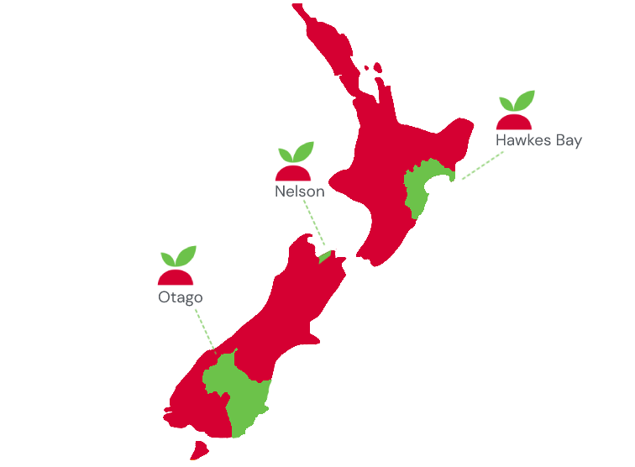

Pipfruit such as apples and pears are grown in several locations in New Zealand.

(a) Describe three reasons why these locations are suited to growing pipfruit.

**Question Four:** Primary Industry Businesses

Primary industry businesses use inputs to make other products.

Name a primary industry business, you have studied.

For this primary industry business

1. Name 2 inputs they use.
2. Name 2 outputs produced.
3. Name 2 management practices the producer carries out to produce an output.

**Question Five**: Primary production systems.

Forestry is a type of primary production in NZ.

1. Name 3 other types of primary production systems.
2. For one of the primary production systems, you have named. Describe three factors that affect the location of the primary production system.

**Answers**

**Question One:** Location of Primary Production Systems

1. Describe **three** factors that influence where primary production systems are found in New Zealand.

Answers include

* Topography- the slope of the land influences the production system. Flat land can be use for horticulture and dairy farming while hill country is suited to sheep and beef farming.
* Location to markets- perishable products such as fresh vegetables need to be close to markets to ensure they are fresh at the market. Products that can be stored can be grown further away from markets
* Soils type and fertility will influence what can be grown. Horticulture needs soils that can fertile with good drainage.
* Temperature/rainfall/climate. Climatic conditions influence pasture and crop growth therefore it is important to match the crop being grown with the climatic conditions.

1. Map **A** shows the areas of extensive pastoralism. Describe the topography of an extensive pastoral farm.

Answer- The land is predominately steep and mountainous although there will be rolling hill country and flat land.

1. The map **C** above shows the main mixed farming area in the Canterbury Plains. Describe what mixed farming is.

Answer: Where crops are grown as well as animals/ a mixture of cropping and farming.

1. The distribution of the intensive horticultural systems is shown on map **D**. Explain what intensive means?

Answer- Small er blocks of flat to rolling land with high inputs and produce a high quantity of valuable outputs

1. Map **B** above shows regions of intensive dairy farming in New Zealand. Explain why dairy farming is found in these areas.

Answers include-

* The ground is flat to rolling and fertile
* Warm temperatures and regular rainfall which are important for growing grass

1. Discuss why primary production is important to the New Zealand economy

Answer: Primary production is the main source of export earnings for New Zealand which is important for the economy, employment and rural communities.

**Question Two:** Terminology

|  |  |
| --- | --- |
| Pastoral | the farming of animals, based on grass consumption. |
| Arable | growing crops. |
| Extensive | covering a large area with few stock per hectare. |
| Prevailing | the direction from which the wind comes. |
| Topography | the shape of the earth's surface. |
| Mixed Farming | the intensive farming of crops and stock (animals) on the one farm. |
| Precipitation | water being deposited on the earth's surface as a solid (e.g. ice, snow) or a liquid (rain). |
| Horticulture | the farming of fruit, flowers, or vegetables. |
| Temperate | a term used to describe the moderate climate found at mid-latitude locations which usually do not experience extremes of temperature. |
| Fertile | soil that is rich in nutrients allowing healthy plant growth. |

**Question Three:** Growing Pipfruit

Pipfruit such as apples and pears are grown in several locations in New Zealand.

1. Describe three reasons why these locations are suited to growing pipfruit.

Answers include-

* The ground is flat to slightly rolling important for
  + the fencing structures to support the apple trees.
  + Safe use of mowing, spraying and harvesting machinery
  + Easier to prick fruit.
* Climate has cold winters and long dry summers. The cold winters stimulate even bud burst and the long dry summers are important for fruit ripening.
* Access to water- Pipfruit need a good water supply to get good fruit sizes.
* Close to urban centres for a reliable permanent and casual labour force.

**Question Four:** Primary Industry Businesses

Student answers will vary depending on the primary production business.

1. Name 2 inputs they use.

Inputs could include: Fertiliser, irrigation, chemical, equipment, fencing materials etc

1. Name 2 outputs produced.

Outputs could include, prime or store stock, milk, grain, booby calves, velvet, apples, squash etc

1. Name 2 management practices the producer carries out to produce an output.

Management practices could include, drenching, vaccinating, spraying, AI , adding lime/fertiliser, irrigation etc

**Question Five**: Primary production systems.

Student answers will vary depending

1. Name 3 other types of primary production systems.

Answer could include; market gardening, arable, horticulture, dairy farming, sheep and beef, aquaculture

1. For one of the primary production systems, you have named. Describe three factors that affect the location of the primary production system.

Answer could include; Topography, climatic conditions, ( temperature, rainfall, sunshine hours) location to market, access to labour,