**Questions with Answers for junior tests**

**Topics**

* Animal Digestion
* Beef Farming
* Dairy Farming
* Pasture
* Pig farming
* Primary Industry
* Plant Production
* Plant Propagation
* Plant Structure
* Plant propagation
* **Sheep Farming**
* Soil Science

If you are planning an assessment for your junior classes here are some questions you can select from and adapt to develop an assessment to suit your class. Most questions a scaffolded with easy simple questions to ones that require more thought and detailed answers.

What you need to do?

* Select relevant questions.
* Add lines or develop an answer sheet so the test can be used multiple times
* Allocate marks

The answers are provided for each question.

**Note:** there may also be other answers to these questions.

**Sheep Farming Questions**

**Question One:** Calculating lambing and survival percentages for a sheep farmer.

A sheep farmer puts rams out with 1200 ewes. The farmer wants to find out the lambing percentage of these ewes.

Use the information provided by the farmer to answer the questions below.

* 5 ewes die before they are scanned.
* 25 dry ewes at scanning and are culled,
* 20 ewes die during lambing, no lambs survive
* 1850 lambs born
* 1950 lambs seen inside ewes at scanning
* 1704 lambs docked
* 1680 lambs alive at weaning

1. How many ewes have lambs?
2. Calculate the lambing percentage
3. At scanning,1950 lambs were seen inside ewes. Calculate the lambing percentage at scanning.
4. If 1704 lambs were docked, calculate the number of lambs that die before docking and the survival rate at docking.
5. If 1680 lambs are weaned, calculate the number of lambs that die before weaning and the survival rate at weaning.

**Question Two:** Scanning ewes

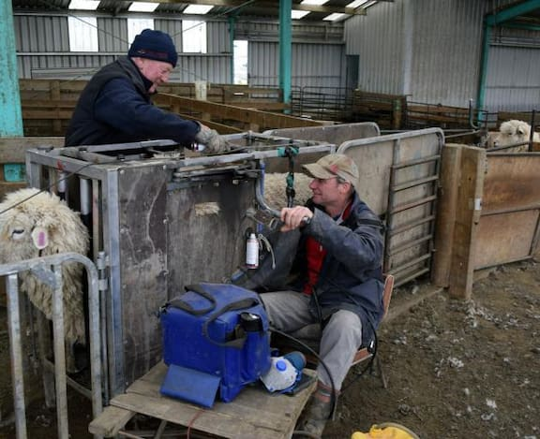

1. What information does a farmer get from scanning ewes?
2. How would a farmer use this information to increase profit?

**Question Three: Drenching**

Drenching sheep is an important management practice on sheep farms and must be done correctly and safely.

1. What is drenching?

1. Explain why drenching lambs is important?
2. Describe how to drench lambs.
3. Drench resistance is a concern for many farmers. What is meant by drench resistance?
4. What can farmers do to minimise the risk of drench resistance?

**Question Four: Seasonal Calendar**

Sheep farming follows a seasonal pattern.

1. Write the management practices in the box below in the correct place on the seasonal planner.

Lambing, Tupping, Weaning, Shearing, Docking, Flushing, Scanning, Dipping

**Winter**

**June- Aug**

**Spring**

**Sep-Nov**

**Autumn**

**Mar- May**

**Summer**

**Dec- Feb**

Sheep farmers flush ewes before tupping.

1. What is flushing?
2. How does flushing improve farm productivity

**Question Five: Sheep breeds**

1. Name these sheep breeds and name the main product(s) they are recognized for producing.

**B**

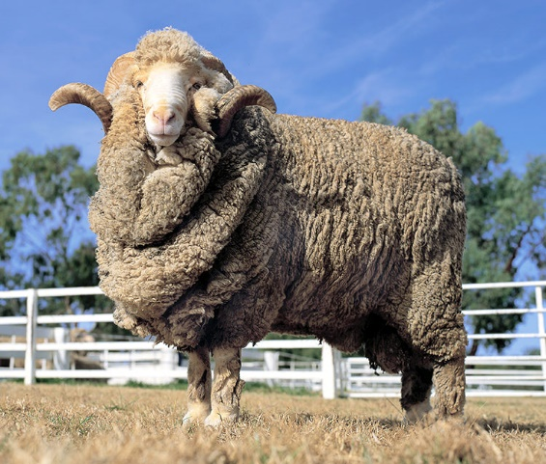

**A**

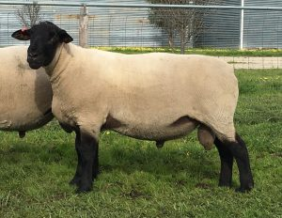

**D**

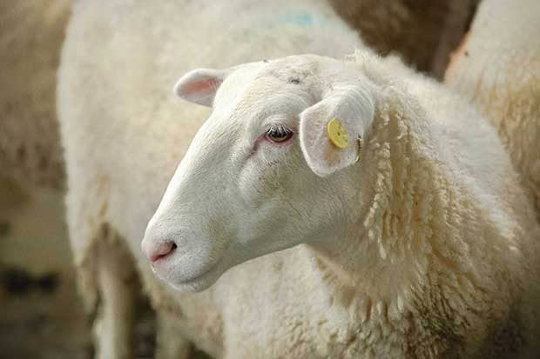

**C**

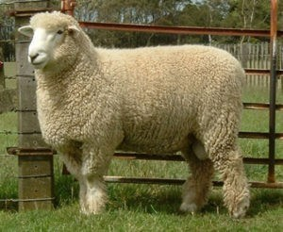

Farmers often put terminal sire over their older ewes.

1. What is a terminal sire
2. What are two reasons why a hill country farmer would use a terminal sire?
3. Explain why using a terminal sire will increase farm profit.

**Question Six: Sheep farming terminology**

Describe the meaning of the following sheep farming terms.

1. Tupping
2. Scanning
3. Micron
4. Crutching
5. Weaning
6. Drenching
7. Vaccinating
8. Flushing
9. Teaser ram
10. Wether
11. Drafting
12. Cryptorchid

**Question Seven: Flystrike**

Blowflies that cause flystrike are attracted to blood and to smell of warm wet wool which has been contaminated by dung and urine. During blowfly strike, blowfly larvae or maggots invade living tissue. In New Zealand it is usually sheep that become flystruck, but other animals can be affected. The life cycle is shown below.

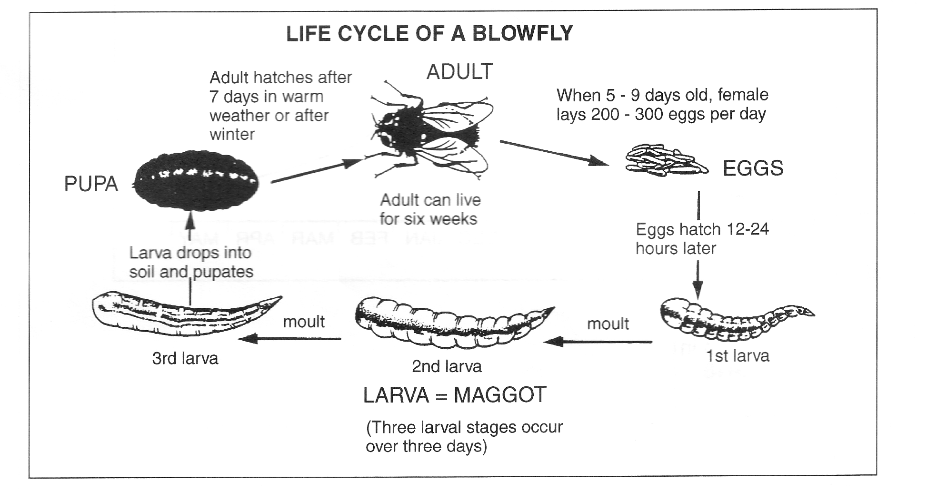

Use the above information and the diagrams to answer the following questions.

1. How long does it take for a blow fly egg to hatch?
2. How may eggs can one female lay per day?
3. Describe **two** factors that increase the risk of a sheep getting flystrike.
4. Describe what a farmer would observe about a sheep that is blowfly struck?
5. Explain how an animal disease such as blowfly strike could affect production.
6. Describe two management practices farmers can use to minimise the risk of flystrike in their sheep flock.

**Question Eight:** Sheep Diseases

For a sheep disease you have studied.

Name the disease.

1. Describe the signs and symptoms of the disease.
2. Describe how farmers can prevent the disease.
3. Discuss the impact of the disease on farm production

**Question Nine**: Selling lambs

Using your knowledge and the information in the graph above, answer the following questions:

1. What is the average carcass weight for prime lambs killed in NZ? **(not on the graph)**
2. In January, what would the price for an average weight lamb be?
3. When is the highest price/kg?
4. Explain why the price/kg for lamb is highest at this time?
5. Explain why farmers can’t sell all their lambs when the price is highest?

**Question Nine:** Grazing systems

Rotational grazing and set stocking are the two most used grazing systems by hill-country farmers.

1. Describe the differences of the two systems
2. Explain why set stocking is used at tupping and lambing times.

**Answers to sheep farming questions for junior tests**

**Note**

For some questions there may also be other answers that are correct.

**Question One:** Calculating lambing and survival percentages for a sheep farmer.

A sheep farmer puts rams out with 1200 ewes. The farmer wants to find out the lambing percentage of these ewes.

Use the information to answer the questions below.

* 5 ewes die before they are scanned.
* 25 dry ewes at scanning and are culled,
* 20 ewes die during lambing, no lambs survive
* 1850 lambs born
* 1950 lambs seen inside ewes at scanning
* 1704 lambs docked
* 1680 lambs alive at weaning

1. How many ewes have lambs?

Answer

1. - 5 ewes = 1195 Ewes

1195 - 25 culled = 1170 Ewes

1. – 20 ewes die during lambing= 1150 ewes have lambs
2. Calculate the lambing percentage:

Answer: 1704 lambs/1200 ewes x 100 = 142%

1. At scanning,1950 lambs were seen inside ewes. Calculate the lambing percentage at scanning.

Answer: 1950 lambs/1195 Ewes = 163%

1. If 1704 lambs were docked, calculate the number of lambs that die before docking and the survival rate at docking.

Answer: 1850/1704=146 lambs die before docking - 1704/1850 x 100 = 92%

1. If 1680 lambs are weaned, calculate the number of lambs that die before weaning and the survival rate at weaning.

Answer: 1850 lambs born –1680 = 170 lambs die before weaning

1680/1850 x100 = 90.8 % survival rate

**Question Two**: Scanning ewes



1. What information does a farmer get from scanning ewes?

Answers

* The number of ewes pregnant or dry
* The number of ewes are having multiple or single lambs.
* When ewes are due to lamb.

1. How would a farmer use this information to increase profit?

* Cull dry ewes so there is more feed for in-lamb ewes increasing lamb survival rates
* Draft ewes into mobs,
  + ewes having multiple lambs so they can be priority feed to ensure good birthweights increasing lamb survival
  + ewes having singles can have less feed than ewes having multiple lambs to prevent the risk of lambs getting too big causing lambing problems increasing survival rate of ewes and lambs.
  + early and late lambing ewes separated to make it easier for management practices such as docking and weaning as lambs are of a similar age. They can be feed differently to achieve growth rates for prime lamb.

**Question Three:** Drenching

Drenching sheep is an important management practice on sheep farms and must be done correctly and safely.

1. What is drenching?

Answer-liquid medicine given orally to animals to kill internal parasites

1. Explain why drenching lambs is important?

Answers. Lambs are prone to internal parasite. Drenching to kill internal parasite helps maintain lamb health and growth. The faster they grow the quicker the farmer can sell them.

1. Describe how to drench lambs.

Answer

* Weight a sample of lambs to determine the heaviest
* Set the drench gun to dose heaviest lambs
* Test the drench gun is working.
* Slide drench gun into the side of the lambs mouth, hold the head up to make sure the lamb swallows the drench.

1. Drench resistance is a concern for many farmers. What is meant by drench resistance?

Answer- Some or all of the worms/Internal parasites are not killed by the drench that would normally kill them.

1. What can farmers do to minimise the risk of drench resistance?

Answer.

* Do not under or over drench.
* Rotate difference drench groups
* Dose to the heaviest animal
* Properly calibrate the drench gun
* Avoid drenching the whole flock so some worms are left behind

**Question Four: Seasonal Calendar**

(a)

Tupping

**Winter**

**June- Aug**

**Spring**

**Sep-Nov**

**Autumn**

**Mar- May**

**Summer**

**Dec- Feb**

Lambing

Scanning

Flushing

Docking

Weaning

Main Sheer

Dipping

(b)Flushing is increasing the ewe’s nutrition 2–3 weeks before mating (tupping) to improve her body condition.

(c) Flushing increases ovulation rate which leads to more lambs per ewe, a higher lambing % so there are more lambs to sell or keep as replacements increasing farm productivity.

**Question Five: Sheep breeds**

1. Name these sheep breeds and name the main product(s) they are recognized for producing.

A Suffolk- meat

B Merino- fine wool

C Romney- dual purpose meat and wool

D East Friesian – milk

Farmers often put terminal sire over their older ewes.

Answers

1. A terminal sire is a ram bred solely for producing high-performing lambs for meat — not for breeding replacement ewes.
2. Reasons include:

* Improve lamb growth rates- lambs reach market weight earlier.
* Get lambs out of older ewes not used for keeping replacements.
* Lambs from terminal sires go straight to slaughter so not kept over dry summer.
* Reduces the pressure on hill country ewes to raise prime lamb.

1. Answers include:

* Terminal sires pass on genetics for rapid growth and muscle development, so lambs reach market weight faster and get high returns.
* Fast growth means lambs can be sold earlier, reducing feed costs per lamb.
* Selling lambs from terminal sires faster means more feed for other stock.
* Lambs can be leaner with a higher dressing out % therefore attract a higher price.
* Get lambs out of older ewes that suitable for keeping replacements from there have more lambs to sell.

**Question Six: Sheep farming terminology**

Describe the meaning of the following sheep farming terms.

1. Tupping - Mating
2. Scanning- using an ultra sound to see if a ewe is pregnant
3. Micron- fibre diameter of wool
4. Crutching- removal of dirty wool from around the tail and belly
5. Weaning- Taking the lamb off the ewe, pasture is the sole diet of the lamb
6. Drenching- Chemical given to animals to kill internal parasites
7. Vaccinating- Injection given to increase immunity against disease
8. Flushing - Extra feed fed to ewes 3 weeks prior to and during tupping
9. Teaser ram - A ram that is not fertile by vasectomy
10. Wether - Castrated male – testes removed
11. Drafting- Sorting animals into groups
12. Cryptorchid- Castrated male – testes pushed up inside body
13. Cast-for age- Ewes culled due to old age

**Question Seven: Flystrike**

Use the above information and the diagrams to answer the following questions.

1. How long does it take for a blow fly egg to hatch? (12-14 hours)
2. How may eggs can one female lay per day? (200-300 eggs/day)
3. Describe **two** factors that increase the risk of a sheep getting flystrike.

* Blood
* Wet contaminated wool
* Dung and urine contaminated wool

1. Describe what a farmer would observe about a sheep that is blowfly struck.
2. Blowfly maggots invading living tissue

* Raw skill
* Wool falling out
* Restless irritated sheep with heads down and stamping feet
* Explain how an animal disease such as blowfly strike could affect production.

1. Describe two management practices farmers can use to minimise the risk of flystrike in their sheep flock.

Answers include;

Describing

* Crutching/ Dagging
* Docking
* Shearing
* Shifting stock to winder/cooler areas
* Fly traps
* Getting rid of dead carcasses
* Drenching to prevent dags

**Question Eight:** Sheep Diseases

For a sheep disease you have studied.

Name the disease – Answers will vary depending on the disease.

**Question Nine**: Selling lambs

Using your knowledge and the information in the graph above, answer the following questions:

1. What is the average carcass weight for prime lambs killed in NZ? **(not on the graph)**

Answer- 19kg ( 17-21kg)

1. In January, what would the price for an average weight lamb be?

Answer 19kg x $5.5 =

1. When is the highest price/kg? September
2. Explain why the price/kg for lamb is highest at this time? Low supply of lambs at prime weights
3. Explain why farmers can’t sell all their lambs when the price is highest?

Student answers may vary but reasons include:

* Not all lambs reach optimal slaughter weight at the same time
* Farmer need to sell lambs when at prime weights usually when there is lots of pasture, which may not coincide with high prices.
* If there is a drought farmers need to sell lambs even as store to ensure enough feed for stock.
* Some farmers forward contract lambs at a fixed price rather than trying to chase high prices.
* Seasonal variation in pasture growth and matching feed demand may influence when farmers sell lambs which may not be when prices are highest.

**Question Nine:** Grazing systems

Rotational grazing and set stocking are the two most used grazing systems by hill-country farmers.

1. Describe the differences of the two systems.

Rotational grazing is moving large mobs of stock regularly on to fresh pasture. Set stocking is spreading stock across the farm in small numbers and not moved for a long period of time.

1. Explain why set stocking is used at tupping and lambing times.

Tupping- ensure ewes have time to find the ram

Lambing – to minimise risk of mismothering