**Questions with Answers for junior tests**

**Topics**

* Animal Digestion
* Beef Farming
* Dairy Farming
* Pasture
* Pig farming
* Primary Industry
* Plant Production
* Plant Propagation
* Plant Structure
* Plant propagation
* Sheep Farming
* **Soil Science**

If you are planning an assessment for your junior classes here are some questions you can select from and adapt to develop an assessment to suit your class. Most questions a scaffolded with easy simple questions to ones that require more thought and detailed answers.

What you need to do?

* Select relevant questions.
* Add lines or develop an answer sheet so the test can be used multiple times
* Allocate marks

The answers are provided for each question.

**Note**: there may also be other answers to these questions.

**Soil Science Questions and Answers**

**Question one: Soil science**

(a) The term soil structure refers to

**A** The size of the individual soil particles.

**B** The way the particles are grouped together

**C** The colour of the soil.

**D** The depth of the soil.

(b) The decayed plant and animal material in soil is called

1. Silt.
2. Clay.
3. Inorganic matter.
4. Organic matter.

(c) The main reason for not using soil straight from the garden in an artificial growing mix is that it

**A**. is difficult to mix thoroughly with the other ingredients

**B**. may contain weed seeds and pests.

**C**. does not provide the correct drainage.

**D.** varies in nutrient content.

Use the diagram below to answer questions (d) and (e)

(d) This diagram is used to determine soil

**A** type.

**B** contents.

**C** structure.

**D** texture.

(e) A soil that contains 20% sand, 60% silt

and 20% clay would be classed as

**A** silt loam

**B** sandy loam

**C** loam

**D** silt

**Question Two:** Soil composition

The pie diagram below outlines the composition of an ideal soil.

1. Name the parts represented by the letters A, B, C, and D and beside each state the relative percentages.

**D _______%**

**________________**

**C_______%**

**________________**

**A _______%**

**________________**

**B _______%**

**________________**

**Question Three:** Soil Air

A student put a 50 ml sample of soil into a measuring cylinder, added 50 ml of water then shook the sample for several minutes before leaving it to settle. The results are shown in the diagram.

1. Complete the diagram by labelling P, Q, R and S
2. Use the information in the diagram to calculate the volume of air in the soil. (Show your working)

**Question Four:** Soil Drainage

A student used the same amounts of dry loamy soil, dry sandy soil, and dry clay soil, to carry out the experiment shown in the diagram below.

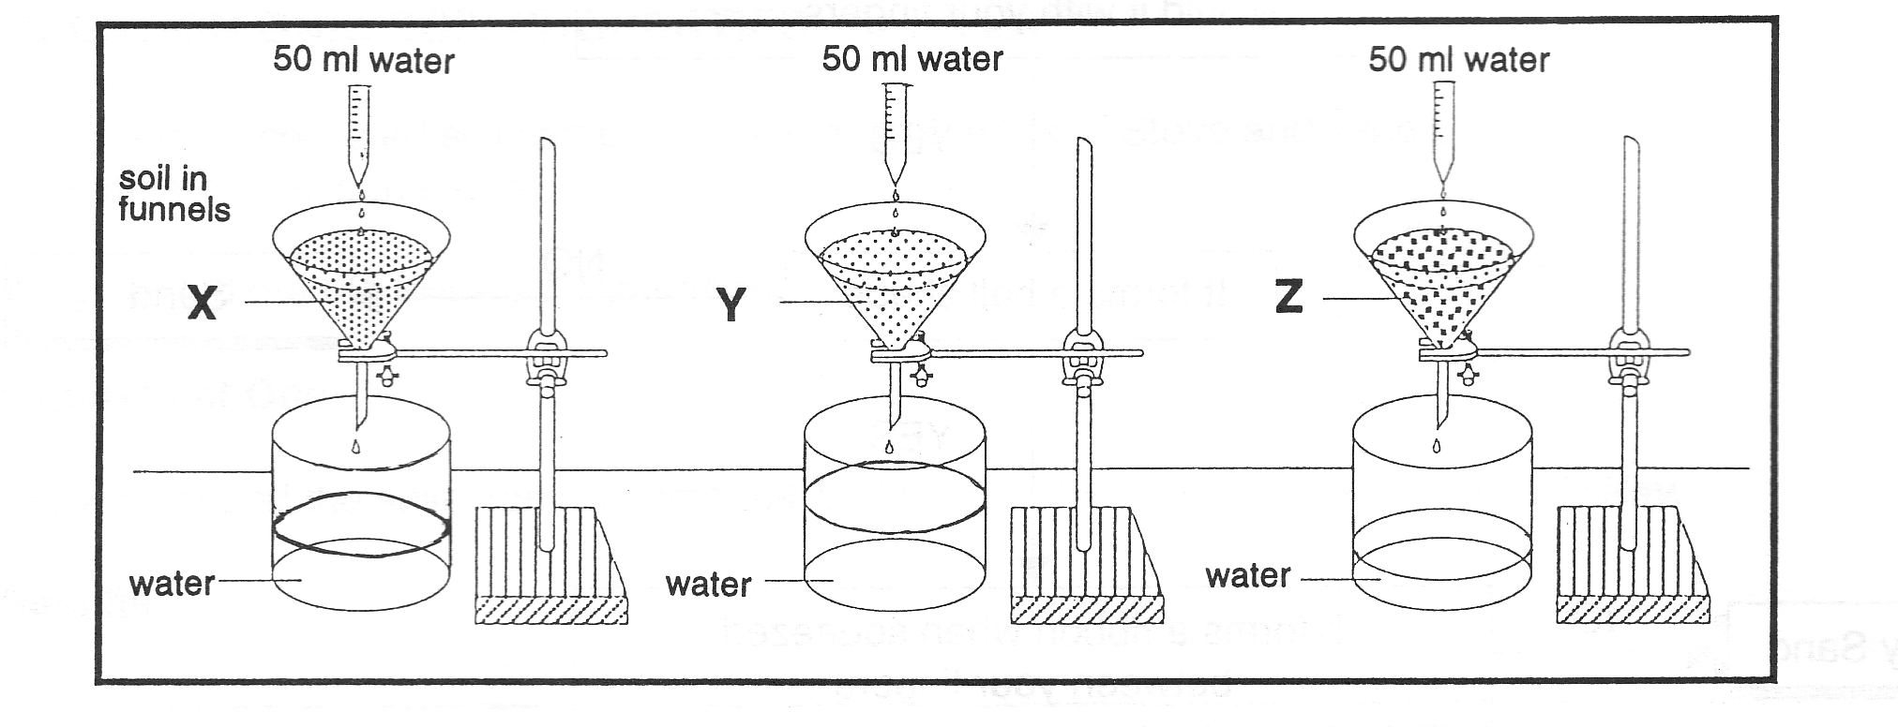

**Clay**

**soil**

**Loam**

**soil**

**Sandy**

**soil**

The results were as follows:

|  |  |  |  |
| --- | --- | --- | --- |
|  | **Loam soil** | **Sandy soil** | **Clay soil** |
| Time taken for first drop to fall | 70 sec | 12 sec | 305 sec |
| Volume of water passed through in 30 mins | 25 ml | 40 ml | 6ml |

1. Which soil drains the quickest?
2. Which soil holds the most water?
3. Explain why the time taken for the first drop of water to fall into the measuring cylinder was different for each type of soil?
4. Explain why the volume of water, which passed through each type of soil was different?

**Soil Science Answers**

**Question one:** Soil science

1. B
2. D
3. B
4. D
5. A

**Question Two:** Soil composition

(a)

A/B: 25% Air 25% Water

C: 45% inorganic matter (sand,silt, clay)

D: 5% Organic matter

**Question Three:** Soil Air

1. P: Organic matter  
   Q: clay  
   R: silt  
   S: sand
2. 100mL-80mL = 20% air

**Question Four:** Soil Drainage

1. Which soil drains the quickest?

Answer- Sandy soil

1. Which soil holds the most water?

Answer- Clay soil

1. Explain why the time taken for the first drop of water to fall into the measuring cylinder was different for each type of soil?

Answer

* Soils have different sized pore spaces
* Clay has smaller pore spaces than sand and loam so it takes longer for water to drain/ move through the soil

1. Explain why the volume of water, which passed through each type of soil was different?

Answer includes

* Soils have different sized pore spaces and some can hold more water
* Clay soils have hold water so drain/ less water through. Sand has bigger pore spaces so drains the quickest
* Clay soils have the ability to absorb and hold water so drain/ less water through. Sand has bigger p[ore spaces and does not absorb water so drains the quickest.
* Loam has more and bigger pores spaces than clay and will hold less water so drains more than clay but less than sand.