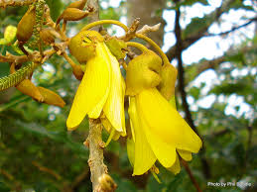

Dormancy Breaking Dormancy Investigation

Kowhai Seeds

- Remove Kōwhai seeds from the pod
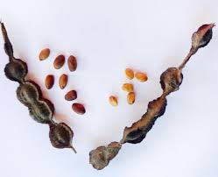
- Label 3 punnets

Punnet 1 Chip seeds
2 Soak seeds
3 No treatment

Aim: To find out the best way to break the dormancy of Kowhai seeds.

Method
1 Each group Chip 12 seeds
Soak 12 in hot water 1 hour
12 seeds no treatment

2 Sow all seeds (spaced evenly) into punnets and cover with seed raising mix.

3 For each treatment record the number of seeds that germinate each day.

Results table

Number of seeds germinated each day | Treatment
Number of seeds germinated each day | Chipping | Soaking | No treatment
1
2
3
4
5
6
6
8
etc

Conclusion

