Graphing Exercise

A group of students had a lot of trouble getting peach seeds to germinate. The students ran the following experiment:
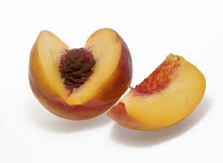
Seed collected from windfall peaches was stratified in a moist peat/pumice mix at 5ºC for varying times. All treatments were removed from cold storage at the beginning of Term 3 and sown in outside beds. The numbers germinated at 10-day intervals were counted.
The following results were recorded:

 | Treatment* | Days to Germinate
 |  | 0 | 10 | 20 | 30 | 40 | 50 | 60
Total Number Germinated (%) | A | 0 | 3 | 37 | 60 | 68 | 70 | 71
Total Number Germinated (%) | B | 0 | 2 | 37 | 43 | 46 | 50 | 48
Total Number Germinated (%) | C | 0 | 0 | 0 | 0 | 2 | 9 | 10

*Treatment
A = 100 day stratified
B = 120 day stratified
C = 40 day stratified
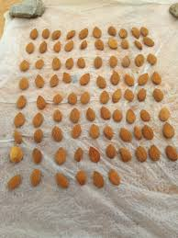
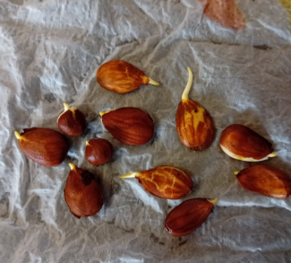

(a). Plot the data onto the grid. Plot THREE lines connecting the points, one for each
treatment.

90
80
70
60
50
Germination %
40
30
20
10
0
0
10
20
30
40
50
60

Days to Germinate

- From your graph, how many seeds of TREATMENT A have germinated after 25 days?
- 1. Suggest a reason for the poor result of TREATMENT C.
2. Why is this requirement of germination of peach seeds an advantage in nature?
- Describe another way dormancy in seeds can be broken other than stratification (cold treatment).
- What THREE conditions are necessary before a seed will germinate successfully?

