**Level 3: Future Proofing Strategies**

**Environmental Strategies Worksheet**

**Teacher Note:**

This worksheet provides an examples of future proofing strategies to mitigate the impacts of an extreme weather event.

This article *“****Northland Growers Rebuild After Cyclone Gabrielle*”** is a shorten version of three articles combined together.

* [**Bumper harvest brings relief for Kaipara kūmara growers**](https://www.rnz.co.nz/news/country/516054/bumper-harvest-brings-relief-for-kaipara-kumara-growers)
* [**Cyclone-hit kūmara growers grateful for support**](https://www.anz.com.au/newsroom/new-zealand/2024/05/james-krista-franklin-dargaville-kumara-cyclone-gabrielle/) **- video shows impact of floods**
* [**Kūmara prices tipped to drop as supply improves**](https://www.rnz.co.nz/news/business/510624/kumara-prices-tipped-to-drop-as-supply-improves)

**Discussion questions** - Stimulate discussion and understanding of the lessons learnt from the extreme weather event and strategies used to minimise the impact of the event.

**Future Proofing Strategy Questions:**

The level 2 **“*Bumper harvest brings relief to Kaipara kūmara growers*”** can be used **as prior learning** for this worksheet

**Northland Growers Rebuild After Cyclone Gabrielle**

One year ago, the future looked grim for New Zealand’s beloved kūmara. Cyclone Gabrielle turned much of Kaipara, where 95% of the nation’s kūmara is grown into an inland sea. Fields were flooded, crops rotted, homes were damaged, and livelihoods were thrown into chaos.

Dargaville grower Doug Nilsson, of Dunsmore Gardens, lost 99% of his 2023 crop. “Cyclone Gabrielle was just the last straw after a record wet winter and a tough planting season,” he recalled. Housing for his workers was also submerged, and insurance delays added to the hardship. But one year later, his story has flipped.

In 2024, Nilsson filled 2,900 bins, 100 times more than the year before. While not his highest yield, he said the harvest conditions were the best in two decades. “The shed’s full of good quality kūmara again,” he said. “It’s probably the best harvest I’ve had in 20 years.”

To survive the fallout from Gabrielle, Nilsson made several key decisions. He switched temporarily to courgettes to keep his workers employed and income flowing. He maintained strong ties with overseas RSE workers from Vanuatu, many of whom returned in 2024 despite being evacuated the year before. Nilsson borrowed heavily to get back on his feet but acknowledged it could take up to 10 years to recover financially.

Another Kaipara couple, James and Krista Franklin, also saw their crop devastated when the Kaihu River burst its banks. They lost 84% of their kūmara, just days before harvest.

“We seriously considered giving up,” Krista said. “But we decided we’d kick ourselves if we didn’t try again.” Their house was saved thanks to being built on piles, highlighting the value of elevated infrastructure in flood-prone areas. The Franklins also focused on mental health resilience, getting off the farm, talking with other growers, and attending support events. Rural Support Trust Northland played a critical role in helping growers stay afloat. After Gabrielle:

* They ran over 100 community events, reaching 5,500 people.
* Sent care packages (including $1,000 Countdown vouchers) to 960 farms.
* Increased one-on-one support clients from 45 to 145.
* Facilitated cleanup efforts on 135 farms.

Funding from MPI and companies like ANZ ($100,000) supported this work. The trust also trained industry professionals to identify signs of mental distress and support farmers more effectively.

Kaipara Kūmara managing director Anthony Blundell said the 2024 season marked a strong comeback. While yields are slightly down, quality is high, and processing is back to normal. “It’s the complete opposite of 2023,” he said.

In 2023, kūmara prices skyrocketed to $14/kg due to the 60–70% crop loss. This year, red kūmara is down to $7/kg, and orange and gold varieties are expected to drop soon. Foodstuffs said improved supply means more consistent sizing and availability.

Even with the recovery, Nilsson remains cautious. “We’ve had to borrow heavily just to get a crop in the ground. It could take five to ten years to repay that. But I’m optimistic, we’ve got sheds full of kūmara again.”

For growers like Nilsson and the Franklins, the return of a healthy kūmara harvest is more than a financial relief. it’s a cultural one too. “Kūmara is part of our history,” Nilsson said. “If there’s meat and veggies on your plate without kūmara, it’s not finished.”

***Adapted from***

[**Bumper harvest brings relief for Kaipara kūmara growers**](https://www.rnz.co.nz/news/country/516054/bumper-harvest-brings-relief-for-kaipara-kumara-growers)

[**Cyclone-hit kūmara growers grateful for support**](https://www.anz.com.au/newsroom/new-zealand/2024/05/james-krista-franklin-dargaville-kumara-cyclone-gabrielle/)**- video**

[**Kūmara prices tipped to drop as supply improves**](https://www.rnz.co.nz/news/business/510624/kumara-prices-tipped-to-drop-as-supply-improves)

**Level 3 Environmental Strategies Worksheet**

**Discussion questions**

1. What lessons do you think kūmara growers might learn from the 2023 disaster?
2. What strategies could help future-proof kūmara growing against extreme weather events?
3. How did Nilsson try to keep his business going when he had no kūmara to sell?
4. Why is it important to have strong community support during hard times for primary producers like kūmara growers impacted by an extreme event.

**Answers**

1. What lessons do you think kūmara growers might learn from the 2023 disaster?

Growers may have learned the importance of being prepared for extreme weather, having backup plans, and not relying too much on one crop. They also saw how climate change can seriously affect a crop and how important it is to be financially and emotionally resilient.

1. What strategies could help future-proof kūmara growing against extreme weather events?

* Improving drainage systems to handle heavy rain.
* Building flood-resistant housing for workers.
* Growing other crops as a backup income.
* Using insurance wisely and speeding up payouts.
* Possibly looking at new locations less prone to flooding.
* Investing in better weather monitoring and planning tools.

1. How did Nilsson try to keep his business going when he had no kūmara to sell?

Nilsson started growing courgettes instead, so he could still have a product to sell and keep paying his staff. This helped keep his workers employed and his business running during a very difficult year.

1. Why is it important to have strong community support during hard times for primary producers like kūmara growers impacted by an extreme event.

Because primary production businesses such as kūmara growers affect more than just the grower, it impacts workers, local businesses, transport companies, and shops. When the community supports the grower by buying their produce or offering help, it keeps the local economy alive and helps everyone recover faster.

**Future Proofing Strategy** **Questions**

The kūmara growers used the future proofing strategies below to help their businesses to survive the impacts of cyclone Gabrielle.

* Crop diversification
* Investing in elevated or flood-resilient infrastructure.
* Leveraging seasonal worker schemes and maintaining strong labour relations.
* Mental health and community support participation.
* Financial risk-taking paired with long-term recovery planning.

1. Describe how each of the strategies above, helped a kūmara business to survive and will remain viable in the long term?
2. Describe another strategy, a kūmara grower could use to ensure their business remain viable long term?

**Answers**

1. Describe how each of the strategies above, helped a kūmara business to survive and will remain viable in the long term?

* Crop Diversification.  
  After Cyclone Gabrielle wiped out nearly 99% of his kūmara crop, grower Doug Nilsson switched temporarily to courgettes. This allowed him to keep his staff employed and generate some income while kūmara crops were unviable.  
  Crop diversification reduces reliance on a single crop, lowering the risk of total business failure in the event of a disaster. It builds financial resilience and allows flexibility in responding to climate or market shocks.
* Investing in Elevated or Flood-Resilient Infrastructure.  
  Growers James and Krista Franklin avoided losing their home during the floods because it was built on elevated piles, keeping it above the water level even though the surrounding fields were completely underwater.  
  Elevated buildings and flood-resilient infrastructure protect vital assets such as housing and equipment from damage. This means growers can recover and resume operations more quickly after extreme weather events, minimising long-term disruption and financial loss.
* Leveraging Seasonal Worker Schemes and Maintaining Strong Labour Relations.  
  Nilsson relied on a 50-50 mix of local and Recognised Seasonal Employer (RSE) scheme workers from Vanuatu. Despite the previous year’s hardship, many overseas workers returned in 2024, due to strong relationships built over time.  
  A dependable workforce ensures that crops are planted, harvested, and processed efficiently. Strong labour relations also mean workers are more likely to return, even after crises, maintaining continuity in operations and reducing retraining or recruitment costs.
* Mental Health and Community Support Participation.  
  The Franklins leaned on the Rural Support Trust Northland and the Northern Wairoa Vegetable Growers Association, attending social events and networking opportunities that helped them stay mentally strong and informed during recovery. Krista noted how important it was “just to have someone to talk to.”  
  Farming can be isolating, especially after a disaster. Support networks help growers manage stress, reduce burnout, and stay connected to advice, financial assistance, and shared experiences. Strong mental health leads to better decision-making and more sustainable long-term farming.
* Financial Risk-Taking Paired with Long-Term Recovery Planning.  
  Nilsson acknowledged that he had to borrow heavily to put a crop in the ground in 2024. After two years of financial losses, this was a calculated risk to stay in business. He knows it will take 5 to 10 years to fully recover, but the successful 2024 harvest means he’s on the right track.  
  Strategic financial risk-taking allows businesses to recover when other sources of income or support are limited. Coupled with a clear long-term recovery plan, it ensures that short-term setbacks don’t lead to permanent closures. Growers who plan for multi-year financial recovery can survive volatile climate impacts and market shifts.

**Top of Form**

1. Describe another strategy a kūmara grower could use to ensure their business remain viable long term.

Examples are:

* Advanced water management systems: A kūmara grower could invest in advanced water management systems, including drainage and flood diversion infrastructure. These systems would help control the movement of water on the farm, protect soil structure, and reduce the impact of flooding. As climate change brings more extreme weather patterns, such as intense rainfall, better water management will become more important. By reducing flood damage, the grower can minimise crop loss and protect their harvest and income stream. Controlled water flow also prevents soil erosion, preserving the long-term productivity of the land. This ensures that growers can continue producing high-yielding kūmara crops year after year, maintaining the revenue needed to cover operating costs and keep the business financially viable. Farms with proactive flood protection may be seen as lower risk by insurers, potentially leading to faster claims and lower premiums in the future. This provides further financial stability and resilience supporting the viability of the business.
* Install sub-surface drainage systems (e.g., tile drains) to improve water runoff in heavy soils like Kaipara’s clay-rich land.
* Develop a flood emergency plan that includes protecting machinery, pre-harvest decisions, and safe evacuation of staff.

**Bottom of Form**

Article 1 **Bumper harvest brings relief for Kaipara kūmara growers**

6:07 am on 6 May 2024

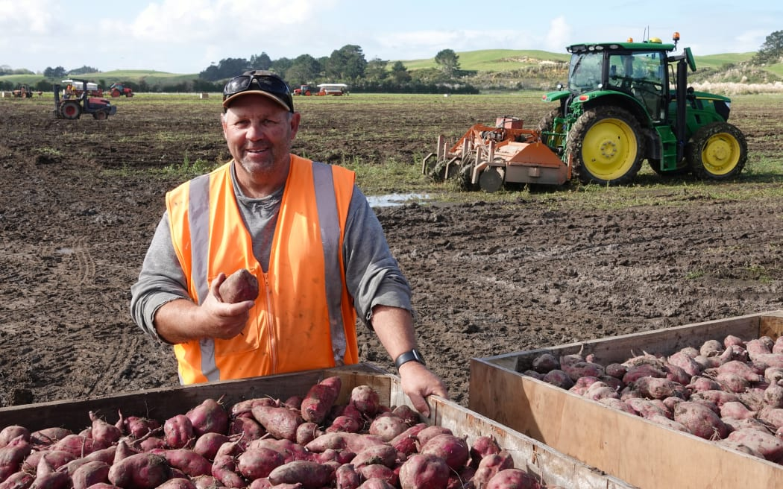https://www.rnz.co.nz/news/country/516054/bumper-harvest-brings-relief-for-kaipara-kūmara-growers

[**Peter de Graaf**](https://www.rnz.co.nz/authors/peter-de-graaf), Northland reporter

One year ago, the future for New Zealand's favourite root vegetable looked bleak.

After a dismal spring and summer, [Cyclone Gabrielle](https://www.rnz.co.nz/news/national/484338/devastation-revealed-gabrielle-in-pictures) turned large swathes of the Kaipara - where virtually all New Zealand's kūmara are grown - into a vast inland sea, causing the harvest-ready crop to rot in the ground.

Dargaville kumara grower Doug Nilsson checks the seed kumara that will form the basis of next year's crop. Photo: Peter de Graaf.

Grower Doug Nilsson, of Dunsmore Gardens on the outskirts of Dargaville, lost 99 percent of his crop, managing to salvage and sell fewer than 30 bins of kūmara.

But the 2024 season has been very different. Last week, Nilsson filled the last of 2900 bins, each containing about 750kg of kūmara - 100 times more than the year before.

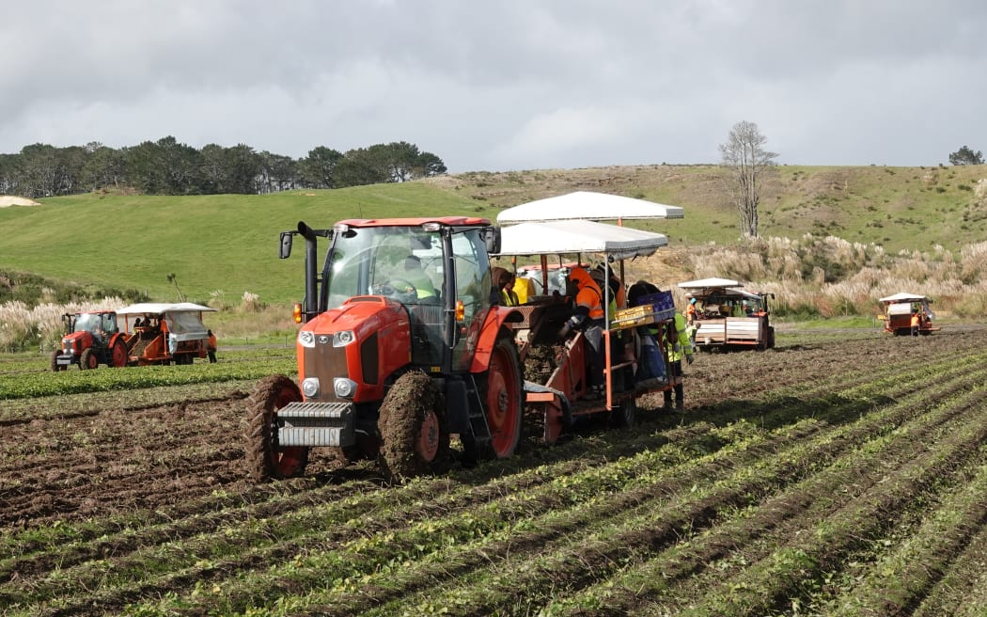While the yield was not his biggest ever, harvest conditions were the best he had experienced in 20 years.

"Last season was a shocker. Cyclone Gabrielle was just the last straw in a bad growing year. It came off the back of a record wet winter, a really wet difficult planting season, in which most growers, us included, were lucky to get 60 percent of their normal crop planted. And then a wet summer, Cyclone Hale and Cyclone Gabrielle," Nilsson said.

Harvesting crews gather the last of Doug Nilsson's 2024 crop at his farm on the outskirts of Dargaville. Photo: Peter de Graaf

It was not just his crop that was affected - housing for his workers was also submerged.

"The accommodation had about a metre of water through it. It took until Christmas time to get the workers back into here. That's been the one bugbear, the time it takes before you can do anything, waiting for insurance. We still haven't been fully paid out."

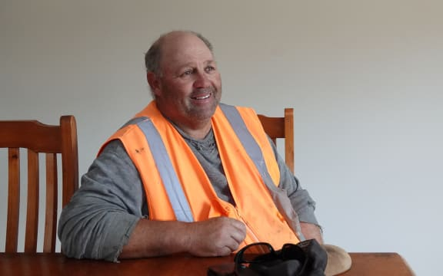The loss rippled across Northern Wairoa, where kūmara growing vied with dairy for the title of the area's biggest earner.

Dargaville kumara grower Doug Nilsson reflects on a roller-coaster couple of years. Photo: Peter de Graaf

"It affects everybody because we're at the start of the chain. If we've got no kūmara to harvest, there's no work - that corresponds to less money spent in town. It also affects our trucking firms that carry the kūmara - nothing to cart. Even our local bin builder, he had a terrible year last year because no one needed bins. It's a snowball effect."

The 2024 season, however, had been the "complete opposite".

Kaipara's Kaihu River north of Dargaville in flood during Cyclone Gabrielle in 2023. Photo: Kaipara District Council / Supplied

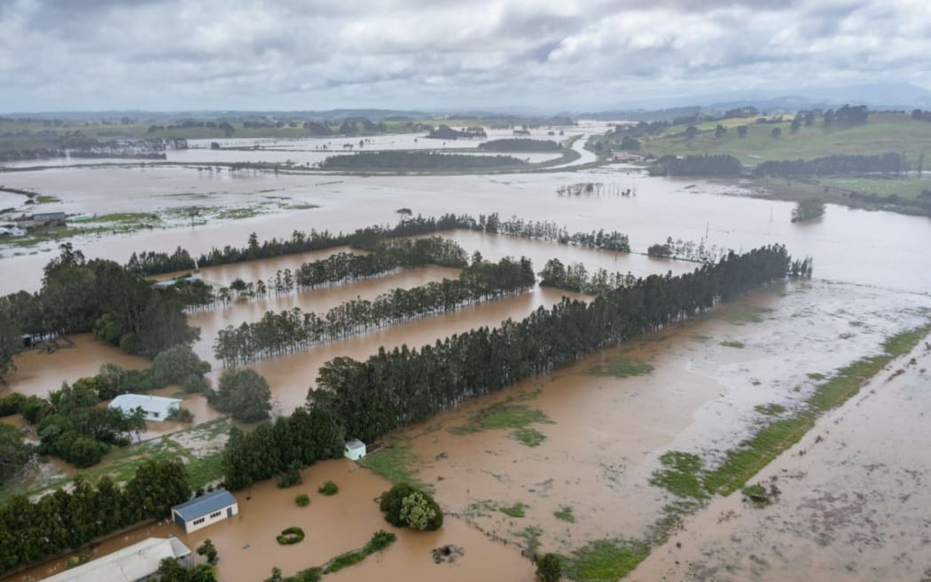"The yields are a bit lighter than average, but we've had tremendously good weather and good digging conditions for harvest. The shed's full of nice kūmara, really good quality this year. It's probably the best harvest I've had in 20 years."

Nilsson said he had also been lucky with reliable staff this year, a 50-50 mix of locals from Kaipara, Kaikohe and Whangārei, and overseas workers employed through the RSE (recognised seasonal employer) scheme.

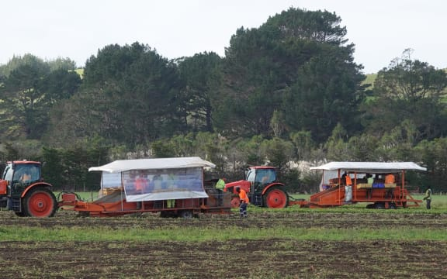

Harvesting crews gather the last of Doug Nilsson's 2024 crop at his farm on the outskirts of Dargaville. Photo: Peter de Graaf

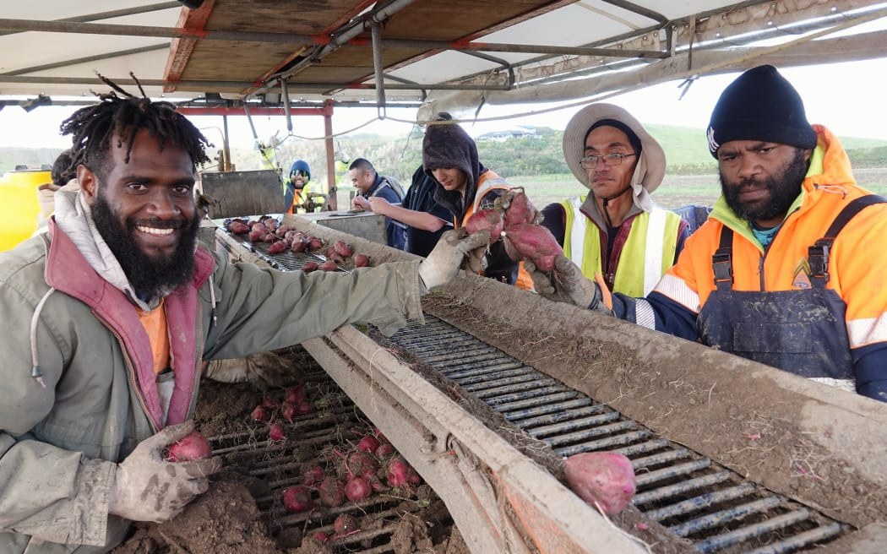Many of those sorting the kūmara pulled from the clay soil were, like Mansen Makito, from Vanuatu.

Makito was among those evacuated last year as floodwaters swamped their living quarters.

"Every part of here was flooded. It was very difficult last season, but this season was really, really, really good," he said.

Mansen Makito, left, of Vanuatu, says the 2024 kumara crop is much better than last year's. Photo: Peter de Graaf

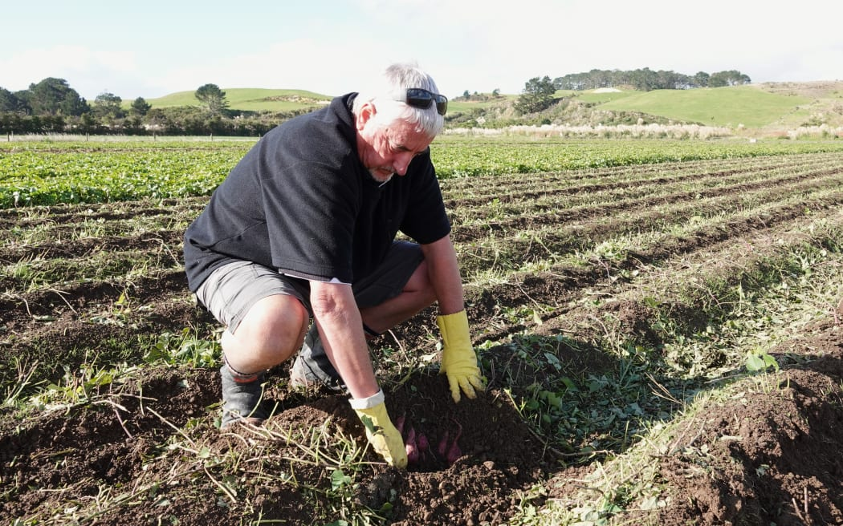Kaipara Kūmara managing director Anthony Blundell said the "once-in-a-lifetime" 250mm of rain dumped by Cyclone Gabrielle was even more than 1988's Cyclone Bola - and it came on the back of a wet spring and summer.

"So that 250mm of rain had nowhere to go but look for a place to make its way out to sea. It flowed over Doug's four or five hundred acres, which included about 200 acres of kūmara, so it wiped out the whole lot. It was up to the top of the fence posts. It was all just a lake."

Kaipara Kumara managing director Anthony Blundell checks soon-to-be-harvested kumara. Photo: Peter de Graaf.

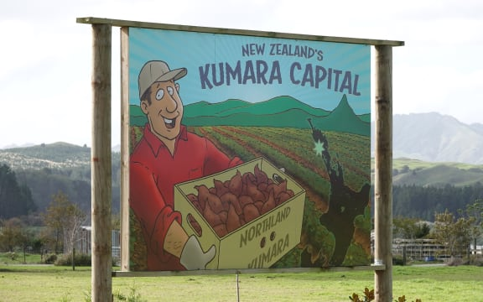Overall, the district's kūmara crop dropped by 65 percent, while the volume processed at Kaipara Kūmara was down 73 percent.

That meant the packing season finished four months early and 24 staff had to be laid off.

Some were able to work for Nilsson, who switched to courgettes so he could keep paying his staff, while others were offered part-time work at Countdown.

An estimated 95 percent of New Zealand's kumara are grown in the Kaipara region. Photo: Peter de Graaf.

"But now we're pretty much back in business as usual. It means we've all got work for four, five days a week, and we've got a lot of kūmara to sell, which is great news for consumers. It couldn't be more the opposite to 2023."

Like Nilsson, Blundell said he was grateful to Kiwi shoppers who kept supporting growers during last year's tough times, when kūmara were scarce and prices were high.

Even with the success of the 2024 crop, Nilsson said it would take years to recover from the ravages of 2023.

"It's going to take a fair while. Prior to this disaster last year, the year before we lost money on our crop, and the year before that was barely break-even prices.

"Financially, our resilience had ebbed away for two years. We've had to borrow heavily this last year to put a crop in the ground, and it's not just going to be paid off in a year or two. Depending on the returns it could be five years, it could be 10."

He was, however, optimistic about the future.

"I'm upbeat because I've got sheds full of kūmara again. It's just a question of what the price will be, if we can start paying back some debt."

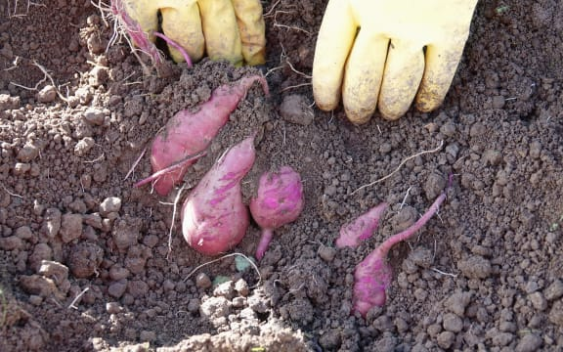Nilsson said kūmara and New Zealand belonged together.

"It's a bit like the All Blacks. It's part of New Zealand's history, isn't it? They're treated as a taonga.

"It's always been part of your diet. If you've got meat and veggies on your plate and there's not a kūmara amongst them, it's not finished, is it? You send the cook back to get a kūmara," he said.

Kumara grow just below the surface of the Kaipara's clay-rich soils. Photo: Peter de Graaf

The last of Nilsson's 2024 crop was harvested on Thursday. His overseas workers are due to fly home today*.*

**Article 2**

**Cyclone-hit kūmara growers grateful for support** **- Has a video**

Published on 5 June 2024

[https://www.anz.com.au/newsroom/new-zealand/2024/05/james-krista-franklin-dargaville-kūmara-cyclone-gabrielle/](https://www.anz.com.au/newsroom/new-zealand/2024/05/james-krista-franklin-dargaville-kumara-cyclone-gabrielle/)

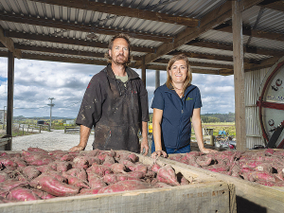With Northland’s kūmara industry back on track after the devastation of Cyclone Gabrielle, one Kaipara farming couple have a simple message for those who helped: “thank you”. Like many growers in the region, James and Krista Franklin’s property near Dargaville was hit hard by Gabrielle, after the Kaihu River burst its banks in February last year.

“We were warned about a storm coming, but never did we expect the devastation that Cyclone Gabrielle dealt to us,” Krista said.

After a night of very heavy rain, the couple woke to find the field across the road had turned into a lake and knew they were in trouble.They took their two young girls to James’ parent’s home and after driving his family to safety, James returned to the farm to try to save what he could. While the couple’s home was fortunately spared due to being built up on piles, hectares of kūmara were completely underwater. In the days that followed, the pair endured a nervous wait. The longer the water sat on their fields, the greater the damage was likely to be. Some exploratory digs confirmed their worst fears - most of the kūmara had started to rot, and in the end, they were only able to harvest 16 per cent of their total crop. The most agonising part was that the cyclone hit only a few days before when they had planned to harvest.

“We had, like many other growers, decided to leave it a couple of weeks to size the crop up,” Krista said. “Hindsight’s a wonderful thing – it was probably the worst mistake we’ve made in our lives.”

The physical and financial damage was so bad that the couple seriously considered leaving the business.

“But in the end, we decided that we’d kick ourselves if we didn’t try again,” Krista said.

**HARD GOING – BUT EASIER WITH SOMEONE TO TALK TO**

As James and Krista faced the daunting task of cleaning up and starting over, Krista said they realised, more than ever, the importance of mental wellbeing, including taking time to get off the farm to unwind.

“It’s a very lonely place when you’re not sure where to turn,” she said. “But there were amazing events run by Rural Support Trust Northland, as well as the Northern Wairoa Vegetable Growers Association – they hosted lots of dinners and lunches where we could all get together as growers.”

Rural Support Trust Northland Chair Michelle Ruddell said, in the aftermath of Gabrielle, the trust organised a wide variety of support initiatives to help farmers like James and Krista.

“The initial impact on farmers was incredibly stressful,” Michelle said. “Kūmara growers had lost upward of 70 per cent of their crops - but initially no one knew just what the damage was - people were shell shocked. The ongoing rain had a more insidious impact on people - the weather ground people down. Rural Support is here to create opportunities for our farmers and growers to get off-farm, connect with other farmers and growers, to realise they are not alone.”

Michelle said Rural Support Trust Northland organised 100 events supporting farmers in 2023, with 5500 people attending, and facilitated the clean-up of 135 farms. The number of one-on-one support clients being helped by the trust increased from 45 before Gabrielle, to 145 afterwards. Care packages were sent out to 960 farmers, which included $1000 Countdown vouchers to enable them to hold end-of-harvest events with their teams. For Krista and James, it made an incredible difference.

“There were information-sharing evenings, or spokespeople would come through from different organisations to offer support,” Krista said.

The trust receives funding from a range of sources, including the Ministry for Primary Industries, private donations, and from corporates. ANZ New Zealand was one such company, donating $100,000 to the trust’s Cyclone Gabrielle relief effort. Michelle said the funding went towards care packages for farmers and training trust staff and agri-sector professionals to better support the community and recognise signs of distress.

“ANZ's contribution made a genuine difference for our farmers and growers,” Michelle said.

**HELP OTHERS, HELP YOURSELF**

Krista realised the impact Rural Support Trust had at times like these, and soon after Gabrielle hit, she decided to get involved herself.

“It was such a welcome opportunity at that point in time,” Krista said. “Being able to work with fellow kūmara growers experiencing something similar to us, and other farmers who were going through the difficult season, it was just really rewarding. A large box of sweet potatoes
When you’re going through a time of devastation and difficulty, it’s just awesome to have someone rurally who can help guide you to the different supports that are available.”  
**Krista Franklin - Kūmara grower and Rural Support Trust Northland Facilitator**A year later, with this season’s kūmara harvest well underway, James says things seem to be back on track, both for the Franklin’s farm, and others in the region.

“We’re looking forward to getting our product out to market, hopefully at a good price,” he said. “Maybe there’ll be a bit of built-up demand in the market, since a lot of people might have missed out last year. But yeah – the quality is looking really good.”

**Article 3**

**Kūmara prices tipped to drop as supply improves**

7:11 pm on 1 March 2024

https://www.rnz.co.nz/news/business/510624/kūmara-prices-tipped-to-drop-as-supply-improves

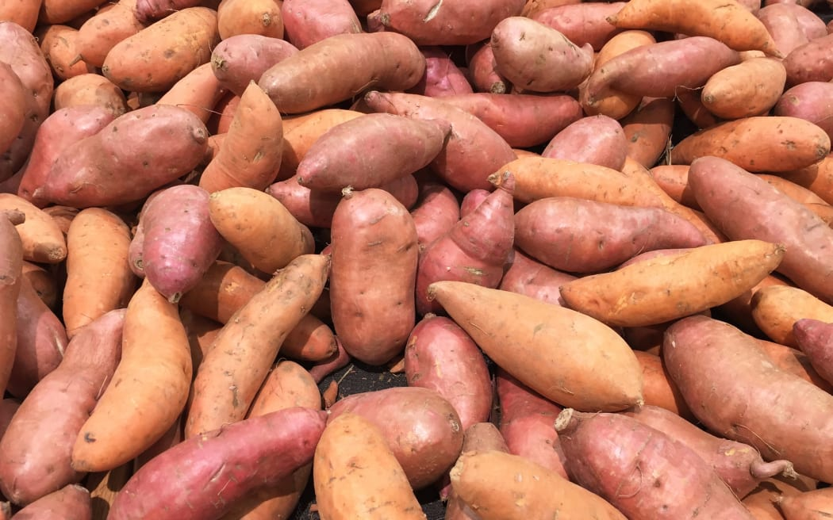Kūmara is [back in abundance](https://www.rnz.co.nz/news/country/507337/northland-kumara-crop-recovers-after-2023-flood-and-cyclone) after many crops were devastated by Cyclone Gabrielle. About 97 percent of Aotearoa's kūmara is grown in Northland due to its warm climate and good soil, but much of it was left rotting in the ground because of storm damage. At its scarcest, some kūmara prices topped out at $14/kg. But the new season's orange, gold and reds are back on supermarket shelves. Foodstuffs Produce and Butchery North Island head Brigit Corson said red was about $7/kg. Orange and gold are only just being harvested, but they are expected to halve in price to $7/kg in the next few weeks. Corson told *Checkpoint* that as supply improved, those prices would come down.

"Kūmara is an amazing crop, so we use all of it. The big ones normally go to processing, the small scrappier ones, they get steam peeled and popped into kūmara hash, and then the ones that are just right end up in Pak'nSave, New World and Four Square for our customers. But over the last year, because of the shortage - big, small, medium and everything in between - we've been trying to get on our shelves and so that's why there's been a bit of a size variation for our customers."

**Kūmara prices up to $14 a kg**

She said in 2023, about 60 percent of the crop was wiped out. This year the crop is expected to return to almost normal levels.

"Kūmara is a once-a-year crop. So, what happens is it gets harvested, and then it gets cold stored and just kind of released to the market. So, we're expecting with a normal crop that we will be able to have kūmara until the new season, which kind of starts in February each year."

According to Stats NZ, average kūmara prices in January 2023 were $4.37/kg, and shot up in September 2023 to $12.98/kg.