Level 3: Future Proofing Strategies
Eco-friendly timber barn formula for viability
Eco-friendly timber barn formula for viability
Teacher Note:
This worksheet is a Future Proofing Strategies exercise based on Willesden Farms composting barn.
A composting barn is a covered housing system for dairy cows where animals rest on a deep bed of organic material, such as woodchips or sawdust, that is regularly aerated to promote composting. The system captures manure and urine within the bedding while providing cows with a warm, dry, and comfortable environment during wet or extreme weather conditions.

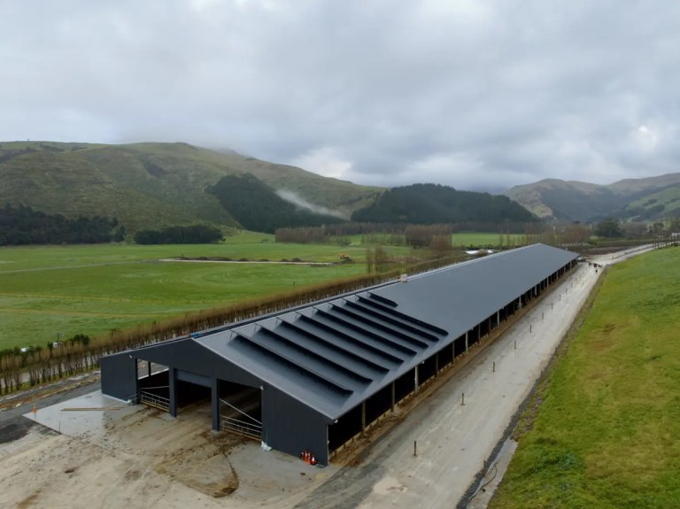
Read the article “Eco-friendly timber barn formula for viability” and answer the Future Proofing Strategy Questions
- What future needs does Willesden Farms face as a dairy farming business?
- What steps has Willesden Farms taken to meet these future needs?
- Describe one strategy Willesden Farms has used to manage environmental influences.
- Explain how this strategy helps ensure Willesden Farms’ long-term success.

The Level 2 powerpoint, “Conscious Valley” is a PESTLE analyse activity which can be used future as prior learning if required.

https://www.agribusinessmagazine.co.nz/blog/eco-friendly-timber-barn-formula-for-viability
Building a composting barn has cut one Canterbury dairy farm’s environmental footprint by nearly half while protecting cows and pastures alike on land with imperfect drainage.
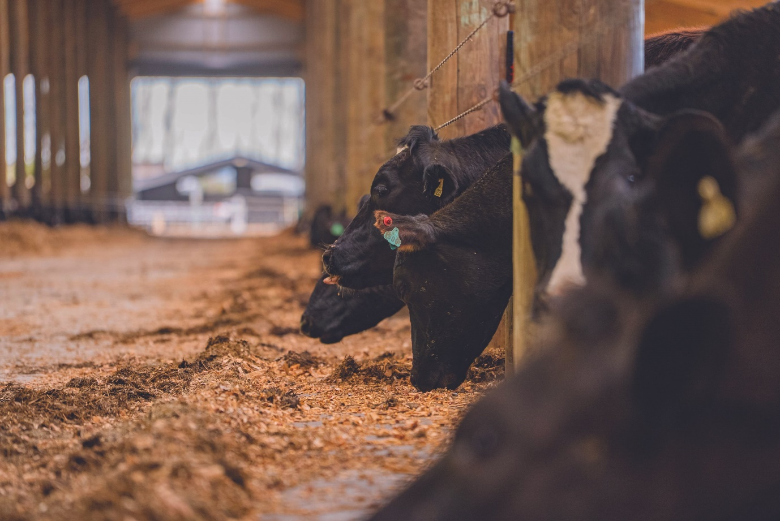
Owner Brent Thomas calls it a formula for viability as milk payouts climb, while general manager Matt Iremonger sees it as a practical fix for tough land.
Willesden Farms in Banks Peninsula’s Kaituna Valley is a 300-hectare (ha) conversion, milking 700 cows this season.
Before the barn, wet winters turned paddocks into mud traps, with cows slipping and pastures taking a beating.
Now, cows are under cover during both rain and hot spells, keeping pastures safe from damage during the wet, and cows shaded from heat stress.
Matt Iremonger didn’t rush into this. He researched composting barns across New Zealand, Australia, and the United States, visiting sites in Waikato, Taranaki, Southland, the West Coast, and Canterbury.
“We looked at how these systems were able to augment our pastoral system,” he says.
The goal was to squeeze more value from wet winter land without ditching pasture, and supplier Numat Agri was chosen for the project.
The barn serves two purposes: wintering 550–650 non-milking cows in June and July and sheltering up to 800 during bad weather.
“It’s designed for the full eight hundred during adverse weather at any time of the year,” Iremonger notes.
That covers spring rains, autumn mud, and summer heat for shade.
Thirty-one metres wide by 185 metres long, the barn has 3500 cubic metres of woodchip bedding, with 740 metres of feed face.
The frame uses NuSpan laminated timber — essentially glulam — sourced from sustainable New Zealand plantations.
This eco-friendly alternative to steel-framed barns is up to 20 per cent more cost-effective than traditional builds. It also handles moisture in effluent-heavy settings without corroding.
“We were really attracted to it because it was cost efficient, and highly durable,” Iremonger says. Plus, it delivers a warmer, softer space that fits the farm’s vibe.
Built for 50+ years, the barn is a long-term play.
“We’ve modelled it as a 50-year piece of infrastructure but there’s no reason that it wouldn’t last significantly longer,” he says.
Return on investment lands in five years, with profits rolling in after from higher productivity and lower costs generating savings on off-farm wintering — no more trucking cows off-site.
In severe weather, both cows and staff are more comfortable, and less stressed.
The barn cuts methane and nitrate outputs, key culprits in dairy emissions.
By keeping cows indoors during wet spells, nitrogen leaching drops from 15–20 kg per ha annually to near zero, per industry benchmarks.
Monitoring during consenting shows net gains, putting Willesden ahead of the curve.
Opportunities abound for growth.
High milk prices fuel conversions, with Canterbury seeing consents surge fourfold since last year.
Exports to markets like China drive demand, while New Zealand’s low-cost production edge keeps farms competitive globally.
Milk output is set to rise, with herd numbers increasing through reduced culling and new setups.
The upsides pull farmers in.
Dairy offers higher returns than dryland grazing on similar land, with asset values climbing in areas like Southland.
Numat Agri says tech like composting barns tips the balance: they cut nitrate leaching by up to 50 per cent, slash methane via better feed efficiency, and enhance sustainability for long-term business resilience.
Willesden’s case fits the pattern.
On Banks Peninsula’s wet slopes, the conversion swaps cropping for year-round grass, avoiding exposed soil and boosting fertility.
The barn’s 46 per cent footprint cut — via captured effluent and indoor shelter — mirrors sector-wide moves to meet 2030 emissions targets without slashing output.
Matt Iremonger’s research echoes broader farmer caution: conversions work when paired with systems that protect assets long-term, turning compliance pressures into straightforward advantages.

Answers
- What future needs does Willesden Farms face as a dairy farming business?
Willesden Farms faces several key future needs to remain viable as a dairy farming business. These needs include:
- Meeting increasingly strict environmental regulations, particularly around methane emissions and nitrate leaching.
- Protecting its wet, imperfectly drained land and pastures from damage caused by winter grazing and extreme weather.
- Ensuring ongoing profitability and productivity as costs rise and milk prices fluctuate, while maintaining high standards of animal welfare.
- Long-term resilience to climate variability, such as wetter winters and hotter summers, is also an important future need.

- What steps has Willesden Farms taken to meet these future needs?
Willesden Farms has taken a strategic, research-led approach by:
- Building an eco-friendly composting barn that houses up to 800 cows during adverse weather and winters 550–650 non-milking cows. Keeping cows off wet paddocks prevents pugging and soil damage, preserving long-term pasture quality.
- The barn is built using sustainably sourced laminated timber, which is durable, cost-effective, and suitable for high-moisture environments.
- The barn captures effluent and bedding nutrients, significantly lowering nitrogen leaching and methane emissions. It also reduced reliance on off-farm wintering, lowering transport costs and stress on animals
- The barn also Improves animal welfare, providing shelter from rain, mud, and heat stress, improving cow comfort and productivity.
- Planning for the long term as the barns is designed as 50+ year infrastructure, supporting future herd growth and regulatory compliance.

- Describe one strategy Willesden Farms has used to manage environmental influences.
Strategy: Use of a composting barn to reduce environmental impact while maintaining production
Willesden Farms mitigates its environmental impact by housing cows indoors during high-risk periods, particularly wet winters and extreme weather. This strategy:
- Reduces nitrogen leaching by keeping cows off saturated paddocks, nitrogen losses drop from 15–20 kg/ha annually to near zero during those periods.
- Cuts methane emissions achieved through improved feed efficiency and controlled feeding environments reducing methane output per unit of milk produced.
- Protects soil and waterways by reducing soil compaction, runoff, and nutrient loss on steep, wet land.
- The composting bedding system which allows nutrients to be reused rather than lost to waterways, helping to manage nitrogen and methane emissions.

- Explain how this strategy helps ensure Willesden Farms’ long-term success.
This strategy helps ensure Willesden Farms’ long-term success by balancing environmental sustainability with economic performance. Environmentally, it reduces nitrate leaching and methane emissions, helping the farm meet current and future regulations. Operationally, it protects pastures, improves cow comfort, and maintains consistent milk production despite adverse weather. Financially, it lowers costs by eliminating off-farm wintering and improves productivity, delivering a return on investment within five years.
Together, these benefits strengthen the farm’s resilience, profitability, and ability to operate successfully in the long term.

