**Level 3: Future Proofing Strategies**

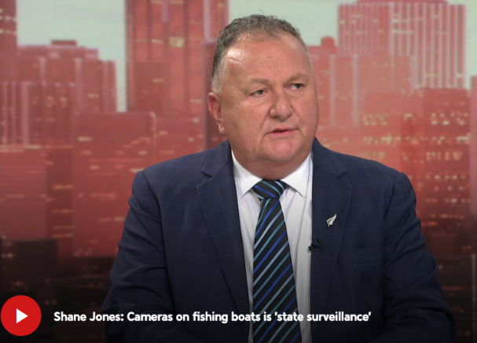**Political and Ethical**

**Teacher Note:**

This worksheet provides an example of political and ethical influences on an agribusiness.

This article *“***Shane Jones Proposes Major Fishing Law Changes – But Not Everyone Agrees”** is a shortened version of “**Major shake-up of fishing quota system on the way*”*** also included in this worksheet.

**Future Proofing Strategy Questions:** Exercise based on future proofing strategy on a fishing business. Either the shortened version or full article could be used.

**Recommended resources:**

[Major shake-up of fishing quota system on the way](https://www.odt.co.nz/news/national/major-shake-fishing-quota-system-way)

<https://www.1news.co.nz/2025/03/16/shane-jones-cameras-on-fishing-boats-is-state-surveillance/>

<https://newsroom.co.nz/2024/09/25/cameras-on-fishing-boats-rollout-resumes-with-a-catch/>

**Shane Jones Proposes Major Fishing Law Changes – But Not Everyone Agrees**

Oceans and Fisheries Minister Shane Jones has announced big changes to New Zealand’s Quota Management System (QMS), the system that controls how much fish can be caught. He says it’s the most important update since the QMS started in 1986.

The new plan includes:

1. Making it easier and quicker to change rules when needed.
2. Giving more protection to footage from cameras on fishing boats.
3. Changing rules about which fish must be brought to shore, and which can be thrown back.

Fishing boats now have cameras to make sure rules are followed. But Shane Jones believes the footage should not be shared with the public through the Official Information Act (OIA). He says it could be used to unfairly damage the industry on social media.

“If crimes are committed, they should be dealt with in court, not on TikTok,” Jones said.

Others disagree. Environmental groups and the Green Party say the public should have access to the footage to help protect the oceans. They believe this change hides bad behaviour and weaken environmental protection.

New Zealand’s fishing system is different from other countries because it is based on property rights, people or companies “own” the right to catch a set number of fish. Jones says this system must respect Treaty of Waitangi settlements but still protect fish stocks for everyone.

He warned that if a fishery is under pressure, no one should be allowed to fish there not even iwi. But he admitted this is a “tricky area” and the government must be careful not to break past agreements with Māori.

Reactions from Politicians and Industry.

* Seafood industry leaders welcomed the changes, saying they will support jobs and sustainability.
* The Green Party was unhappy, saying only industry voices were included in the announcement. MP Teanau Tuiono called it “fishy” and said Jones was ignoring environmental concerns.
* Prime Minister Christopher Luxon said the government is listening to feedback before making decisions.
* ACT leader David Seymour raised privacy concerns, asking whether it is right for camera footage from private boats to be public.

Public feedback on the plan is open until 28 March 2025. After that, the government will decide which changes to make.

*Shortened version of “****Major shake-up of fishing quota system on the way.***

**Major shake-up of fishing quota system on the way**

4:59 pm on 12 February 2025

[**Lillian Hanly**](https://www.rnz.co.nz/authors/lillian-hanly), Political reporter

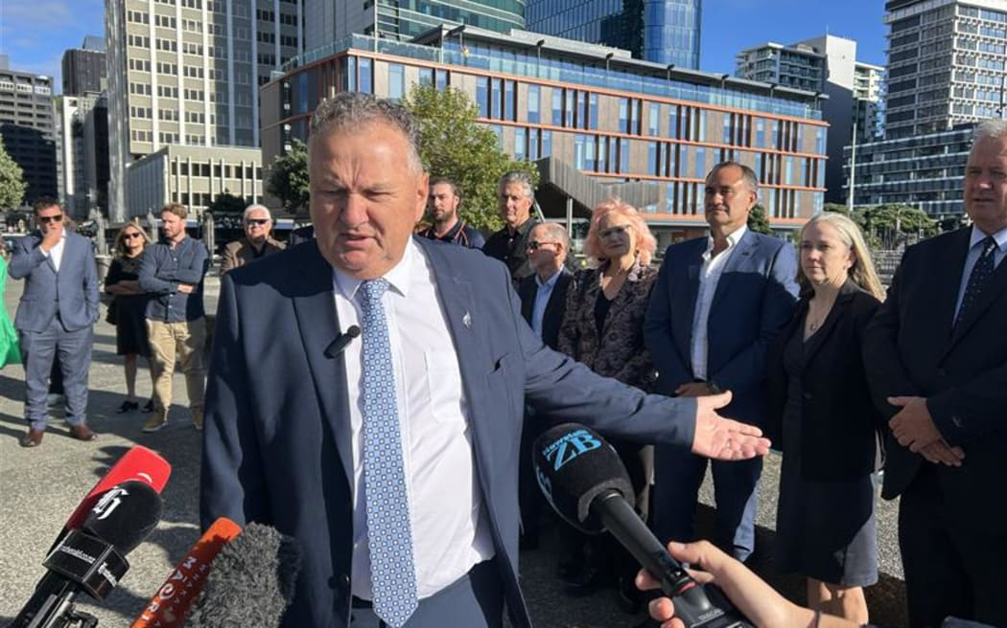https://www.odt.co.nz/news/national/major-shake-fishing-quota-system-way

The courts should deal with illegal fishing, not the "court of public opinion", Shane Jones says, as he announces proposed changes to the Quota Management System.

The Oceans and Fisheries Minister also acknowledged there is a "deeper philosophical debate" underneath the consultation document, now open for feedback on the Ministry of Primary Industries website, because of New Zealand's "unusual fishing management system" due to the property rights-based quota system.

Shane Jones at the event on the Wellington waterfront. Photo: RNZ / Lillian Hanly

Jones made the announcement on the Wellington waterfront alongside a range of industry members, arguing the changes were the broadest and most significant since the quota system was introduced in 1986. He acknowledged cameras on fishing vessels are now a feature of the industry, but made clear his position as a New Zealand First Member of Parliament (MP) that footage should be "exempted from the Official Information Act (OIA)" so it does not fall into the hands of people who "hope to do damage to this valuable industry".

"If there are offences being committed in the industry, they should be charged in the court of a legal forum, not charged on TikTok, not charged in the court of public opinion."

He said the camera footage was very valuable should prosecution come to pass but does not agree "it should be turned into some sort of ideological commodity, used to hammer out of context what the industry is doing when they are incredibly conscious of their social licence. However, that is the view of a New Zealand First MP. It is not the view of Cabinet but let us see what comes out of it."

Jones said the document reflects the fact "we all campaigned on different things" and does not commit Cabinet to one particular outcome. He said it is fair to say ACT leader David Seymour wants to see deregulation, and fair to say that National would be "very conscious that somehow I do not unwittingly fracture the social licence around fishing".

"I think I'm enhancing it, but I accept that my view is only one in a myriad of voices."

Jones also specified the rights that were "protected and safeguarded in the Fishery Settlement will be upheld. But after that settlement, the expectation of New Zealanders is that, irrespective of your background or your ethnicity, we are all in this together to ensure that the industry remains a sustainable enterprise, but at the same time, maintains jobs, income," he said. "You would know that New Zealand has an unusual fishing management system in terms of other countries, because we have the property rights-based quota system."

Customary rights for iwi and hapū were safeguarded in the Sealord settlement in 1992. He acknowledged it is a "tricky area," and said: "We'll have to be very careful that we get the balance right. I do not want to worsen any of the Crown commitments in our Treaty settlements, but if a fishery is genuinely stressed for a period of time, my preference would be no one has access to that fishery."

He accepts through some settlements; others may have different expectations.

"I would not know whether or not that would represent a hitherto unknown fracturing of a settlement at this stage."

The Quota Management System (QMS) controls the overall catches for most of the main fish stocks in New Zealand's waters and ensures a total catch limit is set at a sustainable level.

Jones said the changes will "remove unnecessary regulations that impede productivity and the potential of the sector".

The proposals span three areas:

* Part 1: Proposals to improve responsiveness, efficiency and certainty of decision making.
* Part 2: Greater protection for on-board camera footage and ensuring the onboard camera programme is workable.
* Part 3: Implementing new rules for commercial fishers that set out when QMS fish must be landed and when they can return to sea.

Part 1 changes would look to make clear why, when, or how the Minister would address "sustainability and utilisation matters".

Jones acknowledged some say Ministers should not be involved in sustainability decisions "because we're politicians and we might be susceptible to blandishments and other sorts of depredations”. He said, "as a politician, I just dismiss all that filigree."

**Losing battle over cameras**

Part 2 relates to [possible changes to the rules relating to on-board cameras](https://www.rnz.co.nz/news/political/528976/both-greenpeace-and-seafood-industry-welcome-change-to-fisheries-camera-rules), and includes enhancing protections for footage to address privacy concerns, amending the scope of the on-board camera programme to exclude some vessels where it is not practical, and clarifying when those cameras do not need to be used.

The current rollout began in 2023, and cameras were now operating on 161 commercial inshore fishing vessels. The Ministry of Primary Industries confirmed the installation was scheduled to be completed this year on about 70 remaining in-scope vessels.

Jones acknowledged the dial was shifting when it comes to having cameras on boats.

"I kind of knew I was losing that bet when my own beloved company, Moana Pacific, will not agree with me."

Moana New Zealand (Moana Pacific was a previous name of one of its units) has covered nearly all its fleet with cameras, despite not being legislatively required to.

The company's general manager, Mark Ngata, said it has had cameras for nearly a decade because it wanted to know what was happening, which then allows it to make "good sustainability decisions" and be part of forums within the sector.

Ngata acknowledged one concern was privacy for those working out on the boats.

Currently, camera footage is not exempt from the OIA.

Director of fisheries management at Fisheries New Zealand Emma Taylor said in a statement each request for official information relating to footage was assessed on a case-by-case basis.

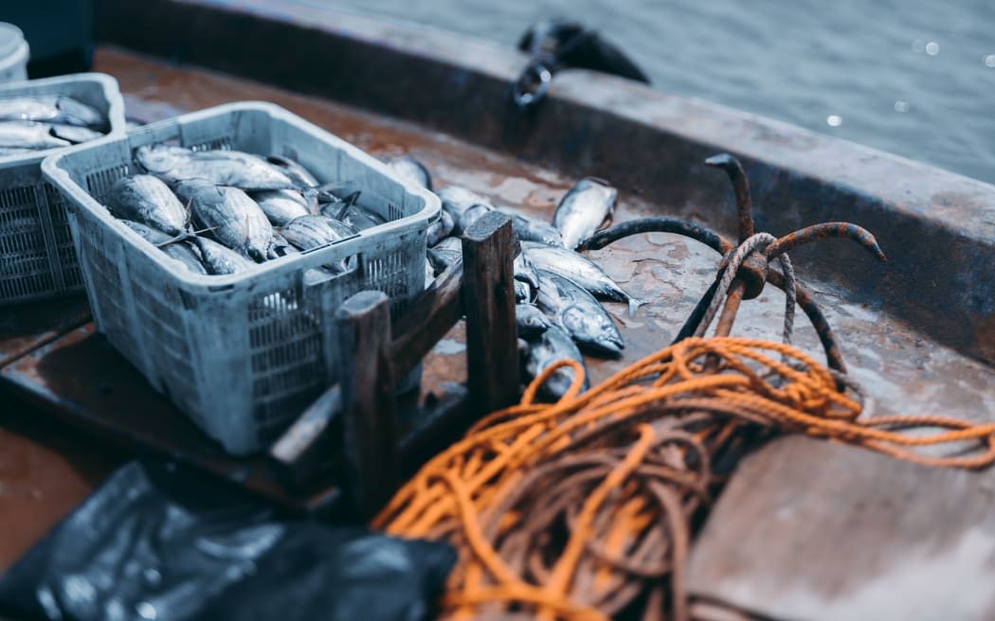"MPI published guidelines outline how MPI considers requests for fisheries information, including footage, in accordance with the Act's provisions to meet the public interest for release of information while protecting privacy of individuals and legitimate commercial interests of businesses."

Part 3 asks for feedback on best practice about when certain catch must be brought to shore, and when it can be returned to sea.

Sealord chief executive Doug Paulin said it was much better to be able to return incorrect catch to the sea. He said if it was brought to shore there were a whole lot of "unintended consequences" and returning it to the ecosystem was a "much better result for us all."

Industry body Seafood NZ also welcomed the proposed changes.

Chief executive Lisa Futschek said they were a "win for consumers, common sense and sustainability" and came at a great time for the sector".

"If you look at the document, sustainability is integrated right throughout it, so we cannot have economic growth without ensuring that sustainability. So that is what the Fisheries Act is all about.

"So, the Fisheries Act promotes and allows for utilisation of the resource, but it has to be ensuring that sustainability is maintained, and nothing about that changes through these proposals."

**Politicians react**

The Green Party is hitting out at the Oceans and Fisheries Minister, saying it is "fishy" only industry members were present at his press conference today.

Coalition partners have also waded in, saying they want to hear feedback - but there are issues of privacy when it comes to footage from fishing vessels being subject to the OIA.

The Greens Oceans and Fisheries spokesperson Teanau Tuiono said he thought it was "very fishy that at his press conference, all the industry people were there - where were the ocean protectors, where were the environmental defenders?"

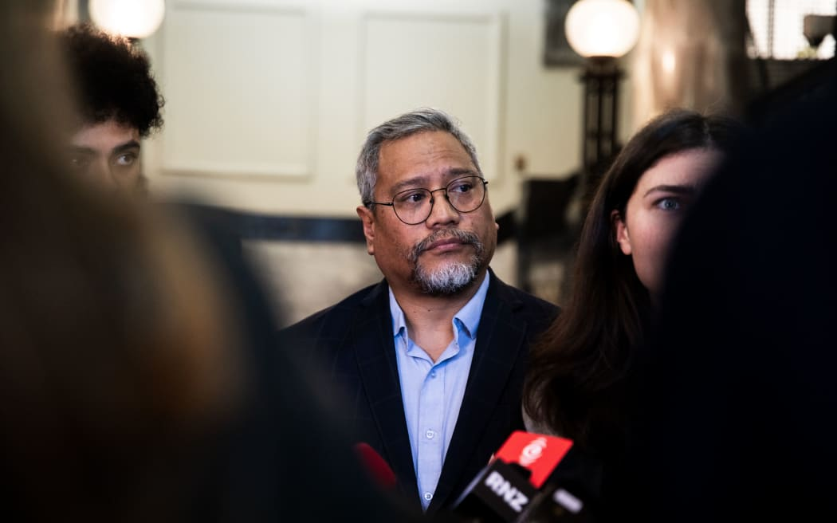When asked if the minister had been bought off by the fishing industry, Tuiono said "the question answers itself."

Co-leader Marama Davidson added "even fishers know, that if you scam all of their fish to big corporate fishing interests, the local fishers, our smaller fishers, they will not have anything left. What sort of economy is that?"

Photo: RNZ / Samuel Rillstone

On the proposed changes, Tuiono said "if we continue to focus on short-term profit over long-term sustainability it is going to wash away the lifeblood of our oceans. He said the problem with Jones, "amongst many other problems", is the "dig, baby, dig; trawl, baby, trawl" mentality that he has.

"He's got an absolute disdain for the environment. "Actually, what we need to be doing is protecting our oceans."

When asked, Prime Minister Christopher Luxon indicated there was an issue of making sure the privacy of workers on boats is protected should footage from cameras on board be exempt from OIA.

But, he said, there's a long way to go before decisions are made.

"We have got a consultation document out, let us get the feedback back and then we will make decisions."

He added it is a $1.6 billion dollar sector and "we want to be able to grow our economy."

Seymour made the point that not too long-ago people claimed there should be cameras in chicken coops as well as boats.

"If you want to get to a world where the government has cameras everywhere, and people can then request footage as public information that has been taken on your private property, I think there would be a lot of people who would say hang on a minute, I am not sure we want to go to that world."

He also questioned whether cameras on boats are good value for money, and then deal with the issue of privacy, "and then we might get somewhere."

"But generally, surveilling someone's private property, making that public information, and then making that subject to the OIA that anyone can access - you have got to ask yourself is that really what the state should do in a free society that respects people's privacy."

Submissions on the consultation document close at 5pm on 28 March 2025.

**Questions**

1. What are the needs of a fishing business to remain viable?
2. What are the political and ethical influences impacting a fishing business?
3. Using either the political or ethical influence, explain one strategy a fishing business is involved in to mitigate that influence?
4. Using another strategy that this fishing business could implement, explain how it has mitigated a different influence for the business?
5. How have these strategies ensured the long-term viability of the fishing business?
6. Provide a new strategy for either influence that would mitigate or solve the influence, to ensure long-term viability of the fishing business?

**Answers**

1. What are the needs of a fishing business to remain viable?

To remain viable, a fishing business needs:

* Access to sustainable fish stocks to ensure continued operations.
* Stable and fair regulations that allow for long-term planning.
* Positive public reputation and consumer trust, especially around sustainability.
* Skilled and reliable workforce who feel supported and respected.
* Investment in modern technology and equipment to stay competitive.
* Compliance with environmental and legal obligations, including Treaty rights.
* Access to profitable markets.

1. What are the political and ethical influences impacting a fishing business?

Political Influences:

* Changes to the QMS affecting how much fish can be caught and under what conditions.
* Treaty of Waitangi obligations, which must be respected in fisheries management.
* Onboard camera regulations and debates over access to footage under the OIA.

Ethical Influences:

* Environmental sustainability, including how fish are caught and whether practices are damaging to ecosystems.
* Transparency and accountability, especially when public trust is low.
* Worker rights and privacy, particularly around camera surveillance on boats.

1. Using either the political or ethical influence, explain one strategy a fishing business is involved in to mitigate that influence.

Ethical Influence: Environmental sustainability  
Strategy: Installing onboard cameras voluntarily and using them for internal review.

Fishing company Moana New Zealand has installed cameras on nearly all its fleet even before being required by law. This shows a commitment to sustainable and responsible fishing practices. This strategy builds trust with consumers, regulatory bodies, and environmental groups. It shows the company is actively protecting the ocean, helping maintain market access, and long-term fishing rights.

1. Using another strategy that this fishing business could implement, explain how it has mitigated a different influence for the business.

Political Influence:Treaty of Waitangi obligations  
Strategy: Engaging directly with iwi and hapū in co-management of fisheries.By building strong partnerships with Māori stakeholders, the business ensures it respects Treaty commitments. This helps avoid legal disputes, builds goodwill, and creates shared long-term goals for fisheries sustainability and use, protecting access to valuable resources.

1. How have these strategies ensured the long-term viability of the fishing business?

These strategies strengthen the business in several ways:

* Improved reputation and trust with the public, customers, and government agencies.
* Maintained access to environmentally sensitive markets by proving commitment to sustainability.
* Avoided legal risks by honouring Treaty obligations and working collaboratively with Māori.
* Increased operational certainty, which supports long-term planning and investment.
* Protected fish stocks, ensuring there will be resources to fish in future years.

Together, these outcomes help secure the business’ social licence to operate and reduce the risks of fines, protests, or loss of access, making the business more sustainable in the long run.

1. Provide a new strategy for either influence that would mitigate or solve the influence, to ensure long-term viability of the fishing business.

Ethical influence: Worker privacy concerns from onboard cameras  
New Strategy: Develop and implement a Privacy and Data Protection Policy in collaboration

with crew and legal experts.

The strategy would include:

* Clear rules about when and how footage can be reviewed.
* Footage used only for compliance and training, not for public release unless legally required.
* Involve crew in policymaking to build trust and transparency.

This strategy would improve worker morale and retention, reduce legal risks, and show the

business values its employees. It balances ethical responsibility with operational needs, which supports a productive workforce and reduces costs associated with high staff turnover.