**Level 3: Future Proofing Strategies**

**Economic and Political Strategies Worksheet**

**NZ Hothouse**

Market leaders in hothouse produce

NZ Hothouse has grown, packed and marketed New Zealand's freshest and most flavoursome produce for over 30 years.

For more information visit [NZ Hothouse](https://nzhothouse.co.nz/about) it includes a short video.

Founder and Executive Chairman Brett Wharfe started growing tomatoes in 1984.

**Teacher Note:**

This worksheet is a **Future Proofing Strategies** exercise based on the **gas supply crisis**. The shorter article, *“Gas Crisis Threatens Tomato Growers and Jobs,”* has been adapted from the longer piece, *“The Industry-Killing Crisis: Indoor Food Production,”* which is also included in this worksheet.

The **Level 2 worksheet**, *“Indoor Food Production: Crisis,”* uses the same article to explore the influence of future proofing and can be used as **prior learning**.

**The industry-killing crisis- Indoor food production**

**Gas Crisis Threatens Tomato Growers and Jobs**

Simon Watson, managing director of NZ Hothouse, says a growing natural gas shortage could destroy parts of New Zealand’s hothouse industry, cost thousands of jobs, and make food more expensive.

NZ Hothouse, based in South Auckland, has been growing tomatoes in large greenhouses for 25 years. When it started, it used natural gas from the Maui pipeline, a cleaner and cheaper option than coal. The gas was used to heat the greenhouses and feed the plants carbon dioxide, helping them grow.

But now, gas supplies are running out, and prices are rising fast. Watson says they are now paying three times more than they did in the past, and it's still going up.

“Gas was cheap, and we were told it would last forever,” Watson says. “Now we’re facing the biggest challenge in over 30 years.”

His 10-hectare greenhouse in Drury produces nearly half a million tomatoes a year and employs many workers. But the future is uncertain. Watson only recently realised how serious the gas crisis is. At a meeting with business leaders, he learned that many industries, including meat, dairy, drinks, sugar, alcohol, building, and even schools and hospitals depend on natural gas.

“Around 80 to 90% of the products in a supermarket have some gas connection,” he says.

The company first noticed gas supply problems three years ago, but the situation has gotten much worse. A government report says gas reserves have halved in just four years, and supply is falling faster than expected.

NZ Hothouse is now looking at moving to a new location, possibly near Taupō, where it could use geothermal energy instead. Watson thought they had 5–10 years left at the current site, now he says it may be just three years.

He warns that many growers using similar gas systems won’t survive if prices keep rising. The government and energy companies have nine months to come up with a solution before next winter.

*Adapted from “****The industry-killing crisis- Indoor food production”*** *article included in this worksheet.*

26 August 2025

[**Sharon Brettkelly**](https://www.rnz.co.nz/authors/sharon-brettkelly), for The Detail

<https://www.rnz.co.nz/news/thedetail/571148/the-industry-killing-crisis>

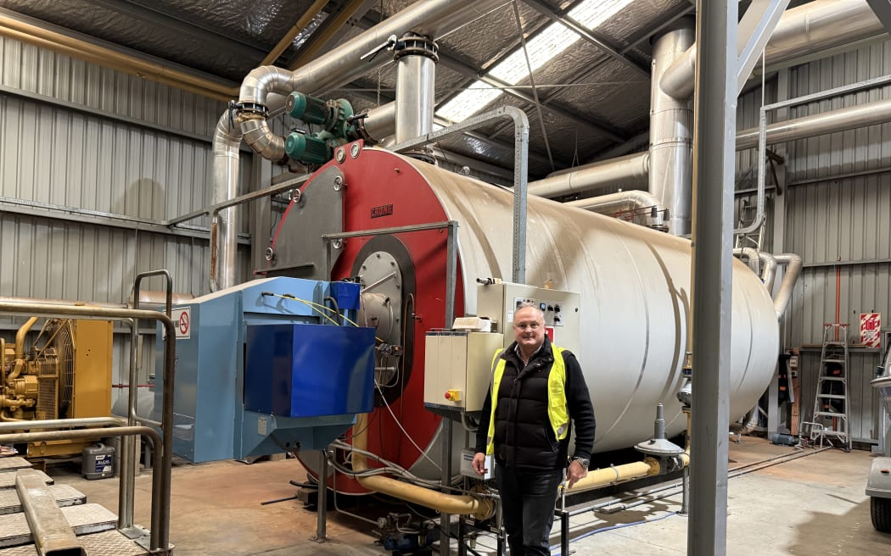

NZ Hothouse managing director Simon Watson at one of two giant gas boilers that help fuel and feed thousands of tomato plants. Photo: Sharon Brettkelly

**Tomato grower warns the gas supply crisis could threaten the hothouse industry, end thousands of jobs and send consumer prices even higher.**

When NZ Hothouse built its tomato growing operation 25 years ago in South Auckland, hooking up to the nearby Maui pipeline was a key factor.

In an area where most growers were using the dirtier, less efficient coal, natural gas was cutting edge and the company brought in the latest technology from The Netherlands.

"It was the best in show in the world at the time," said managing director Simon Watson.

The gas was abundant and inexpensive, and they were told it would last forever.

"Gas was incredibly cheap. Probably about a third of what we're currently paying and obviously a fraction of what we're going to be paying when the price goes up," said Watson.

But the very lifeblood of the operation - the thing that keeps the plants warm through winter and feeds them much-needed carbon dioxide - is dying.

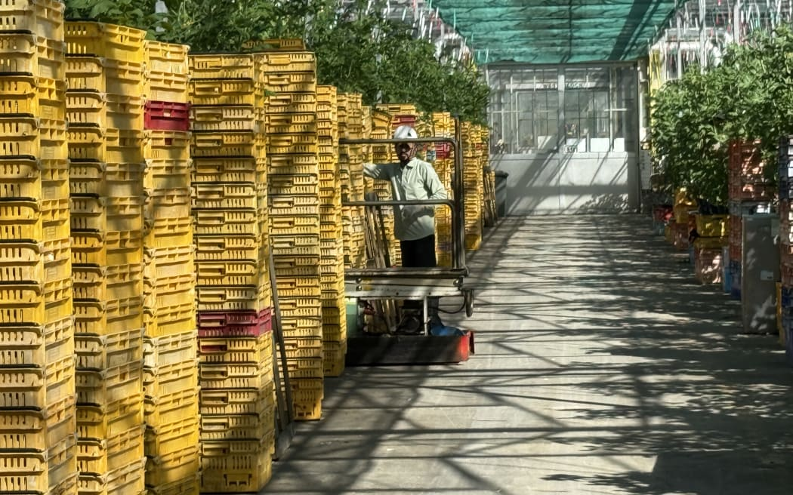NZ Hothouse managing director Simon Watson says the gas supply crisis could end thousands of jobs. Photo: Sharon Brettkelly

Natural gas supplies are running out and as the shortage bites, the rising cost of it is threatening the future of some businesses.

It is likely to uproot NZ Hothouse's operation and disrupt hundreds of workers.

Watson said it is the toughest problem he's faced in his 31-year career there. But he had no idea of the widespread impact of it until a business leaders' meeting a couple of weeks ago.

"Until we started looking into the depth of this crisis, we had no idea how extensive this is and how far reaching it is. It's going to have a massive effect on our society unless we can make some changes pretty quick," he says.

He thinks most people are unaware of how many different industries depend on natural gas as their energy source.

"If New Zealanders walk through a supermarket and all the regular things that they buy, basically 80, maybe 90 percent of that product in a supermarket has some gas content.

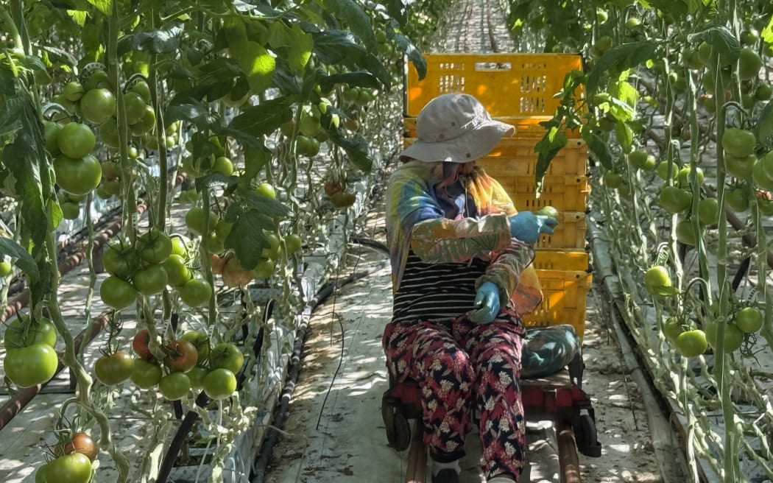NZ Hothouse’s 10-hectare hothouse in Drury grows nearly half a million tomatoes every year. Photo: Sharon Brettkelly

"Your meat industry, your dairy industry, your drinks industry, anything with sugar in it, your liquor industry, the breweries utilise a lot of gas. And then you look to the building industry, the glass industry, the aluminium industry, the timber industry and then you look beyond that to old people's residential homes, schools, hospitals, local bodies, heating swimming pools."

Today, Watson takes *The Detail* on a tour of its 10-hectare hothouse packing and distribution operation in Drury, where it grows nearly half a million tomatoes every year.

His company first got an inkling of a shortage about three years ago when the gas producers said the supply had become more unstable.

"At that time, it was a short-term issue which they fixed. But it was a bit of a heads up as to what was going on," he said.

But this year it was revealed that gas reserves had more than halved in just four years. And the news keeps getting worse. Just last week the Ministry of Business, Innovation and Employment (MBIE) warned that gas supply may be falling faster than previously expected.

Watson said it has forced his company to look urgently at alternative energy sources and it will probably relocate to a site where it can tap into geothermal energy, such as Taupō.

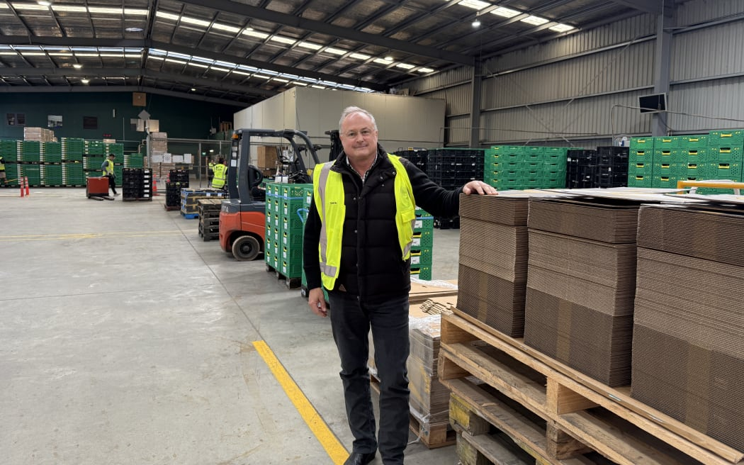NZ Hothouse managing director Simon Watson Photo: Sharon Brettkelly

He thought the company would have five to 10 years more at the current site, now he thinks it will be three years.

But much of the industry is in the same boat, with glasshouses or covered crop operations all around 25 years old, he said. NZ Hothouse's two plants make up 19 hectares of the 200-hectare covered crop sector in the upper North Island, and he predicts that many will have to cut back or close down because they can't afford to pay for the gas.

Watson said the government and the energy industry have nine months to come up with a solution, before the high energy demands of next winter.

**Level 3 Future Proofing Strategies Worksheet**

**Questions**

1. **What are the future needs of NZ Hothouse?**
2. **What does it mean for an agribusiness like NZ Hothouse to be “future-proofed”?**
3. **Why is it important for an agribusiness like NZ Hothouse to find alternative energy sources?**
4. **What are some other renewable resources that NZ Hot House use?**
5. **How can using renewable energy like geothermal help a business stay profitable in the long run?**
6. **NZ Hothouse is considering relocating to Taupo to use geothermal energy. What would be the impact of this strategy?**
7. **What other future proofing influences are impacting NZ Hothouse?**
8. **Using one of the influences e.g., economic from question 7, explain one strategy that the business has considered using to mitigate that influence?**
9. **Using another strategy that NZ Hothouse has considered, explain how that has mitigated a different influence for the business e.g., environmental?**
10. **Describe two new strategies (not in the article) for each of the influences e.g., economic and environment, that would mitigate or solve the influences, to ensure long-term viability of NZ Hothouse.**
11. **Explain which of these new strategies would best meet NZ Hothouse future needs?**
12. **Justify your decision, by discussing how the best strategy, would ensure the long-term viability of NZ Hothouse?**

**Future Proofing Strategies Answers**

1. What are the future needs of NZ Hothouse?

* Access to a reliable and affordable energy source to continue growing tomatoes all year-round.
* Long-term reliable sustainable energy source to replace natural gas.
* Sustainable energy source to meet environmental standards and customer expectations.
* Investment in modern, efficient infrastructure adapted to a new energy system.
* Strategies to maintain workforce stability during transitions.
* Remain a viable business.
* Possible relocation support and infrastructure for alternative energy, like geothermal if there is no suitable alternative reliable and affordable energy source.

1. What does it mean for an agribusiness like NZ Hothouse to be “future proofed”?

Future proofing means preparing the business to withstand and adapt to future challenges such as changing market conditions, resource shortages, environmental pressures, and technological shifts. For NZ Hothouse, it means ensuring ongoing productivity, profitability, and sustainability despite issues like gas shortages and rising energy costs.

1. Why is it important for businesses like NZ Hothouse to find alternative energy sources?

NZ Hothouse’s current energy source natural gas is becoming scarce and expensive, relying on it risks operational disruption, increased costs, and potential closure. Without an alternative, the business cannot grow crops in winter or maintain production. Alternative energy sources like geothermal offer more stable, sustainable, and potentially cheaper energy, helping ensure reliable production, sustainable operational costs and the long-term viability of the business.

1. What are some other renewable resources that NZ Hothouse could use?

* Solar energy – to power systems or support heating.
* Biomass – using organic waste for fuel e.g. wood chip.
* Wind energy – to power electrical systems.
* Hydroelectricity –if relocating near sources of flowing water.

1. How can using renewable energy like geothermal help a business stay profitable in the long run?

Renewable energy like geothermal provides a consistent, reliable, and cleaner energy supply that is less vulnerable to market price spikes and supply shortages. It can lower operating costs over time, reduce carbon footprint, meet increasing environmental regulations, and improve brand image, all of which improve long-term profitability and business resilience.

1. NZ Hothouse is considering relocating to Taupō to use geothermal energy. What would be the impact of this strategy?

The positive impacts would be access to clean, reliable geothermal energy which will have

lower energy costs in the long term. Using geothermal energy would enhance NZ Hothouses sustainability image which could attract new customers seeking sustainable produced tomatoes.

However, the negative impacts would be high cost and time involved with relocation building new infrastructure. Being able to source and train new workers as some workers may not relocate which will take time and increase costs.

1. **What other future proofing influences are impacting NZ Hothouse?**

* Economic: Energy supply shortages, rising gas prices and operating costs, and the need for investment in new infrastructure.
* Environmental: Pressure to reduce carbon emissions and move towards a reliable and sustainable energy.
* Technological: need to adopt a new energy system that will be sustainable long term and meet the requirements for growing tomatoes.
* Political: Government regulations on energy use and emissions, the lack of clear action and the need to engage with policymakers.
* Social: Maintaining jobs and community trust while meeting climate responsibilities and a reliable food supply.

1. **Using one of the influences (e.g., economic), explain one strategy that the business has considered using to mitigate that influence?**

Influence: Economic – Rising gas prices and supply shortages.

Economic strategy: NZ Hothouse is exploring relocation to an area like Taupō with access to

geothermal energy. This strategy would reduce dependence on expensive and unstable natural gas, providing cheaper and more stable energy, helping control costs and improve profitability ensuring long-term economic viability.

1. **Using another strategy that NZ Hothouse has considered, explain how that has mitigated a different influence for the business (e.g., environmental)?**

Environmental strategy:

By considering a switch to geothermal energy, NZ Hothouse is reducing its carbon footprint compared to fossil fuel gas use. This shift helps the business comply with stricter emissions regulations and contributes to environmental sustainability, supporting long-term social license to operate.

1. Describe two new strategies (not in the article) for each of the influences (economic and

environmental) that would mitigate or solve the influences, to ensure long-term viability of

NZ Hothouse?

Economic:

* Partner with a local landowner to install solar panels as a solar energy farm to provide a direct source of energy to NZ Hothouse which long term could reduce electricity costs.
* Develop partnerships with local renewable energy providers or co-operatives to secure favourable energy contracts and shared investment in infrastructure.

Environmental:

* Invest in research for integrating solar panels or biomass energy systems to diversify renewable energy sources.
* Introduce water recycling and waste reduction programs to minimise environmental impact and reduce operating costs.

1. Explain which of these new strategies would best meet NZ Hothouse’s future needs?

The economic strategy to partner with a local landowner to install solar panels as a solar energy farm to supply energy directly to NZ Hothouse would best meet their future needs. It provides a renewable, scalable, and cost-effective energy solution that can be used independently over the long term. Additionally, any surplus energy could be sold, providing an extra income stream for NZ Hothouse.

1. Justify your decision by discussing how the best strategy would ensure **the long-term viability of NZ Hothouse?**

Partnering with a local landowner to install solar panels would require an initial investment but, it would offer a sustainable supply of energy. This would reduce long-term operating costs by lowering power bills. Solar energy could also work alongside other energy sources like geothermal creating a hybrid energy approach that would improve energy security. The use of a renewable energy source would help NZ Hothouse meet environmental standards and appeal to environmentally conscious consumers, strengthening its market position. Any surplus energy could be sold providing another income stream for NZ Hothouse improving financial resilience. This strategy provides both economic savings and environmental benefits, making it a strong solution to ensure NZ Hothouse’s long-term viability.