Level 3: Future Proofing Strategy
Social Strategy Worksheet.
Teacher Note:

This worksheet is on Social Future Proofing Strategies exercise based on Hohepa Farm.
Discussion Questions: Explore social strategies over economic goals on the long-term viability of the agribusiness.

Hohepa Farm: More Than Just Dairy Farming
Hohepa is a special assisted living facility in Hawke’s Bay that runs a small dairy farm. But it is not just about farming, it is about giving people with intellectual disabilities meaningful work and life experiences.
The farm has about 52 cows and produces fresh milk, cheese, and vegetables. What makes Hohepa unique is how it supports its residents by involving them in real farm work like milking cows, helping in the cheese factory, and running the farm shop. This helps residents feel part of the community, learn new skills, and gain confidence.
The farm follows organic and biodynamic farming methods, focusing on natural treatments and care for animals. The quiet cows and friendly environment make it a great place for people to connect with nature and animals, which can be very therapeutic.
Hohepa’s social approach means residents live, work, and learn together, creating a close-knit community. Staff support residents to become as independent as possible, encouraging them to contribute meaningfully based on their interests.
This community-driven, caring model shows how an agribusiness can combine farming with social support, helping people grow while producing quality organic products.
Shorten from” Farming with a Higher Purpose”

Discussion Questions:
Social Strategies Over Economic Goals
- How does Hohepa prioritise social well-being and personal growth over making the farm highly profitable?

- Why might providing meaningful work and life experiences be more valuable than just focusing on financial success in this agribusiness?

- How do the social strategies at Hohepa like involving residents in farm tasks and community life help create a supportive environment?

- In what ways do you think the farm’s focus on care and connection benefits both the residents and the business in the long run?

- What challenges might arise from choosing social goals over purely economic ones, and how might Hohepa handle them?

- How does supporting independence and inclusion on the farm show that social strategies can lead to success beyond money?

- How does Hohepa’s focus on social strategies impact the long-term viability of the business?

Answers
- How does Hohepa prioritise social well-being and personal growth over making the farm highly profitable?
Hohepa focuses on giving residents meaningful work and a sense of community rather than just maximising profits. The farm supports people with intellectual disabilities by involving them in daily tasks, helping them develop skills and independence, even if it means slower or smaller economic growth.

- Why might providing meaningful work and life experiences be more valuable than just focusing on financial success in this agribusiness?
Meaningful work helps residents feel included, respected, and motivated. It improves their confidence, social skills, and overall happiness, which cannot be measured just in money. The social impact creates a positive environment where people thrive.

- How do the social strategies at Hohepa like involving residents in farm tasks and community life help create a supportive environment?
By encouraging participation in real farm work and daily activities, residents build friendships, routines, and a sense of purpose. This creates a caring community where everyone feels valued and supported.

- In what ways do you think the farm’s focus on care and connection benefits both the residents and the business in the long run?
Caring for residents builds trust and improves their well-being, which leads to better work and positive attitudes. This creates a stable workforce and a unique, valued brand for the farm that attracts customers who support their mission.

- What challenges might arise from choosing social goals over purely economic ones and how might Hohepa handle them?
Social goals can mean higher costs or lower productivity compared to commercial farms. Hohepa handles this by balancing organic farming practices, careful herd management, and community support, focusing on quality and meaningful engagement rather than volume.

- How does supporting independence and inclusion on the farm show that social strategies can lead to success beyond money?
Supporting independence helps residents develop skills and confidence that improve their quality of life. This social success strengthens the community’s reputation and impact, showing that success is not just financial, it is about people thriving.

- How does Hohepa’s focus on social strategies impact the long-term viability of the business?
Hohepa’s focus on social strategies such as inclusion, meaningful work, and community living helps build long-term stability for the business. While it may not aim for maximum short-term profits, its strong social mission creates a loyal customer base that values ethical and sustainable products. Residents who work on the farm become committed contributors, and the supportive environment reduces staff turnover. These social strengths also attract funding, donations, and government support, helping to maintain operations over time. By staying true to its values, Hohepa builds a resilient business that is trusted, respected, and sustainable well into the future.

Farming with a Higher Purpose
https://dairycountry.co.nz/farming-with-a-higher-purpose/
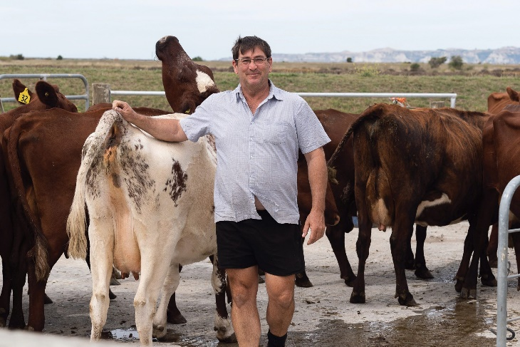
Hawke’s Bay assisted living facility Hohepa runs a small dairy farm which not only produces artisan goods but provides life experiences and work opportunities to people with intellectual disabilities. Jackie Harrigan visited the farm to find out more. Photos Brad Hanson.

Hohepa farm manager Carl Storey says the interaction with so many people makes the milking Shorthorn herd very quiet.
A farm with a higher purpose, Hohepa is a small dairy unit in the heart of the Hawke’s Bay region offering living and working opportunities to people with intellectual disabilities to interact with nature through dairy farming and market gardening.
The opportunity to have meaningful work and experiences relates to the ethos of Hohepa as ‘every life fully lived’.
A small dairy farm, cheesery, farm shop, vegetable growing patches, and fruit trees exist on the outskirts of Clive on Hawke’s Bay’s dry coastal strip and a further block at Poraiti on the hill make up 60 hectares in total, housing and providing dairy products and vegetables for up to 180 residents.
In this magical place, the Rudolph Steiner philosophy and the creativity and compassion of a dedicated group of people make Hohepa a living community enterprise where cultural, social, environmental and financial practices are the key elements that make Hohepa, and its people succeed and grow through time.
The farm is Demeter and Organic certified and runs according to biodynamic principles. The milk is sold fresh and pasteurised and made into artisan-style cheeses. Selling the dairy products at the farm shop, along with other Hohepa-made products alongside locally produced organic vegetables and fruit, sweets, meat, breads and dry goods, provides a small income for the farm, and an opportunity to interact with the public.
The shop also acts as an ordering point to keep all of the Hohepa homes and the Hohepa school in fresh produce, dry goods and dairy products – including cheeses and fresh milk delivered in stainless steel milk billies. The refrigerated Hohepa truck is a regular at the Saturday Napier Farmers market and the huge Sunday Farmers Market at Hastings Showgrounds.
Alongside the 40ha at Clive, the original Hohepa block is a 12ha support block on the hill at Poraiti with an expansive view out over Napier where children and young adults live in supported homes and attend the Hohepa Special School.
Biodynamic gardens and tunnel houses produce vegetables for the homes and young stock and dry stock from the dairy farm graze the paddocks that also grow grass for supplements in the form of hay and baleage.
A further arm of the Hohepa organisation maintains a creative space in Napier, with a candle making enterprise for dipping, dyeing and forming a range of beeswax candles that are packed and distributed to 120 retail shops around New Zealand. At the creative space there is also a weavery producing handwoven fabrics and garments, and a small shop sells these products and wooden toys and garden furniture, crafted at the wood-working shop at the Hohepa, Clive campus.
A total of 180 residents, ranging from seven to over seventy are supported by over 500 staff, making Hohepa one of Hawke’s Bay’s larger employers.

HISTORY
Hohepa was established by the joint venture of Marjorie Allen (later Dame Allen) and Hawke’s Bay farmer Lewis Harris (later Sir Lew). Marjorie had been inspired by the work of Rudolf Steiner and wanted to provide a nourishing developmental community for her nephew with Downs Syndrome, so joined forces with Harris who had a Downs Syndrome daughter and wanted a good education and outdoor experience for her. The Hohepa community was founded on the Poraiti hill close to the Harris home farm in 1957.
The first houses and the school were originally set up for Downs Syndrome children, but the remit over the years has widened to all people with intellectual disabilities, of different levels of need, who come from all over NZ. Some live in houses on the property with live-in carers, meaning they walk to and from school past fruit trees, grazing calves and vege gardens, surrounded by a community of people who know them and take time to stop and chat and befriend them.
Three eldercare houses have residents up to 70 years of age. Many of the people Hohepa supports live in the wider Napier community in a number of home settings.
Through living, working and taking an active part in community life alongside staff, the people Hohepa support and grow to experience satisfying lives with as much independence as possible, according to Hohepa general manager, Santiago de Marco.
The Steiner philosophy is that every child or person has the capacity to become as independent as possible and to be able to impart purpose and direction in their lives, encompassed in the mantra of Hohepa, ‘every life fully lived’.
The people Hohepa support are able to work in the area of their own interest. The aim is to be involved in real life and work processes thus participating and contributing in a meaningful way to their communities, said Farm and enterprises manager Alfred Busch.
Hohepa now has three other centres of residential support in Wellington, Auckland, and Christchurch.

BIODYNAMIC AND ORGANIC FARM
Milking 52 cows on 22 hectares through a 6-bail walk-through dairy shed is far from the norm in the dairy industry, but Hohepa farm manager Carl Storey says it means people can be supported and work in a meaningful way.
Balancing year-round milk supply with seasonal grass growth and maintaining genetic growth in a small herd are challenges Carl grapples with, while the pleasure and growth opportunities afforded to the people at Hohepa by working and interacting with the farm, cows and products makes it a great experience.
The Hohepa farm herd is mainly Milking Shorthorn and Ayrshire cows, now transitioning to straight Ayrshire as the Milking Shorthorn semen is no longer sold by LIC.
The cows are split into an autumn herd, with 20 cows calving on 20 March and a spring herd of 35 cows, with a couple of carryovers. Up to 50 cows are milked from spring through till after Christmas when the autumn calvers are dried off for 12 weeks.
Carl prefers a longer dry-off period to give the cows a good rest and to help manage somatic cell counts, which cannot be treated with antibiotics under the biodynamic and organic farming guidelines.
“It’s a totally different philosophy, we always go to homeopathic products first, and also second – and we use True Health products for intra-mammary treatments with their garlic, herbs and echinacea.”
If really necessary for animal care they work with the veterinarian to use the most appropriate mainstream medication, then that cow leaves the property.
Having said that, Carl said he hasn’t had a case of clinical mastitis for 12 months and only two sub-clinical cases during that time. The milk is tested each week, and all of the milk is pasteurised as 700-800 litres each week is bottled and sold through the shop or markets or delivered to the Hohepa houses and school in stainless steel billies.
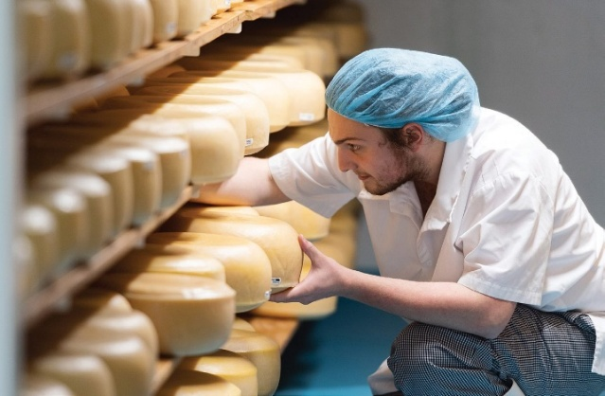
CREAMERY FOR CHEESES
Award winning artisan cheese is produced at Hohepa.
The excess milk is made into cheeses in the cheesery next door to the dairy with each cow producing an average of 3800l/lactation and over 200,000 litres each year.
The cows are all milked twice each day, at 4.30am and then at 1.30 in the afternoon when Carl has an ‘open shed’ for the milking, with several residents helping out.
David loves to help get the cows into the yard, Jamie and James are adept at cupping the cows and giving them a good pat and scratch and Katherine often comes to help with hosing down the shed and yard. Others love to help rear the replacement calves – four heifers for the spring herd and four for the autumn herd – before they are weaned and transferred up to the 12ha Poraiti farm.
‘The residents are totally animated by the connection with the cows and by helping with them – it’s all happy smiles and excitement – it’s like animal therapy,” Carl added.
The walk-through shed is the only one used for commercial supply left in NZ and although the dairy is being largely rebuilt this year, the walk-through setup is being retained and renovated.
“This style of shed gives us really good cow contact. Hohepa is all about the residents – it’s great for them to be able to help out and give the cows a pat and a scratch,” said Carl.
As a result, the cows are super quiet and Carl said they love the interactions with the milkers. There are up to 22 people daily, enjoying coming to the farm for some meaningful work all year round.

FARMING IN ABUNDANT SUNSHINE
Supplying customers and residents with organic dairy products is a 12-month business, but anyone who has visited the sunny Hawke’s Bay knows it is difficult to grow pastures in the long hot summers. Carl says it is always a challenge – he runs three small irrigators on manual shifts and spends lots of time walking the farm to measure how much pasture is in front of the cows.
The small farm up the hill grows supplement, usually 80 bales are transferred down to Clive to feed the herd and Carl says they are lucky to be able to access and buy hay and baleage from a local biodynamic farm.
A small crop of winter oats is resown into new grass – and Carl says the 5% of non-organic inputs allowed under the Demeter certification system usually ends up being grass and crop seed.
“We also grow sugar beet through the summer and Japanese millet, fed off during the winter as green feed but generally having enough feed is always a struggle.”
Hohepa farm has different opportunities and challenges than a commercial farm which makes it so interesting to be involved in, Carl said.
“It is a different pressure to commercial farming – but we need to keep the factory going and our customers around the country supplied.”

SAY CHEESE
Recently Hohepa invested in a certified milk bottling plant and set up and now supplies pasteurised milk in reusable glass bottles through local shops, in their Clive shop and at the weekly Hastings and Napier farmers markets. The empty bottles are returned and reused in a twice-weekly bottling.
There is a growing demand for glass-bottled milk and Hohepa Farm is exploring sales to further regional outlets, shops, supermarkets, cafes and restaurants.
One of the residents works in the bottle washing station and another works the filling machine recently installed to automate the process.
There is no home delivery service to customers at the moment, but it is something the staff are contemplating for the future.
Residents who are able to work are paid for their time and enjoy having an income to spend on themselves. Others have secured work in the community and many of the residents enjoy community activities like Riding for the Disabled, special Olympics, swimming, bowling and football.
Three residents work in the make room at the cheesery, where the milk is split into curds and whey and the different cheeses formed. Most of the Hohepa range are European-style cheeses, made by three passionate professional cheesemakers. Their Danbo, vintage and tasty cheeses have over many years won New Zealand Champions of Cheese awards along with cumin, fenugreek and biodynamic blue cheeses. They also produce a range of soft cheeses like mozzarella, halloumi, cream cheese and herb-flavoured quark. The maturing rooms hold 6kg rounds of the Danbo and European cheeses that are matured for up to 18 months before being sliced, packaged and sold.

