Level 3: Future Proofing Strategies.
Autonomous Tractors: Innovation Meets Reality on the Farm

Teacher Note:
This worksheet provides an example of technology future proofing Strategy based on autonomous tractors.
Future Proofing Strategy Questions
- Evaluate how well autonomous tractor technology aligns with the future needs of primary production systems.
In your answer, consider the impacts:
- Socially
- Environmentally
- Economically

- Using either a viticulture or pip fruit business, analyse how autonomous tractor technology could affect the long-term viability of the business.
In your answer, consider:
- Labour and skills
- Productivity and efficiency
- Costs, risks, and limitations
- Suitability to New Zealand conditions

Autonomous Tractors: Innovation Meets Reality on the Farm
https://www.ruralcontractor.co.nz/blog/autonomous-tractors-innovation-meets-reality-on-the-farm
In the rolling fields of Spain, something quietly revolutionary is underway. Voltrac, a young startup, has developed an electric autonomous tractor engineered with dual use in mind. While its agricultural potential is obvious, the prospect of defence applications shows how ag tech is increasingly tied to advanced, multi-purpose systems.
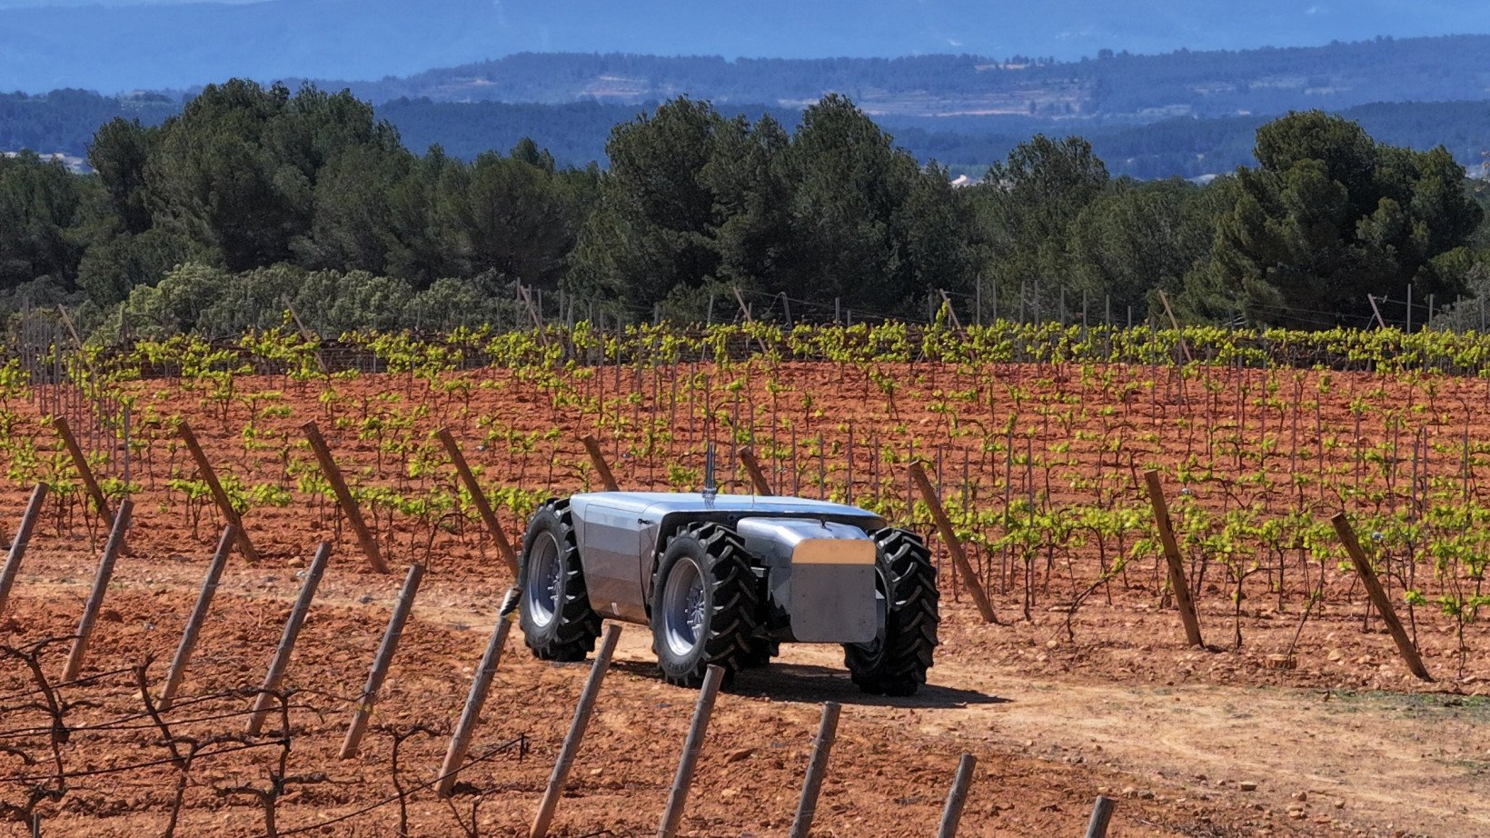
The Voltrac machine is no concept sketch. It’s a 3.5-tonne electric tractor capable of carrying up to 4,000 kilograms, travelling at speeds of up to 40 km/h and running for as long as 20 hours on a single charge. Modular attachments - ploughs, mowers, cutters or a flatbed for transport -snap on easily. Swappable batteries stored in the chassis keep downtime to a minimum.
Co-founders Thomas Hubregtsen and Francisco Infante Aguirre bring heavyweight credentials. Hubregtsen worked in artificial intelligence at BMW and Google X. Aguirre is an aerospace engineer with family roots in farm machinery supply. Together they have built a tractor that learns, adapts and can turn its hand to more than one role.
For farmers, that means the potential to fine-tune inputs. Even in early development, the tractor is designed to “experiment” in the field, treating patches differently, observing crop responses and adjusting treatments on subsequent passes. The promise is higher yields, reduced chemical use and more efficient management.
What grabs global attention is the tractor’s dual-use potential. Voltrac has been clear that with small modifications - anti-jamming systems, mine detection, frontline supply roles - the platform could serve in conflict zones. Aguirre points to Ukraine as an example where autonomous machines might save lives: “Many lives are lost in non-combat situations, including frontline resupply missions. That’s where we see a machine like ours making a difference: it’s built for tough terrain, and it doesn’t risk human life.”
For New Zealand farmers and contractors, the technology invites both interest and caution. Autonomous machines promise to ease labour shortages, improve precision and cut emissions with electric drivetrains. A modular platform that swaps between roles has obvious appeal. Voltrac has raised millions in early funding, built its prototype and aims for first deliveries as early as 2026. The pace is fast.
But scepticism is warranted. Farming isn’t done on test tracks. New Zealand’s terrain - from steep hill country to heavy wet soils - is a tougher proving ground than most European farmland. Autonomous tractors may run for 20 hours on flat dry ground, but how will they cope with clay tracks in winter, shifting stock or working on slopes where judgement and caution matter as much as horsepower?
Cost is another hurdle. Electric drivetrains and advanced AI aren’t cheap. Contractors already face tight margins and high capital costs. The idea that a robotic tractor will simply replace a skilled operator is far from straightforward. Farmers may question whether the technology will pay for itself, especially when reliability and local servicing support are untested here.
Regulation also lags. Remote operation or machines running without anyone in the cab raises safety, insurance and liability issues. Until the legal framework is clear, few will hand over key tasks entirely to an algorithm.
And then there’s the human element. Farming is not only about efficiency; it’s about experience and judgement. A seasoned operator can read the weather, hear when a machine sounds off and make on-the-spot calls no software can yet match. Machines may reduce drudgery, but replacing skilled drivers is a long way off.
That doesn’t mean the technology should be ignored. Early adopters here may trial these machines in flat arable systems or controlled environments where logistics or repetitive operations dominate. Contractors might partner with suppliers or universities to test the potential. But it would be unwise to assume a quick road to replacing every driver with a robot.
There’s also the risk of hype. Technology companies often promise breakthroughs that never reach mass adoption. Farming still demands human involvement at every level. The Voltrac platform is exciting, but until it proves itself in real paddocks, under real pressure, the jury remains out.
Where the concept may gain traction sooner is in support roles - moving supplies, hauling loads or working in hazardous environments where the risk to people is high. In those spaces, the value of autonomy is clearer. But when it comes to the delicate, variable and unpredictable realities of farm work, people will remain central for a long time.
Voltrac’s autonomous tractor signals where technology is heading - smarter, more modular, more autonomous. But as we weigh its relevance to New Zealand agriculture, it pays to stay grounded. Machines like this may one day complement farm work, but they won’t quickly or easily replace the skill, adaptability and resilience of the farmers and contractors who keep the country fed.

Answers
- Evaluate how well autonomous tractor technology aligns with the future needs of primary production systems.
Social
Autonomous tractors align partially with the social needs of future primary production systems. New Zealand agriculture faces ongoing labour shortages, particularly for seasonal and skilled machinery operators. Autonomous tractors could reduce reliance on scarce labour for repetitive or hazardous tasks such as spraying, mowing, or transport.
However, the technology does not fully replace the value of human experience and judgement. Skilled operators read weather conditions, soil moisture, and animal behaviour - skills current AI systems struggle to replicate. There are also concerns about job displacement and the need for new digital skills, meaning training and upskilling will be essential. Overall, autonomous tractors are more likely to support workers rather than replace them in the near future.
Environmental
Environmentally, autonomous electric tractors strongly align with future sustainability goals. Electric drive trains reduce greenhouse gas emissions compared with diesel-powered machines. Precision technology allows machines to vary treatments across a paddock, which can reduce chemical use, fuel consumption, and soil compaction.
The ability of the tractor to “experiment” and adjust inputs in real time could lead to higher yields with fewer resources, supporting more sustainable land use. However, real-world performance in New Zealand’s wet soils and steep terrain remains uncertain, and battery performance may decline in cold or heavy conditions.
Economic
Economically, the alignment is mixed. Autonomous tractors could improve efficiency by operating for up to 20 hours, reducing downtime and labour costs. Modular attachments increase versatility, meaning one machine could replace several specialised units.
However, high upfront costs, uncertain reliability, and unclear servicing support present significant risks. Many New Zealand farms operate on tight margins, and the return on investment is uncertain. Until costs fall and performance is proven locally, widespread adoption is unlikely. Early adoption is more realistic for contractors or large, flat arable systems.

- Using a viticulture business, analyse how autonomous tractor technology could affect the long-term viability of the business.
Autonomous tractor technology has the potential to positively influence the long-term viability of a viticulture business, particularly in regions with flat terrain and high labour demand.
Labour and skills
Viticulture relies heavily on seasonal labour for tasks such as mowing, spraying, under vine weeding, and transport. Autonomous tractors could perform repetitive tasks consistently, easing labour shortages. Staff roles may shift from operating machinery to monitoring, programming, and maintenance, requiring higher technical skills.
Productivity and efficiency
Precision spraying and mowing could reduce chemical use and improve vine health. The tractor’s ability to treat different vineyard blocks differently would allow site-specific management, improving grape quality and yield. Long operating hours mean tasks can be completed at optimal times, such as spraying during calm night conditions.
Costs, risks, and limitations
The main challenge is cost. Electric autonomous tractors are expensive, and vineyards must justify the investment through improved efficiency or reduced labour costs. Reliability is another risk—vineyards operate in tight seasonal windows, and breakdowns could have major consequences. Regulatory uncertainty around autonomous machinery also presents a barrier.
Suitability to New Zealand conditions
Autonomous tractors are best suited to flat, well-structured vineyards, such as those in Marlborough. Steep or irregular terrain would limit effectiveness. Over time, as the technology matures and local support develops, autonomous tractors could significantly improve business viability by reducing costs, emissions, and labour pressure.

In summary autonomous tractors like Voltrac represent a promising but evolving technology. They align well with environmental goals and offer solutions to labour shortages, but economic and practical challenges remain. In controlled systems such as viticulture, they are more likely to enhance business viability than in complex, variable farm environments. For the foreseeable future, autonomous tractors will complement rather than replace skilled farmers and contractors.

