Level 3: Future Proofing Strategies.
Drone Technology
Teacher Note:
This worksheet provides an example of technology future proofing Strategy based on drones.
Future Proofing Strategy Questions
The level 2 “Drone Technology UP, Up and Away” worksheet can be used as prior learning

Up, up and away
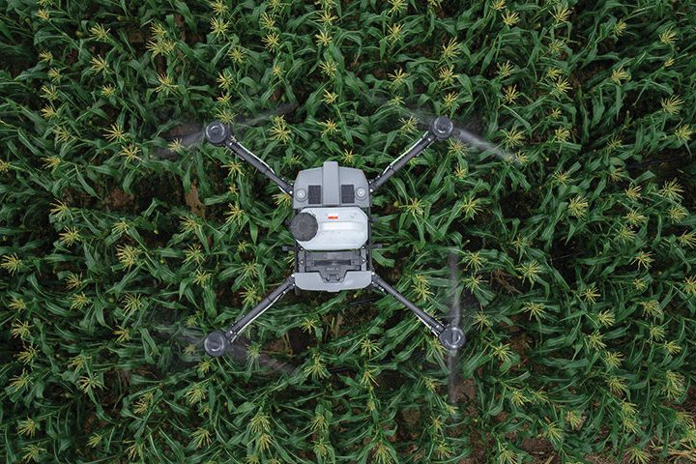
Country-Wide August 2022
The latest and greatest developments in drones was the topic of a South Otago field day. Over two days more than 80 people came to look and learn about the potential of drones on-farm.
A range of drones were on display, from the portable and entry price level to trailer-towed commercial spray drones.
Drone specialist company Ferntech overviewed the capabilities and uses of Mavic, Phantom and AGRAS spray drones. What became obvious was the big leap forward in drone technology over a short time such as the improved high definition and zoom capabilities of cameras along with the developments in thermal imaging and mapping. Drones could capture more precise and accurate information than before, Luke Johnson of Ferntech said.
Drones have come a long way and their capabilities in agricultural use are significantly improved. By Lynda Gray.

A growing area of use was for the spraying of crops and weeds. Spray drones have been around for about five years but there was not huge interest initially because of the small payload capacity of about 10kg, Johnson said. However, the development of 30kg payload drones made them a more practical option for farmers.
“The more they can spray and faster makes them a more attractive option for spraying.”
He gave a demonstration of how to plot a grid map for a spraying mission which included continuous and spot spray areas.
Onlooker and an early adopter of drone technology Brett Sanders (Country-Wide, July 2017) was interested to see the spray drones in action. They are expensive at about $50,000 which includes necessary accessories to map a spraying mission, but he thinks they could work out on extensive hill properties reliant on helicopters for the spraying of crops and weeds.
“If you are spending $15,000 a year to spray 100ha using a helicopter, that money might be better invested in a drone which could be used for more spraying around the farm.”
However, he says the big turn-off for most farmers would be the mandatory requirement for Civil Aviation Authority 102 certification which applies to owners of drones used for the application of agrichemicals. Certification costs between $2,500 to $3,500 and takes about a year to complete.
Johnny Bennett, another farmer at the field day was impressed with the improved zoom capabilities of the new drone cameras. He has owned two drones and used them for checking sheep, water troughs and for picking up obvious issues on regular flights over his Te Houka farm. The first, a Phantom 4 went for about three years until it went AWOL on a pre-planned mission, never to return. It was replaced with a second-hand drone, but that met with a crashing end due to a burst of speed at the wrong time. Despite the run-ins, he is still keen on them because they saved a lot of time, especially checking ewes at lambing time.
“The drone could do a circuit around the farm in 20 minutes which was enough to uncover any problems. To do the same driving would have taken four hours.
“There’s greater accuracy than with the older drones. Often, I would see there was a problem but not the detail whereas I probably could now. I will buy another one at some stage, but it is not a priority at the moment.”
The field days organised by the Otago South River Care group with MPI funding attracted a lot of interest.
“We asked local farmers about innovations they wanted to know more about, and drones was a reoccurring topic,” Rebecca Begg, group coordinator, said.
“A lot are interested in the technology but not necessarily at the tipping point of buying one. The idea of the field day was to let them see the technology in action and start more conversations.”
Drone rules and regs
You do not need a licence to fly a drone in New Zealand provided it is less than 25kg fully loaded and is not being used for the application of agrichemicals.
However, all drone users need to follow the Civil Aviation Authority Part 101 drone rules.
Go to: www.aviation.govt.nz/drones/part-101-rules-for-drones/
Pilots of drones used for agrichemical application need CAA Part 102 certification. This takes about 12 months and costs $2500-$3500. Go to: www.aviation.govt.nz/drones/part-102-certification-for-drones/
New versus second-hand
There is a second-hand drone market, but Brett Sanders thinks buying new is probably the better way to go. Newer models have intuitive technology, so they are easier to use. A new release model, a Mavic Mini 3 which retails for about $1,400 and includes one battery could be a good option. If a control base and screen were included it would cost $1,700-$2,000.
“For that amount you should be able to get good quality pictures.”
His advice for buying second-hand is to go with a reputable brand, and check that the batteries are in working order and hold their charge.
A Mavic Mini 3 is a possible option but Luke Johnson said it would not withstand the wind conditions on exposed farms. A better choice was a Mavic Air 2S for about $2500 which would provide quality video and photography.
Farmers wanting a ‘barking drone’ and thermal imagery features would need a Mavic Enterprise Advanced or similar ($9,500).
A ready-to-go AGRAS spray drone with a 30kg payload and supporting mapping functions costs about $50,000. This would include three batteries which could be rotated to enable continuous spraying.
Spot on
Covid led to the start-up of Bill Paterson’s drone contracting business. Until March 2020 Bill’s main income was from helicopter flying tourists in and around the Queenstown southern lakes region.
That business dried up with Covid leading Bill back to the family-owned Waikaka Station where he was able to combine helping on the farm with development of a drone contracting business.
In January, he started out with a $70,000 XAG P30 which has a 16kg payload. It has been used for spraying and seeding work throughout Otago and Southland. Bill mapped and precision-sprayed areas for thistles and insect strike, and spot sprayed for particular weeds. He is also reseeded areas of crops that did not establish due to the dry summer. There is potential for more seeding jobs once he gets a bigger payload system in place.
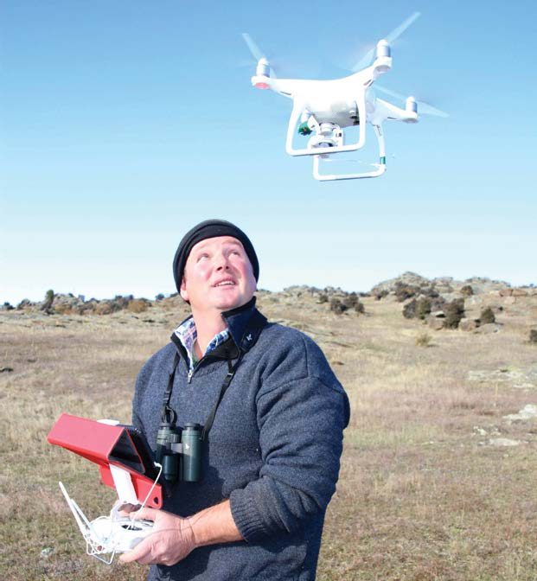
“There is a lot of potential but there is still a lot of R&D to do.”
Self-taught pilot
Brett Sanders is a self-taught drone user. He soldered together his first drone in 2013 from a basic frame with add-ons and bought a DJI Phantom in 2016. It was used a lot for mustering and was especially good at hunting out elusive Merinos from steep schist and briar country.
Brett also used it to accurately map the slope and drainage of land. The Phantom had probably flown the length of the country when it was replaced with a Mavic Enterprise Advanced last year for $10,000.
“It’s a lot of money, but I am an experienced user and know how to get the most out of them,” Brett said.
The thermal imaging is great for tracking down sheep and pests such as wild pigs and the zoom power of the camera means it is possible to identify the ear tag numbers of ewes in a paddock without disturbing them.
At the field day farmers were interested to hear about Brett’s dog barking drone which had reduced the workload of Matangi’s working dog team.
“We still use dogs, but they are probably not on to it as they used to be. When the drone comes out, they sit back and watch.”

Discussion Questions
- Discuss how well drone technology aligns with the future needs of a hill country sheep and beef farmer.
- Socially
- Environmentally
- Economically

- Using a hill country sheep and beef farming business, how could drone technology impacting their viability?

Discussion Question Answers

- Discuss how well drone technology aligns with the future needs of a hill country sheep and beef farmer.

- Socially
Drone technology aligns well socially with the future of hill country farming:
- Reduces physical strain: Farmers can inspect remote areas, check stock, or identify issues without physically travelling over steep or dangerous terrain.
- Saves time: Drones can complete in 20 minutes what used to take 4 hours by vehicle – freeing up time for other tasks or family.
- Improves safety: Less time spent on ATVs or helicopters reduces the risk of injury.
- Generational interest: Younger people may be more interested in farming if it includes modern technology, helping future-proof labour on farms.
Socially, drones help support work-life balance, safety, and make farming more attractive to the next generation.

- Environmentally
Drone technology provides environmental benefits:
- Precision spraying means less agrichemical use and less runoff into waterways.
- Thermal imaging and mapping can help identify land-use issues (e.g. erosion, water pooling) and allow for better planning.
- Seeding with drones can restore damaged land with less soil disturbance.
Environmentally, drones help hill country farmers move toward and achieve more sustainable goals.

- Economically
Economically, drone technology offers both opportunities and challenges:
- Cost-saving potential: Over time, drones can reduce helicopter use, fuel costs, and labour.
- High upfront costs: Quality drones (e.g. AGRAS spray drones) cost $50,000 or more with accessories and certification.
- Contracting opportunities: Farmers could either start drone-based services (like Bill Paterson) or hire contractors, which spreads the cost.
Economically, drones align well with long-term savings and new income streams, but initial investment and training may limit access.

- Using a hill country sheep and beef farming business, how could drone technology impact their viability?
Drone technology has the potential to significantly improve the viability of a hill country sheep and beef farming business by increasing efficiency, reducing costs, and supporting better farm management. Drones can replace expensive and time-consuming tasks like checking stock, fences, and water systems across difficult terrain. For example, what once took four hours driving can now be done in 20 minutes using a drone. This not only saves time and labour but also improves animal welfare, as drones can monitor lambing or locate missing animals without causing stress. Advanced features like thermal imaging and mapping also help farmers make smarter decisions about land use, drainage, and pasture, leading to more productive and sustainable operations. Drones can also keep farms running when ground access is limited, adding to the overall resilience of the business.

However, high upfront costs (around $50,000 for a fully equipped spraying drone) and the need for Civil Aviation Authority certification for spraying work add regulatory and financial pressure which could put strain on cash flow and therefore the viability of the business.
Farmers must also learn how to fly, maintain, and get the most value out of their drones, to get a return on investment to cover the costs involved. This may be challenging for those less experienced with technology and could add more costs which could put a strain on farm operational costs and the viability of the business.

There is also the risk of equipment failure due to crashes or harsh weather, particularly in exposed hill country. This loss of this investment will impact put additional pressure on farm finances and long-term viability.

Overall, drone technology can greatly improve the viability of a hill country sheep and beef farming business by:
- Reducing costs.
- Improving productivity.
- Supporting sustainability.
- Helping meet consumer and regulatory expectations.

However, initial costs, training, and regulation remain barriers. The greatest gains will come to a hill country farming business willing to invest, learn, and adapt, or who access drones through contractors or shared ownership.

