3.8 Case Study - Farming

Summary
What is the business/industry – explain the product
Identify the risks the industry/business is facing in general.

Future Needs
Future needs – List with brief sentences what the needs are.

Identified Risk
Identify the risk – what is it and explain in full (BLT)
Why/how does it affect the business and why do they need to do something.

Strategies
4-6 strategies that would address the impact of the issue you have identified.

Selected Strategy
Which one would you recommend the business use


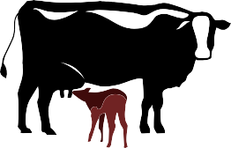

Justify & Evaluate
Clearly link back to all future needs.

