Future Proofing the NZ Cherry Industry

Overview
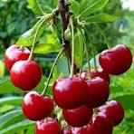
The New Zealand cherry industry is primary a high-quality export industry with 90% of cherries grown in Central Otago, which has ideal growing conditions of high summer sunshine hours and cold winter chilling hours. This focus on superior quality over volume has established NZ cherries as a prized horticulture product in markets like China, Taiwan, Vietnam, and Australia and fruit can be up to 5 times more profitable per hectare than other fruit. The industry's key commercial strategy is to leverage its December-to-February season to target the lucrative Northern Hemisphere winter holidays, especially the Chinese New Year market, when demand and prices are highest. Annual production is around 4,000 to 5,000 tonnes with most orchards maximum yield at 20 tonnes per hectare.

To maintain its high standards, the industry is adopting advanced growing technologies, such as retractable covers, denser planting, espalier and UFO planting. Emerging markets, including the Middle East and the United States a set to help grow the export industry.
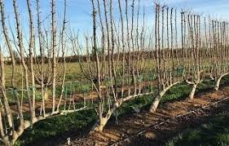
Upright Fruiting Offshoot (UFO) growing system (a high-density trellis technique designed to create a 2D, vertical wall of fruit) boosts productivity and helps to mitigate weather events. This system offers two key economic advantages: it makes for easier picking and increases harvesting and pruning speed by up to 50%, the system lends itself to mechanisation and robotic harvesting as well.
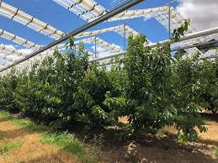

Retractable rain covers are also being used. These PVC-polymer covers prevent rain from splitting the fruit during the critical December harvest period. Cost for installation a=can be around $200,000 per hectare but it also doubles as bird netting. This significant investment is driven by the necessity to prevent large-scale crop losses caused by increasingly frequent rain events, thereby securing a consistent yield of up to maintain New Zealand's premium export reputation.

Key Challenges:

- Weather and Climate Risk
- Frost in spring can damage blossoms
- Rain close to harvest causes cherries to split, ruining crops
- Increasing climate unpredictability due to climate change

Future Proofing Strategies
- Use frost protection systems (e.g. wind machines, sprinklers)
- Invest in rain covers or tunnel houses
- Develop climate-resilient cherry varieties

- Labour Shortages
- Cherries are labour intensive, especially at harvest time
- NZ’s reliance on seasonal migrant workers (e.g. RSE scheme) is vulnerable to border closures (as seen during COVID-19)

Future Proofing Strategies
- Expand automation and robotics for picking, sorting, and packing
- Improve working conditions and incentives to attract local workers
- Collaborate with government on long-term labour planning

- Market Access and Trade Barriers
- Heavy reliance on a few key markets, especially China
- Vulnerable to trade tensions, tariffs, and biosecurity issues
- Air freight disruptions can delay exports (e.g. during pandemics)

Future Proofing Strategies
- Diversify markets (e.g. Japan, South Korea, Middle East)
- Strengthen cold chain logistics for longer shelf life
- Invest in brand building and direct-to-consumer channels (e.g. online sales overseas)

- Pests and Biosecurity
- Fruit flies or fungal diseases could threaten entire crops and export status
- High biosecurity standards must be maintained for premium markets

Future Proofing Strategies
- Ongoing research and development in pest management
- Use of integrated pest management (IPM) strategies
- Strengthen border biosecurity and traceability systems

- Environmental Pressures and Consumer Expectations
- Customers expect sustainable production (low chemical use, water conservation)
- Pressure to reduce carbon footprint and plastic packaging

Future-Proofing Strategies:
- Adopt regenerative farming and organic practices
- Switch to eco-friendly packaging
- Track and reduce emissions across supply chain

Considerations:
- Why is climate risk such a big issue for cherry growers?
- How could technology help the cherry industry in NZ?
- What could a cherry grower do to prepare for the next 10 years?

https://www.tupu.nz/en/fact-sheets/cherries/
https://hea.co.nz/2012-05-11-03-05-28/summerfruit-trade
https://www.hortnz.co.nz/news-events-and-media/media-releases/innovating-for-the-perfect-cherry-every-time
https://www.grower2grower.co.nz/cherry-production-in-new-zealand-mike-nichols/

