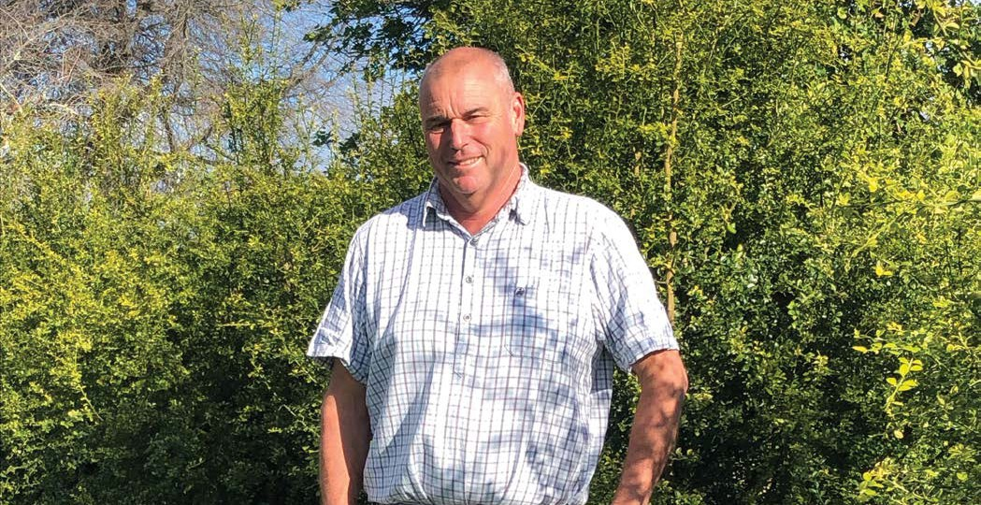

Alchemy Gisborne grower Jason Galloway and his family are investing in added value products for finger lime

CAVIAR FROM WASTE
A new finger lime initiative with citrus growers Alchemy Gisborne in conjunction with Callaghan Innovation’s Biotechnology Group and the Bioresource Processing Alliance is a great example of how growers can leverage science support to innovate and increase orchard and farmgate revenue.

Aimee Wilson

Jason Galloway and his wife and two daughters are involved in the family business Alchemy Gisborne and they are hoping to have some new products to bring to market next year.
“Finger limes have definitely got the most potential for added value,” Jason says. “They’ve got three different and distinct uses – seeds, peel and the fruit itself.”
Finger limes (Citrus australasica) are known as ‘citrus caviar’ because the uniquely-shaped fruit contains many small pearls, which are sought after for both high-end culinary uses and by the international cosmetic industry for use in exclusive beauty products.
Finger limes, which are rich in calcium, magnesium, potassium, phosphorus and Vitamin E, grow on a rare rainforest tree, native to Australia.
Jason says there is a lot of waste fruit that comes with finger lime growing, because of the nature of how
it is grown.
“It’s quite a different fruit from any other citrus. “The plants are particularly thorny – I mean
next level, which means having to wear gloves up to your armpits to pick the fruit.
“Given the nature of the tree, you’re going to get a lot of damage to the fruit.”
He says Poverty Bay had experienced a huge amount of finger lime plantings in recent
years, and Alchemy Gisborne wanted to be ahead of the game in terms of creating a viable market for second-grade fruit.

NZGROWER & ORCHARDIST : AUGUST 2025 53

MARKETS AND VALUE ADD

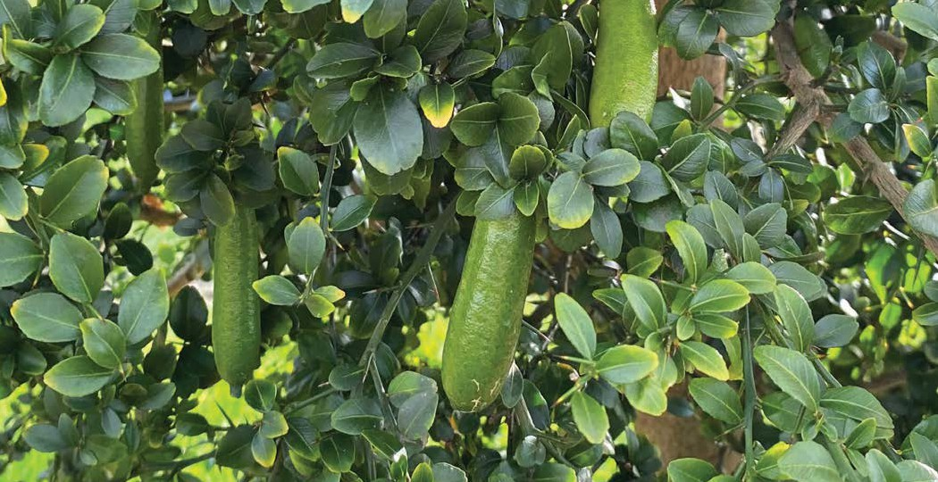

Look closely at the finger lime tree and you’ll see it is particularly thorny

He has been working with senior food technologist Campbell Ellison from Callaghan Innovation to develop an automated process for the second-grade fruit to separate the pearls from the skins, and then process the separate fractions to extract fragrance and oils from the seeds and skins.
GET SUPPORT TO ADD VALUE FROM ORCHARD AND FARM WASTE
Funded by the Ministry of Business, Innovation and Employment (MBIE), the Bioresource Processing Alliance (BPA) supports industry-led projects that aim to create additional economic value from low value bioresources. These initiatives align with the Aotearoa Horticulture Action Plan, which includes a focus on optimising waste value streams.
Thirteen innovative horticultural projects are benefitting from more than $1 million in research funding, thanks to BPA’s support and expertise.
BPA funding has supported many successful projects in the horticulture sector, including the development of an innovative beverage, Kabocha Milk, from waste kabocha squash; New Zealand Extract’s development of high-value bioactives from grape seed and other low value raw materials; and OVĀVO freeze-dried avocado powder from process-grade fruit.
The BPA also supports student projects, with current Master’s projects in the horticulture industry including the creation of fibre from apple
pomace and the development of grape-marc derived biochar and its potential to improve soil fertility and mitigate carbon emissions.


Creating an avenue to connect primary industry with R&D expertise is important
The Callaghan robotics team of Kit Wong, Luke Holibar and Chong Deng designed a machine to separate the pearls from the fruit under pressure, vastly improving the efficiency of what was once a laborious job done by hand.
A second part of the project involved finding the best way to preserve the pearls. Campbell says that after some research they were able to extend the chilled shelf life of the second-grade fruit from under a week to well over
a month, creating cost savings for the grower through reduced waste and transport costs.
He said that further work could investigate stability at ambient temperatures which would reduce costs further.
Jason says this is not yet commercialised and would form part of the next phase of the project.
The actual processes developed are commercially sensitive, but creating opportunities for second-grade fruit is crucial given the recent increase in interest in finger lime growing in Poverty Bay.

54 NZGROWER & ORCHARDIST : AUGUST 2025

MARKETS AND VALUE ADD

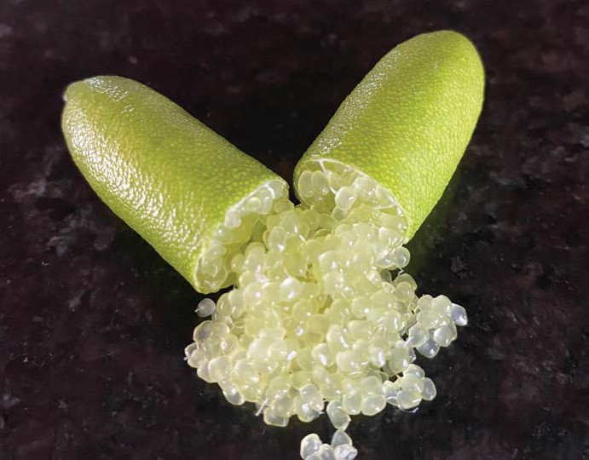

The small pearls in finger lime, known as ‘citrus caviar’, are highly sought-after


Alchemy Gisborne owns the IP of the new technology, particularly as they had invested $20,000 of their own money into the project, and had three years to use it under conditions of the funding contract.
“We have had great pleasure in finding
every commercial application must be supported by an industry partner whose driver is to commercialise the research aspect – we request they contribute 20–30 percent of
the project cost to show their commitment,” she says. Alchemy Gisborne
a way to add further value to an amazing little citrus fruit, and we’re optimistic
it will be the way forward,” Jason says.
The project was supported by the Bioresource Processing
Alliance (BPA). BPA support is available to businesses in all primary sector industries, including horticulture, helping them to access relevant R&D from one or more of BPA’s partners.
“Creating an avenue to connect primary industry with R&D expertise is important,” says Dr Nicky Solomon of the BPA.
“Researchers from the BPA alliance oversee the funding applications, but

Finger limes, which are rich in
calcium, magnesium, potassium, phosphorus and Vitamin E, grow on a rare rainforest tree, native to Australia
currently supplies domestic supermarkets with their first-grade fruit, and have partnered with a local
hospitality company to supply freeze-dried powders for garnishes and drinks.
Now using the new robotic technology, they were also able to start designing special trays to capture the pearls once they have been extracted – for the second-grade waste fruit.
“We’re just wanting to tackle it one job at a time, but the opportunities are very exciting,” Jason says.

