IS IT TIME FRO PINEAPPLE

GROWING IN NEW ZEALAND?
Wendy Laurenson
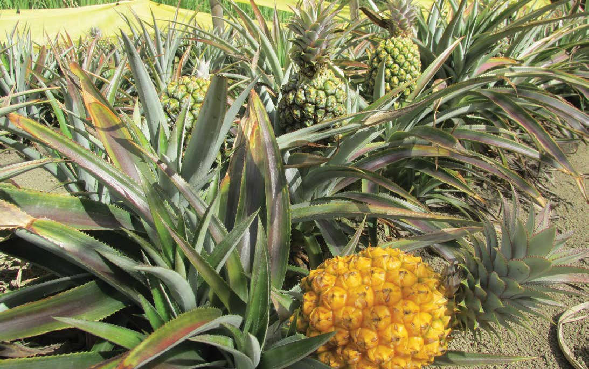
Ripening Queen pineapples, a small gourmet variety that is super-sweet, golden yellow and has an edible core

Could pineapples be a new crop to help growers diversify, particularly kumara growers with existing machinery for planting in mounds? Since Covid-19, there has been an increasing interest in sourcing locally grown food with a known story, and this includes tropical fruit as growers explore what else might thrive in our subtropical regions in
a potentially warming climate.
New Zealand’s only commercial pineapple growers, Owen and Linda Schafli, have grown and harvested thousands of pineapples near Whangarei in recent years as their project comes to fruition. “We harvested our first sizeable crop in 2021 after seven years of building up our plant numbers,” Owen says, “and the fruit is much loved by our customers. We’ve run out of land here with 1.3 hectares in pineapples,

so now that we’ve proved they can be a viable crop in warm areas in New Zealand, we’re ready to share our knowledge and plants with other potential growers.”
“We would like to encourage commercial growers to diversify into pineapples on their existing kiwifruit, kumara or dairy farm properties, especially if they have suitable machinery for planting in mounds. While we know pineapples can grow here in warm Northland sites, other coastal regions like Gisborne and Bay of Plenty are also potential locations.”
Owen Schafli grew tropical fruit in South Africa before the family moved to New Zealand in 2008 and later bought property near Whangarei to grow mainly bananas and pineapples.
“We initially planted several banana varieties for a cash crop while we experimented with growing pineapples,” Owen says. “We bought the first plants from a friend, trialled them in mounds on our higher ground, and when we knew they would grow and fruit well we started taking suckers to build up plant numbers, and preparing the land for planting to make the best economic use of our sloping property.”


From one hectare you will have replacement stock for five hectares
When the Schaflis were propagating from every small sucker, the plants took two to four years to flower, but their mature plants now provide a good supply of larger suckers that will flower in one to two years, with a further few months until pineapple harvest. By the end of 2021 they had 40,000 pineapple plants in the ground and have since increased their numbers to nearly 50,000.
Part of Schalfis’ pineapple growing success is their choice of the Queen variety. It’s a small gourmet pineapple that is super-sweet, golden yellow, has an edible core, a good shelf life and multiplies faster than some varieties. It’s an old cultivar still grown in Australia, India and South Africa for fresh fruit rather than canning. It also has a better tolerance of cold, disease and stress than Cayenne, the main commercial pineapple variety grown worldwide and imported here.
Kiwifruit or kumara growers are well placed to diversify into pineapples especially if they have suitable machinery for planting in sounds
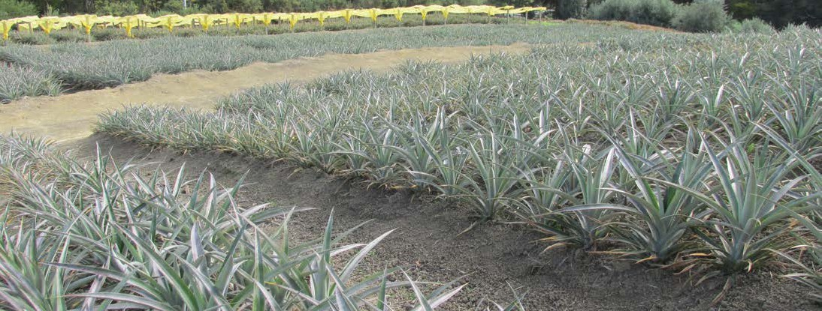
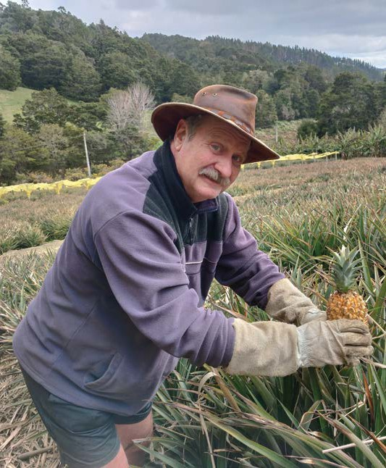
Owen Schafli says he has shown that growing pineapples in New Zealand is viable. Photo courtesy of the Schafli

“Cayenne is well suited for large scale harvesting and processing because the big fruit fit the cans with little waste,” Linda explains. “The plants are usually sprayed to induce uniform flowering and harvest times, and are picked unripe then gas ripened for fresh fruit export. We chose Queen to give New Zealanders the option of a super-sweet locally grown pineapple that is spray free and available nearly year-round.”
Pineapples like warmth, protection from frost, rich slightly acid soil, and free-draining ground, and they’re slightly more cold-hardy than bananas. “They’re in the bromeliad family so they like humidity but they hate wet cold ground,” Owen explains, “so we plant the suckers straight into mounds in October when the ground has warmed up. We can plant four rows in one mound for optimal land use without crowding the plants, and we protect some of the lower blocks with frost-cover during the cooler months.”

Because our crop is year-round we’re not dependent on one season’s weather
Pineapples are seldom irrigated where they are grown commercially in the tropics, but they do need enough moisture for the developing fruit to fill out and mature. “Ideally pineapples love a hot wet summer,” Owen adds, “but so far we’ve managed to get away without irrigation. Northland is usually humid, and because our crop is year-round we’re not dependent on one season’s weather.
We initially had some root rot problems which we’ve now solved with good hygiene, and we’ve managed to stay spray free.”
There are very few pests and diseases affecting pineapples in New Zealand, partly because our cooler climate doesn’t sustain those that are common in the tropics, and partly because there are fewer host plants for them to thrive on.
Imported pineapples also now have their leafy tops removed to reduce the biosecurity risk from supermarket fruit being used by insect pests as a source of plant material.
The Schalfis’ whole operation, including picking, is done by hand because of their sloping land and lack of space. “Pineapples are reasonably easy to harvest despite their prickly leaves,” Owen explains, “and we’re able to sell them here with the tops still on. For early harvest in March or April we wait until the fruit is fully orange before picking
it, but in August and September we pick as soon as there is a bit of orange to prevent the core going brown, then it colours up in about a week.”
Interest in New Zealand grown pineapples increased dramatically after the Schaflis’ enterprise was featured on Country Calendar, and the exposure helped people realise pineapples could grow outside here. “We regularly sell at the Whangarei Growers’ Market where we were originally known for our bananas,” Owen adds, “and there’s now a huge interest from our customers in the Queen pineapples. We usually sell out, and at our production peak of 700 pineapples at one market last May we sold out by 9.15am, and that was with a limit of six fruit per customer, so we know the market is expanding.”
Owen explains that pineapples will provide a return in one to two years, with the first fruit being the biggest. “After six years mature plants are usually dug out, but
they will provide enough suckers for five times the original area, so from one hectare you will have replacement
stock for five hectares.”
Linda and Owen have recently been joined by their son Colin, and their focus is now on gearing up to take orders later this year for growers interested in mature Queen pineapple plant suckers for planting in October 2024. “We anticipate selling a minimum of 40,000 plants per grower, ideally to plant at 40,000 plants a hectare, plus we’ll provide knowledge about growing them. We’re keen to support what could become a new small industry.”

